

**IS3106 Project Written Report**

**Group Number 3**

**Group Members**

Chong Kai Yu (A0216937W)

Irene Lie (A0222651N)

Srinivas Ganesan (A0216694W)

Koh Wen Jie (A0214346L)

## Cover Page

## **Table of Contents**

Cover Page 1

Table Of Contents 2

Description of Idea 2

Value Proposition 3

Business Content 3

Revenue Model 3

Market Opportunity 4

Competitive Environment 4

Competitive Advantage 7

Marketing and Advertising Strategies 8

UML Use Case Diagram 8

UML Class Diagram 9

UML Component Diagram 10

Prototype 11

References 12

## **Description of Idea**

Our proposed business idea is a laptop sales platform. Laptops have gained popularity over the years as more people value mobility over large, power-hungry setups. However, the laptop customization industry is not nearly as prevalent as the desktop one. There is an abundance of sellers where you can purchase desktop parts to build your own. This is not the case for laptops. As such, we would like to target people who would like the same level of freedom in customization and modularity in their laptop, as they would experience while shopping for a desktop.

## **Value Proposition**

The laptop customization industry in Singapore lacks variety, as customers often have limited options for customization. As a company, we seek to fill in the gap by providing a one-stop solution to laptop customizations and accessories. Besides bringing the ability to customize a laptop build specially for our customers needs and wants, we also aim to bring to them support and convenience through a support ticket system, we also hope to foster a community of like-minded laptop customization enthusiast through a forum system, where our customers can share their builds and communicate with other customers.

## **Business Content**

### **Revenue Model**

Our company will be adopting a sales revenue model. Our income stream is generated when customers purchase our laptop and other computer products available on our website. We offer customers a wide variety of customizations, regular laptops, as well as laptop peripherals such as mouses and keyboards. As mentioned above, we will mainly be focusing on customized laptops as our main product.

### **Market Opportunity**

With little competition in the laptop customization scene in Singapore, it would be simple for our company to fill the gap and deliver to the many customers who seek to own a powerful yet affordable laptop that is truly of their own design. Since the start of the Covid-19 Pandemic, there has been a sharp rise in demand for personal computers, especially laptops, for working from home situations. During this time, being able to offer laptop customization is particularly enticing, since customers would then be able to choose and spend only on what they need or want, instead of being stuck to pre-made laptops that are offered by most brands.

### **Competitive Environment**

|  |  |
| --- | --- |
| **Competitor** | **Notes** |
| **Aftershock**  https://www.aftershockpc.com/ | * Direct competitor in SG * Other than customized laptops, Aftershock also sells desktops and workstations * Offers products that are ready to ship as well (lack customization choices) * Allow accessories (add-ons) bundles * Customization can be done via the website * Does not provide chassis cosmetic customization services * After-sales services need to be done outside of the website (via external emails) |
| **Lenovo**  https://www.lenovo.com/ | * Allow customer to track their laptop by serial number on the website * Customization can be done on the website * Users will be able to key in their laptops’ serial numbers on the website to keep track of available warranties and after-sales services for the products * Customization can only be done for certain laptops which are very limited in number * During customization, the display of pictures takes a long time to load |
| **HP**  https://www.hp.com/us-en/shop/vwa/custom-laptops/ordr=Customizable | * Allow customers to compare one laptop with another type of laptop sold on the same website through side-by-side display * On top of the common customization attributes, HP allows users to choose laptop color as well * Allows website users to send laptop configuration to other people through emails. * The website allows members to collect rewards and points * The website allows customers to track orders * Request for cancellation and change of order can be submitted through the website * Not available in Singapore, item needs to be shipped from the US |
| **XOTICPC**  https://xoticpc.com/ | * Laptops can be customized on the website * Cluttered UI/UX. The homepage is not very intuitive. It takes users quite a long time to execute certain tasks. * Allows the users to track their order on the website, however, after-sales service requests need to be submitted through external emails * Not available in Singapore. Shipping from the US might be needed. |
| **GooGoo Custom Computers** http://www.googoo.com.sg/contactus.asp | * Customization needs to be done on the physical store * The website does not provide a lot of information regarding the products * The unresponsive website does not have good UI/UX. While it’s simple, it does not provide a lot of functionalities. |

### 

### **Competitive Advantage**

* **Laptop Customization**
  + customers can customize a laptop build to have the specifications that they desire by choosing the specific parts that are available (e.g ram, CPU, GPU, storage) from the various brands available that suit their needs and price range
  + configuration checking will be in place to ensure that the parts chosen are compatible with the build order
  + price will be auto-updated according to the selection
* **Account Management for Customers**
  + Customers can sign up for a member account, which will enable them to be able to track their build orders
  + Support ticket system for after-sales services
* **Inventory and Order Management for Staff**
  + Staff will be able to track and update their inventory (e.g quantity of stock)
  + Staff can also view and track orders
* **Convenient Delivery**
  + Customers can choose the type of delivery they want (Express or Standard)
  + Customers can also specify their preferred 2-hour time slot for delivery to be made upon checkout
  + A calendar will be in place to allow users to conveniently select the date of delivery
* **Promotions**
  + Promotions for laptop builds and accessories can be enabled by Sales Staff for certain products
* **One-stop shop for all things laptop**
  + besides being able to buy customized laptops, accessories are also available for purchase, such as computer peripherals (e.g mouse, keyboards, monitors)
* **Customer forum** 
  + Customers show off their customized builds by uploading pictures, and interact with other customers through the built in forum
* **Support Tickets**
  + Customers who have any queries or issues with their purchase can create a support ticket, which can be seen and will be attended to by the staff on the staff portal

### 

### **Marketing and Advertising Strategies**

We will be employing the use of Social Media, through the use of influencers, as well as traditional advertisements on billboards and TV commercials to reach out to as many people in Singapore as possible. We are marketing our product to potential investors for our system and company, hence we will be reaching out to private investors via networking events and social media.

## **UML Use Case Diagram**

Use Case Diagram of Before Lightning Staff Portal

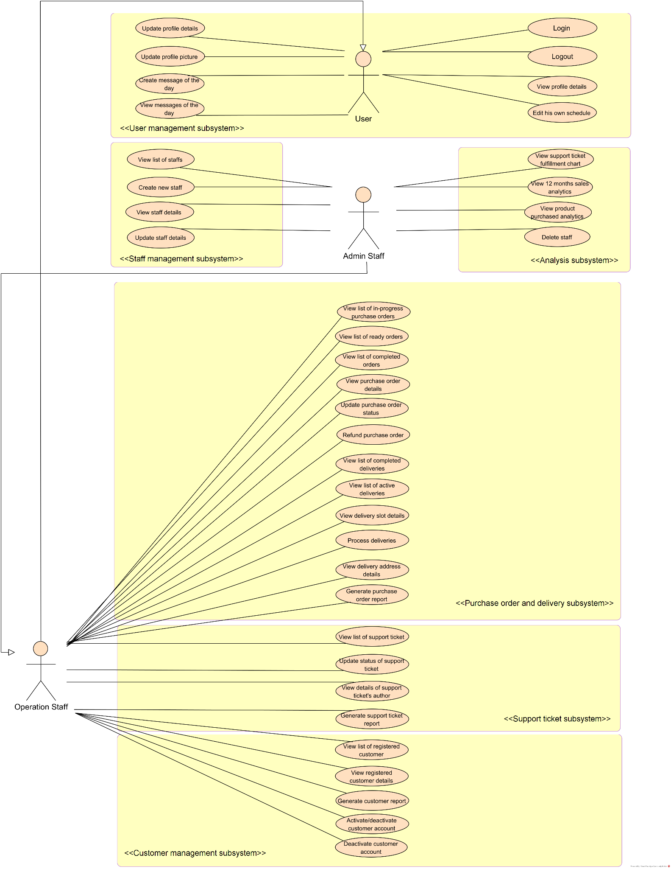

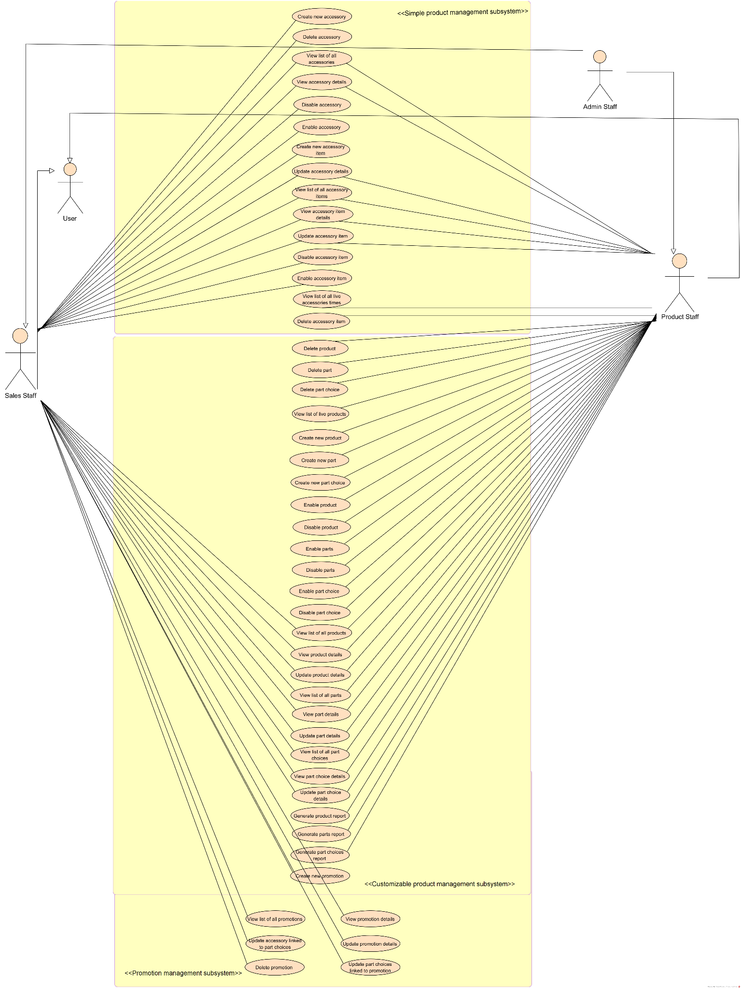

Use Case Diagram of Before Lightning Common Backend

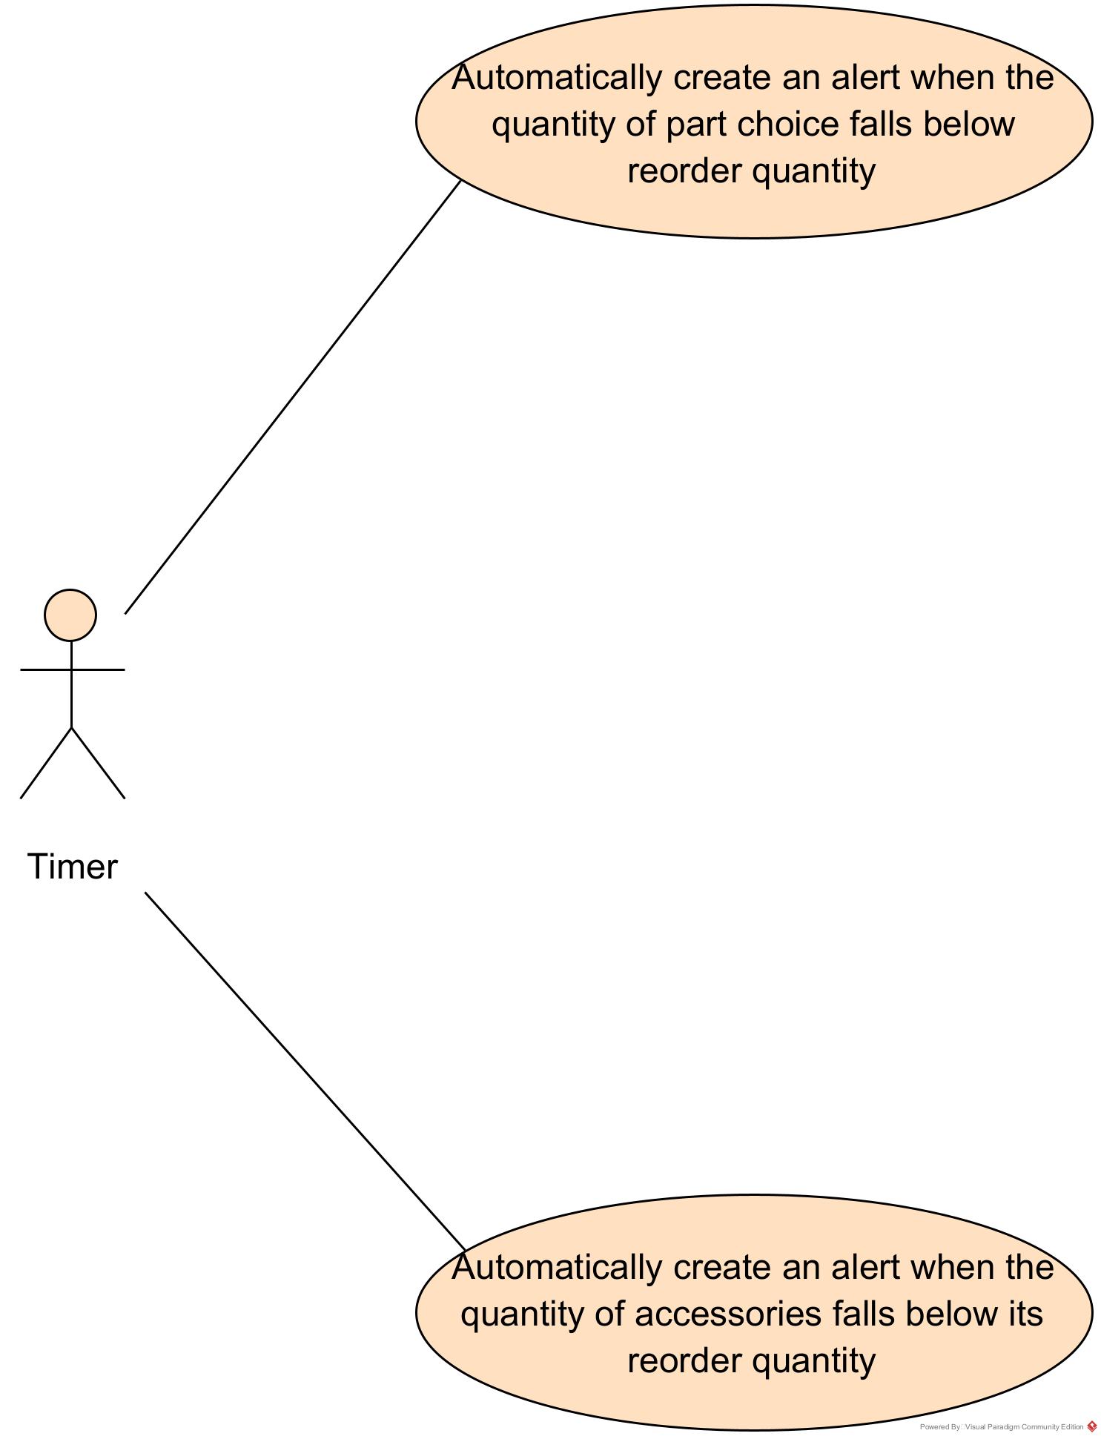

Use Case Diagram of Before Lightning Common Backend

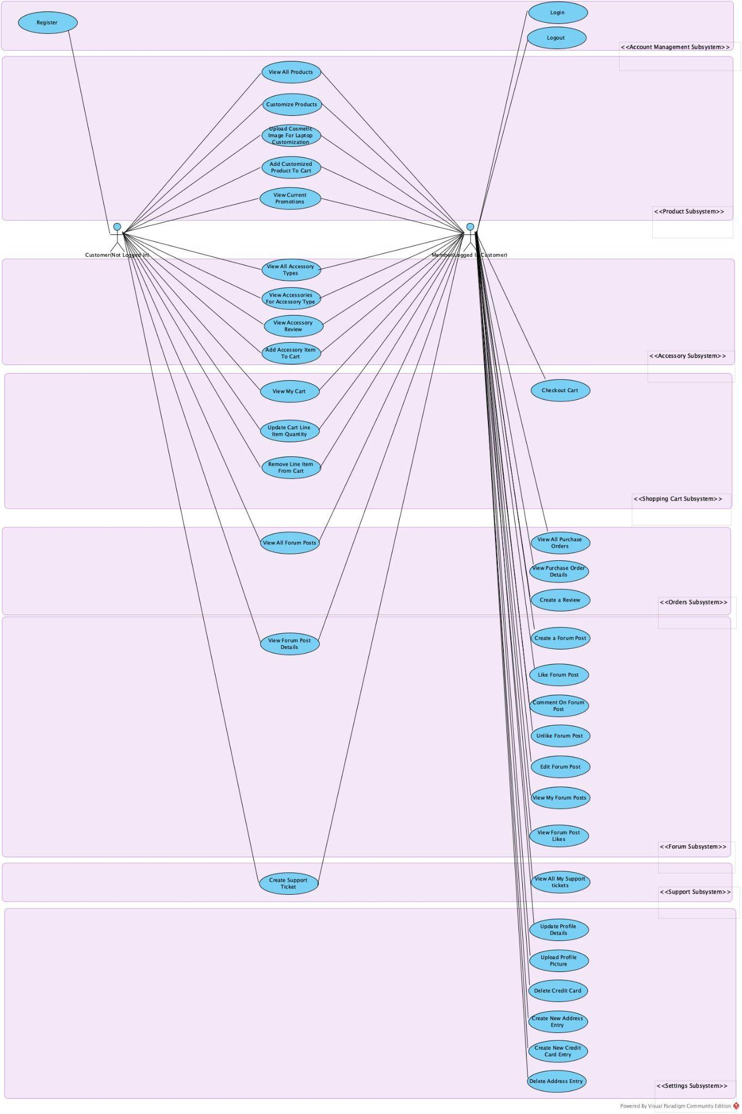

## **UML Class Diagram**

This is the UML Class Diagram.

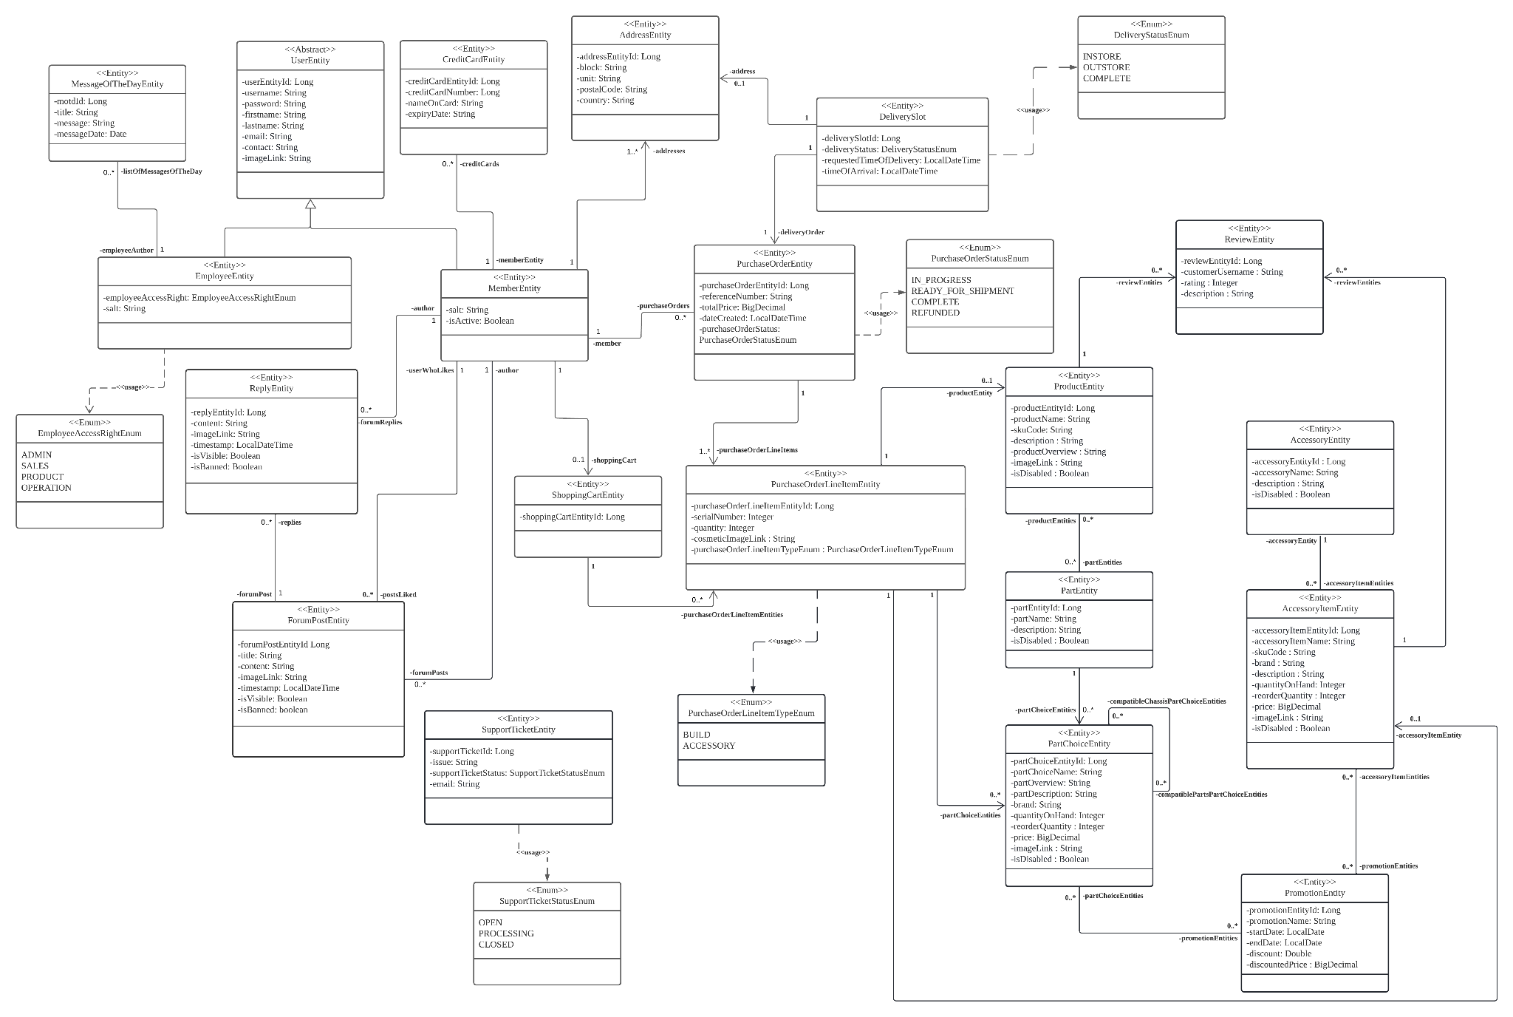

## 

## **UML Component Diagram**

Here is the UML component diagram depicting all Jakarta EE components in the common backend of the enterprise system together with their provided and required interfaces.

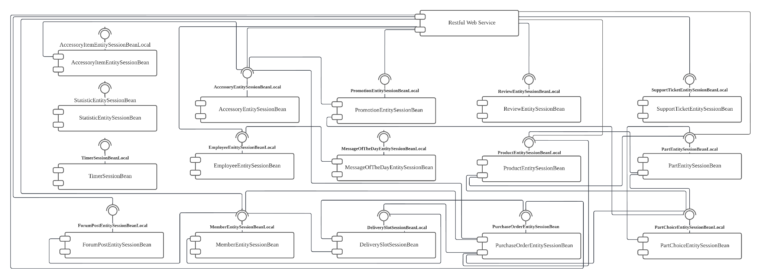

## 

## **Prototype Writeup**

Staff Portal

1. Login/Logout

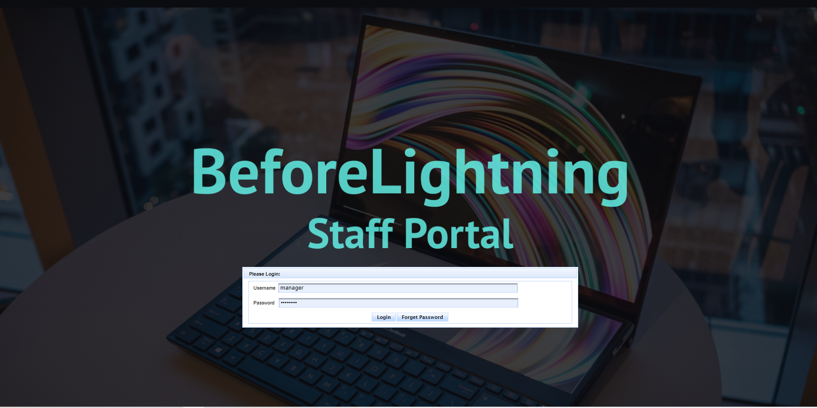

Fig. 1.1.1

Any staff will be able to log in to our staff portal with accounts that are created by the admin staff. The staff portal will not have any sign-up use case to avoid outsiders from making an account and having access to the company’s sensitive information.

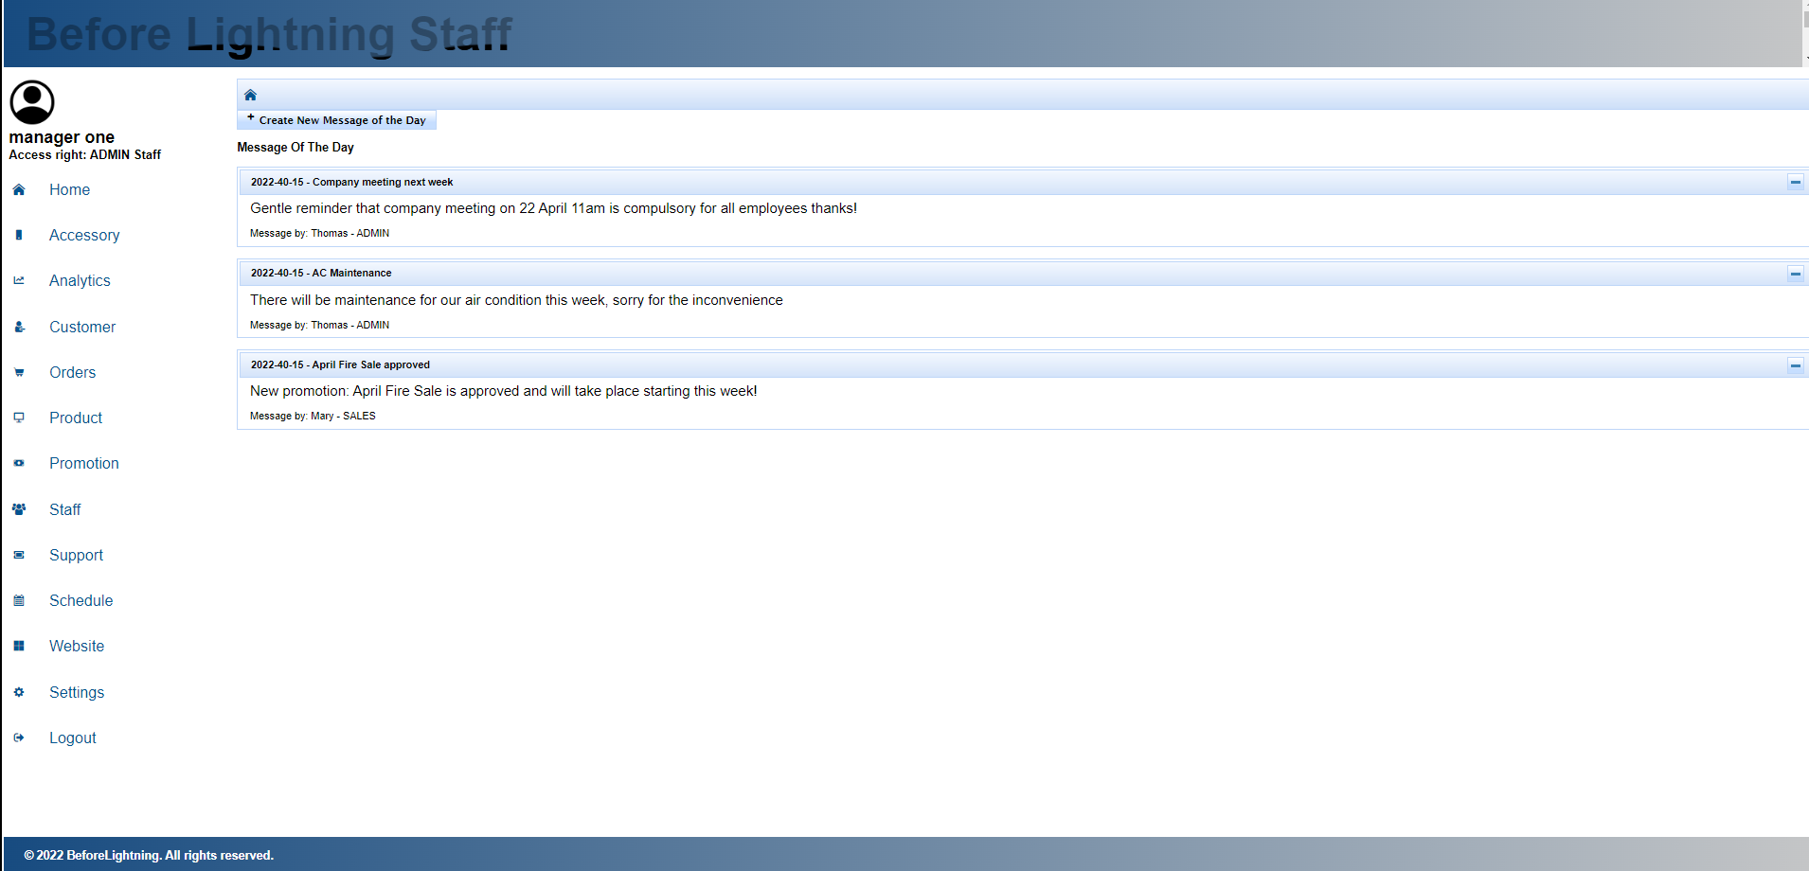

Fig. 1.1.2

Staff will be able to log out once they are done with their work as well.

1. Home Page Message of the Day

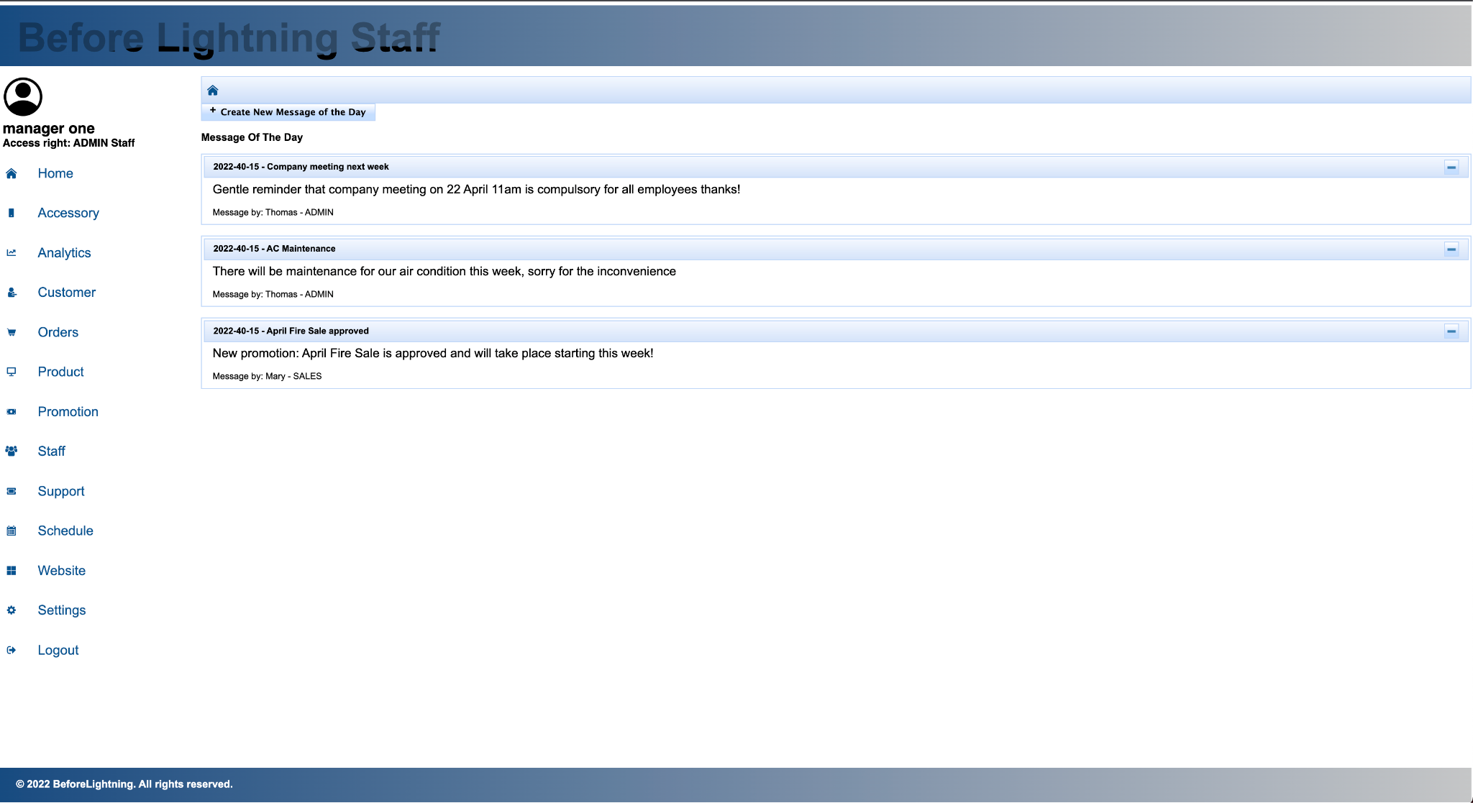

Fig. 1.2.1

Staff will be able to write a “Message of the Day” to be announced to all other employees via the home page as shown in figure 1.2.1

1. Accessory
   1. View Live Accessory

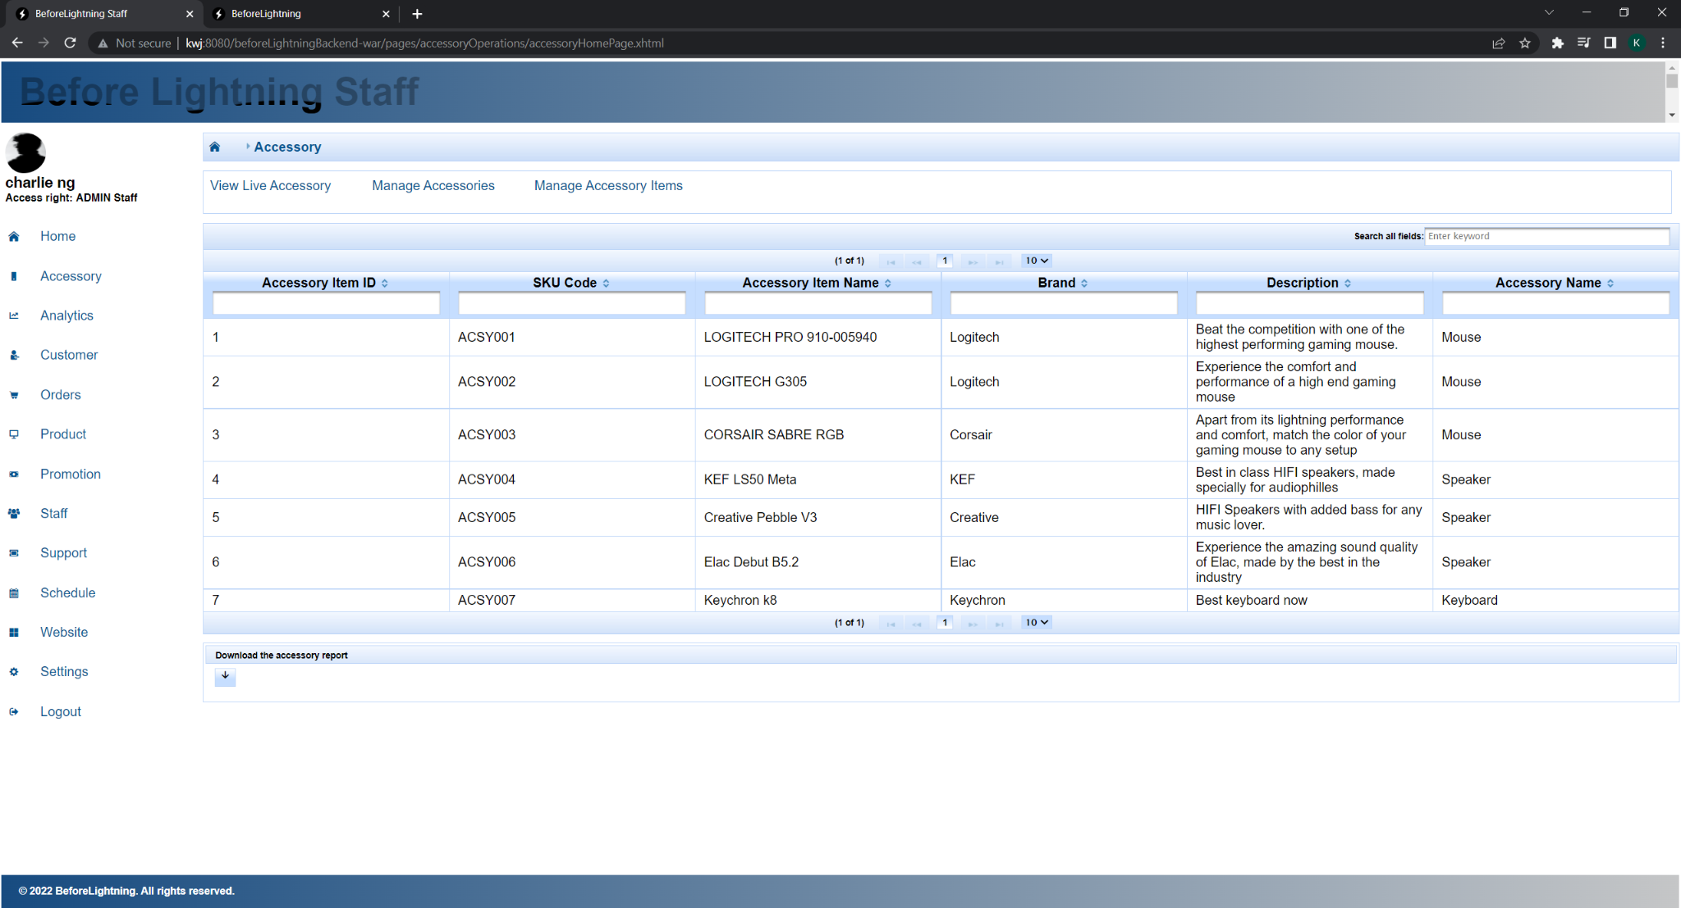

Fig. 1.3.1

The “View Live Accessory” page as seen in figure 1.3.1 shows the list of all the accessory items that exist in the inventory, and are currently sellable to customers in the Customer Portal. It serves to help the staff know what accessory items in their inventory are currently what the customers can see and purchase. An accessory report can be downloaded from the button at the bottom to view the details of the accessory items.

* 1. Manage Accessories

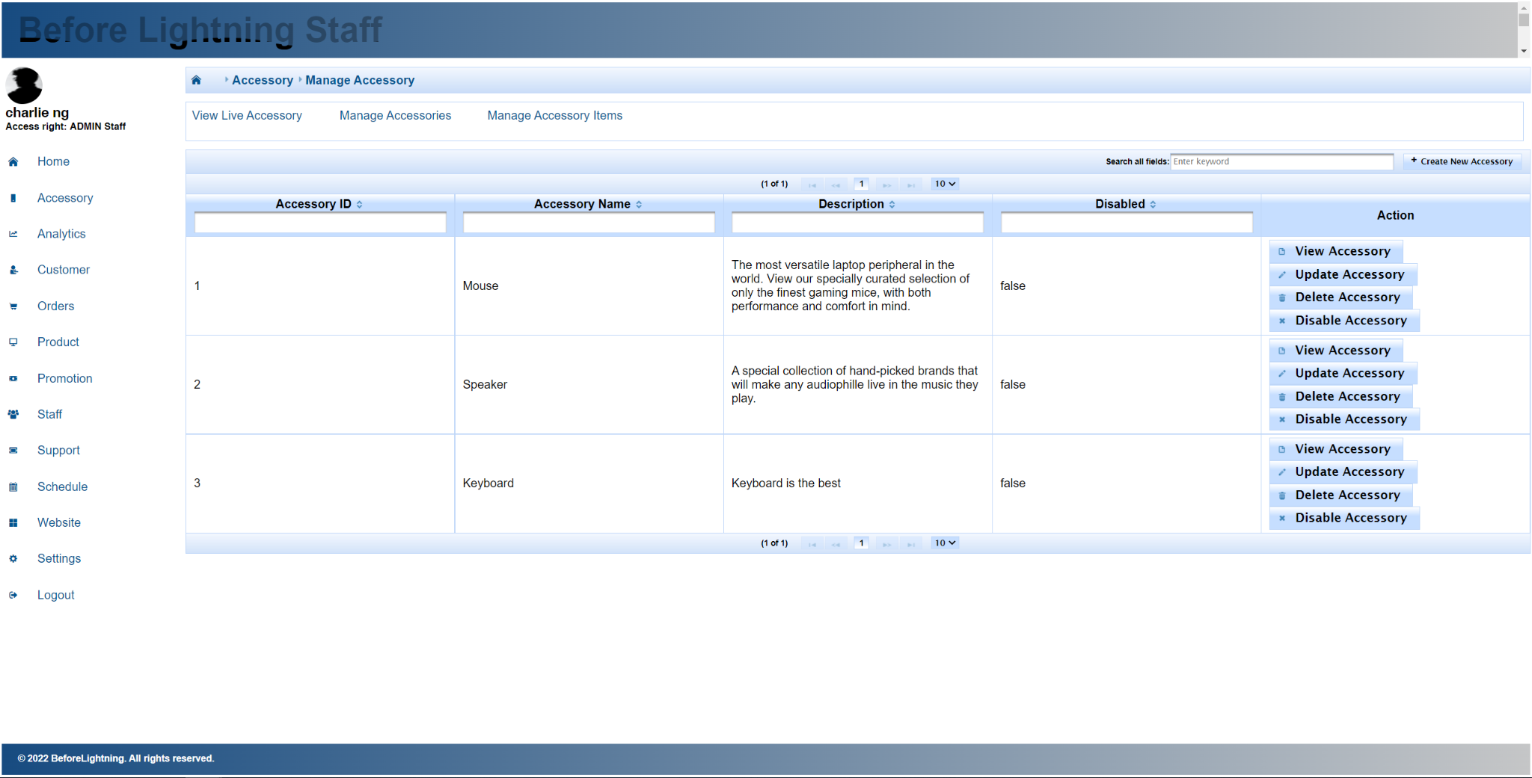

Fig. 1.3.2

The “Manage Accessories'' page as seen in figure 1.3.2 shows the list of all accessories, regardless if they are live or not. The “View Accessory” button opens a dialog and displays the details of the accessory. The “Update Accessory” button opens a dialog and allows the staff to update the details about the accessory. The “Delete Accessory” button will allow the staff to delete the accessory, only if the accessory has no accessory items in it. Lastly, the “Disable Accessory” button will disable the accessory. Once disabled, any accessory items linked to this accessory will also be considered disabled, and the accessory items will not show in the list of live accessories. Once disabled, the staff can enable the accessory once more to undo the disable. The “Create New Accessory” button opens a dialog that allows the staff to create an accessory, which will not have any accessory items initially.

* 1. Manage Accessory Items

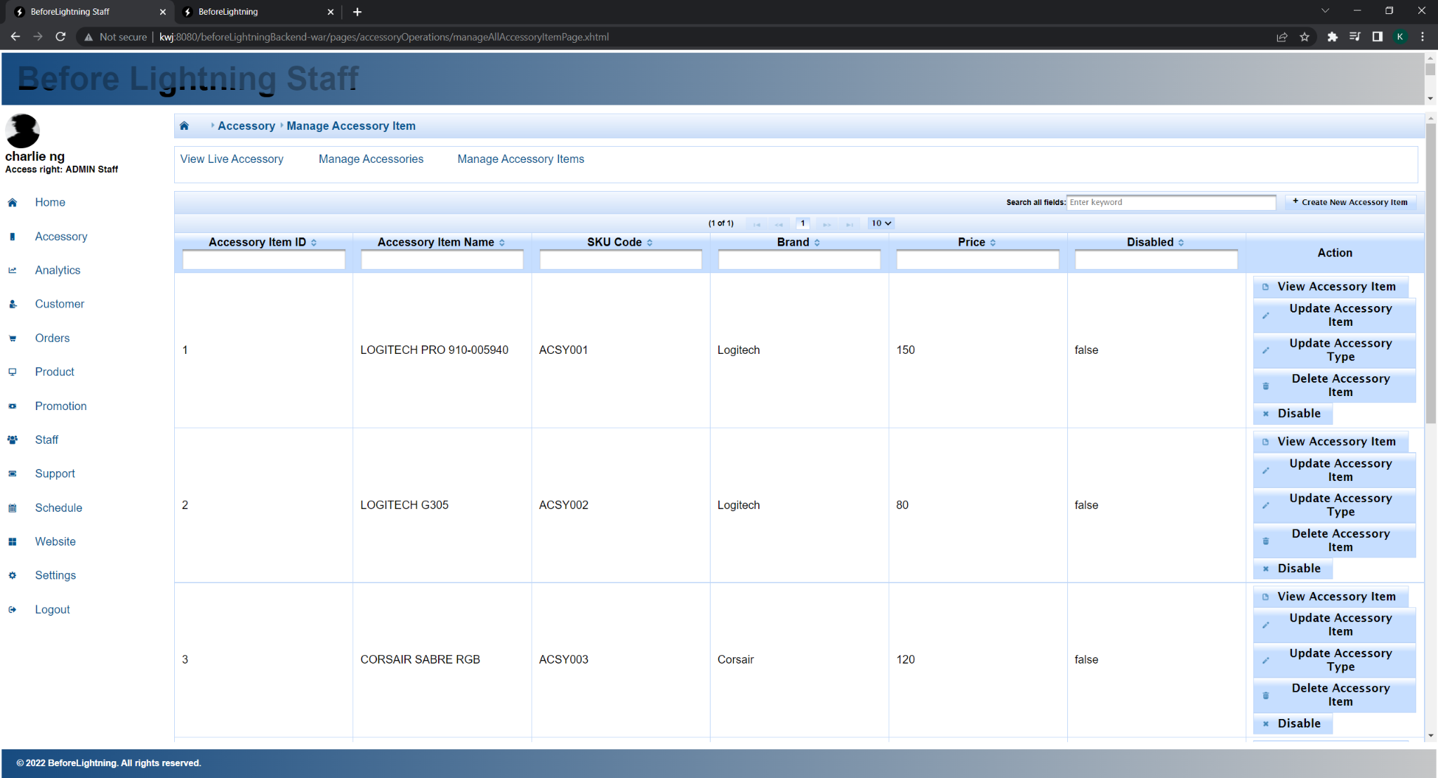

Fig.. 1.3.3

The “Manage Accessory Items'' page as seen in figure 1.3.3 shows the list of all accessory items, regardless if they are live or not. The “View Accessory Item” button opens a dialog and displays the details of the accessory. The “Update Accessory Item” button opens a dialog and allows the staff to update the details about the accessory item. The “Update Accessory Type” button will open a dialog and allow the Staff to change the Accessory that the Accessory Item is linked to. The “Delete Accessory Item” button will allow the staff to delete the accessory item. Lastly, the “Disable” button will disable the accessory item. Once disabled, the accessory item will not show in the list of live accessories. Once disabled, the staff can enable the accessory item once more to undo the disable. “Create New Accessory Item” button opens a dialog that allows the staff to create an accessory item and link it to an Accessory at the same time.

1. Analytics

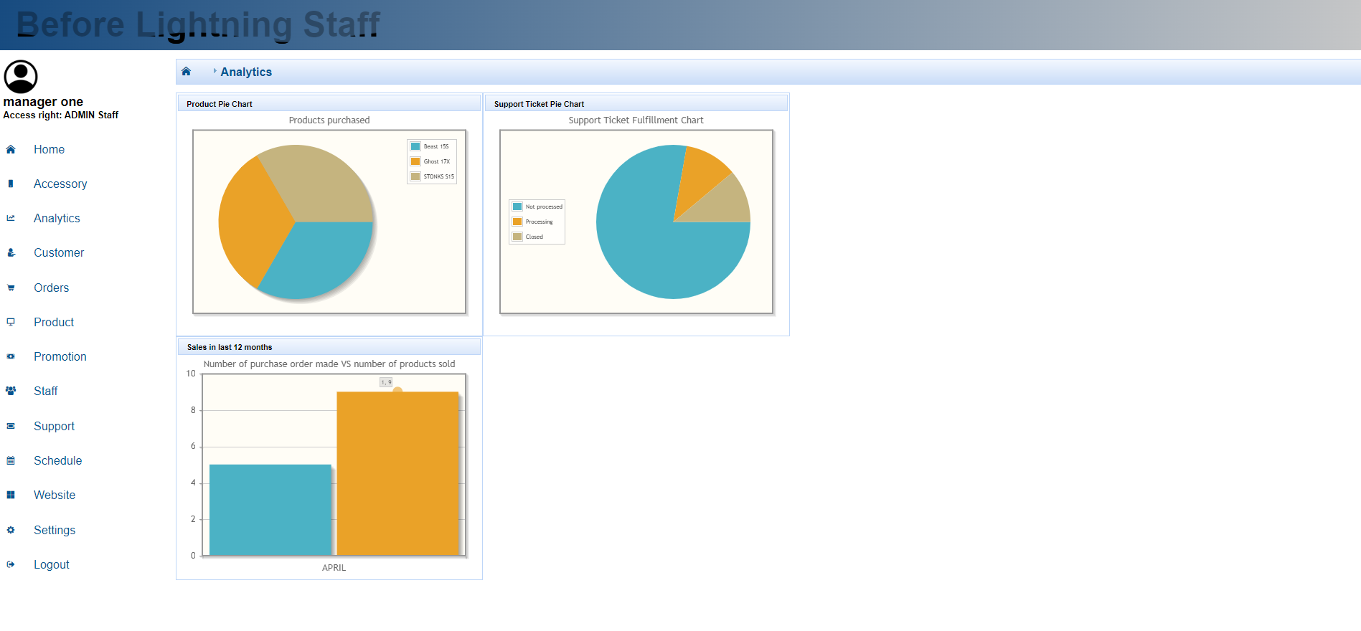

Fig. 1.4.1

Clicking the analytics tab will lead the staff to this analytics page. Only admin staff will be able to access this analytics page, since it may contain sensitive information that should not be available to normal staff, as shown in figure 1.4.1.

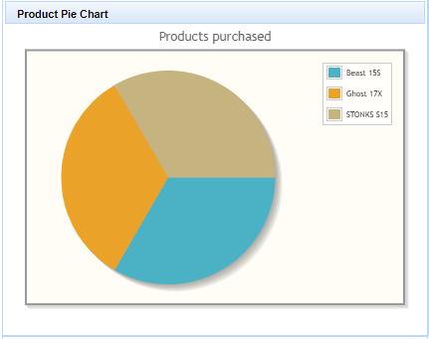

Fig. 1.4.2

The product pie chart is a live pie chart that visualizes the comparison between various customizable products successfully sold by Before Lightning, as shown in figure 1.4.2 It is automatically updated every five seconds, even when the staff stays on the same page. When the cursor is used to hover over a certain area in the chart, the number of products sold can also be retrieved from the chart.

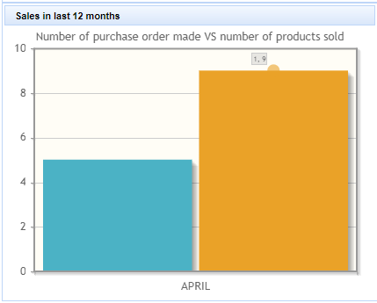

Fig. 1.4.3

This bar chart is a visualization of the number of purchase orders made and built sold made over the last 12 months, as shown in figure 1.4.3 Since all of our purchase orders are made in the month of April, only the bar of total purchase orders made in April and the bar of total products sold made in April can be seen.

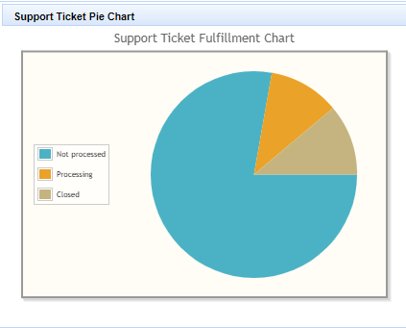

Fig. 1.4.4

The admin staff will also be able to see the visualization of support ticket fulfillment in a pie chart, as shown in figure 1.4.4. This can be used to gauge the productivity of the operation staff in processing customers’ requests for support.

1. Customer

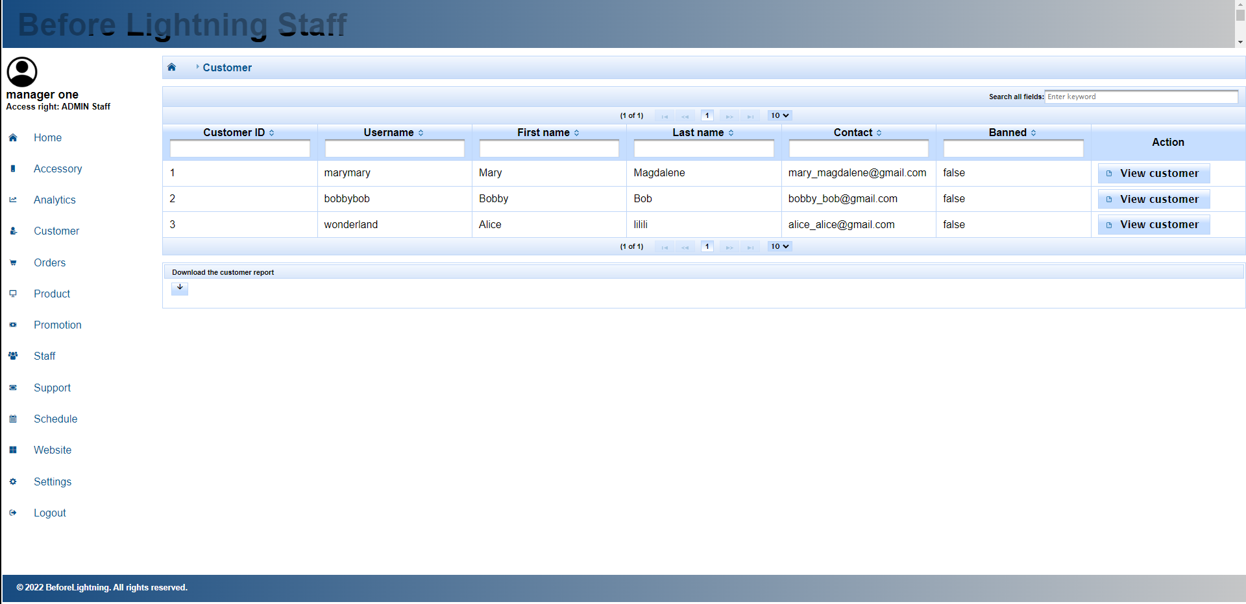

Fig. 1.5.1

The customer tab will be accessible by operation staff and will be used to display a list of customers that have member accounts on our customer portal. The staff will be able to see the ID, username, first name, last name, contact number, and the ban status of each of the customers.

Clicking the view customer will direct the staff to the dialogue box below. The chat icon brings up a dialog that allows customers to leave a review if the order has been completed, or be redirected to the forum page to post about their builds.

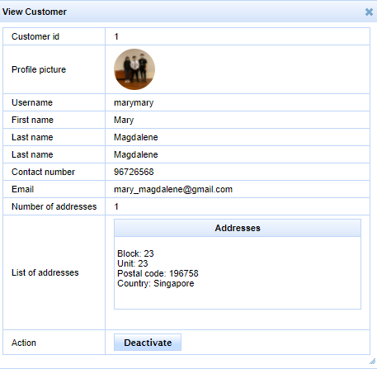

Fig. 1.5.2

Additional information about a customer that may be obtained from the ‘view customer details’ use case would be the profile picture used by the customer, contact number, and list of addresses. Through this use case, the staff will also be able to ban a certain customer.

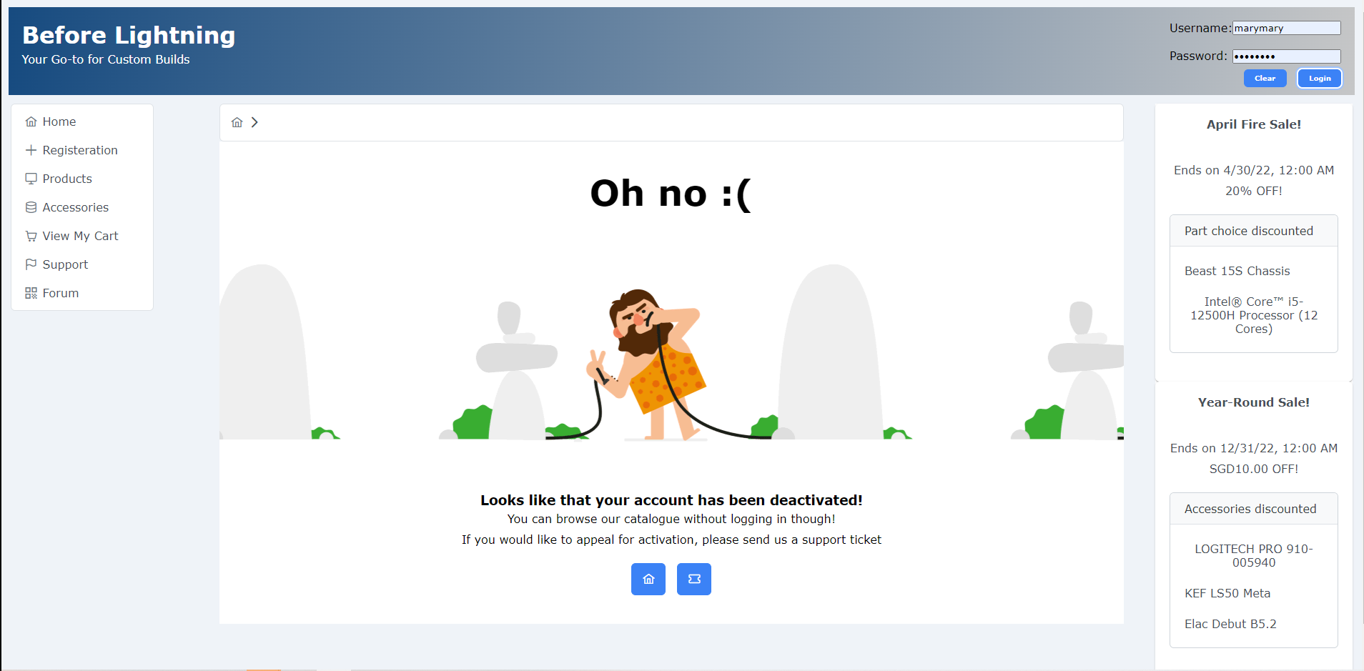

Fig. 1.5.3

When a banned customer tries to log in to their account, he will not be able to. To appeal for the activation of his account, he may send a support ticket.

Orders

Clicking the orders tab will lead to a page which showcases orders and delivery at every status, classified as tabs.

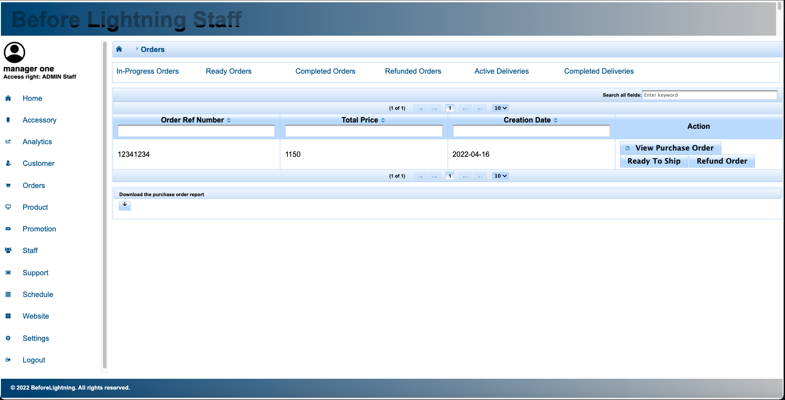

Fig. 1.5.4

In the in-progress tab, all in progress orders are displayed. You have the option to view purchase orders and change the status of an in progress order to complete. You also have the option to refund the purchase order, which will add the stock of the order back into the inventory on the back end.

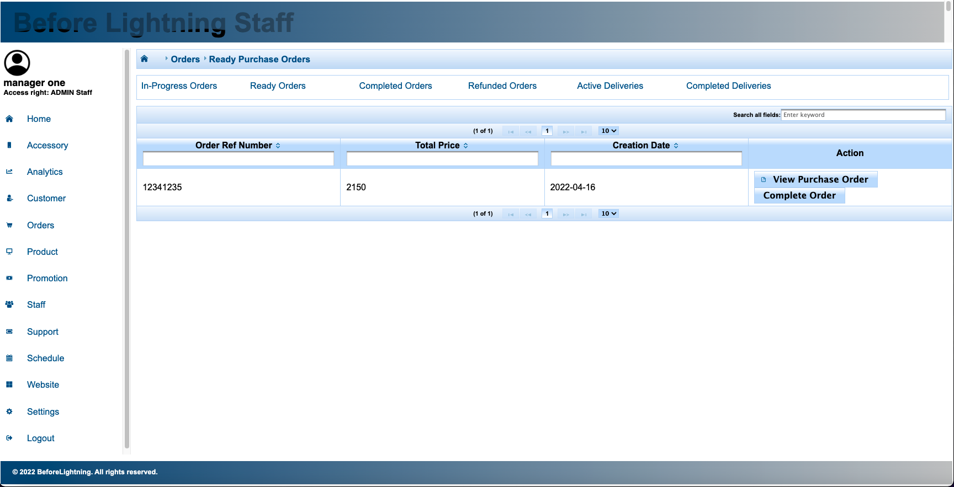

Fig. 1.5.5

In the ready order tab, you can view the purchase order and change the status of the order from ready to complete. This is for when the order has been successfully given to the customer, whether via delivery or self pickup.

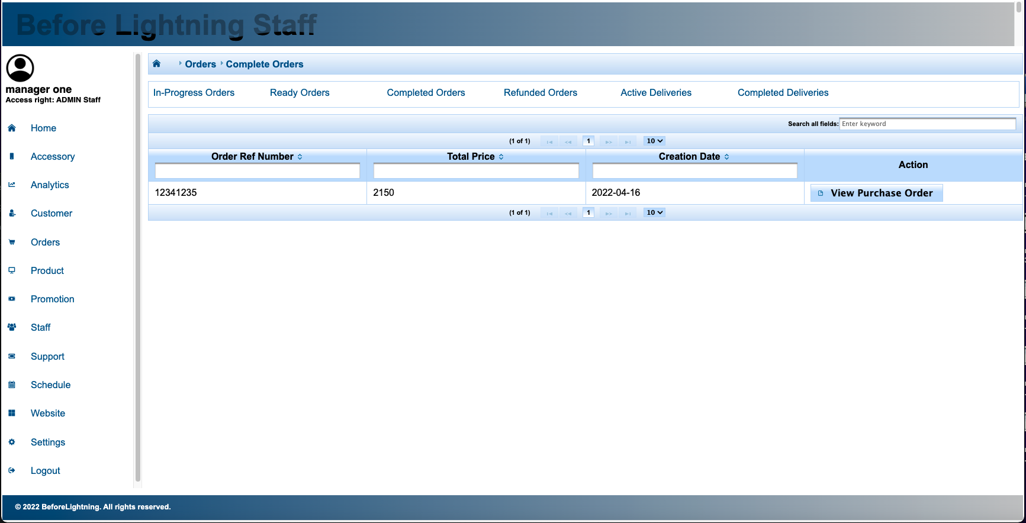

Fig. 1.5.6

In the complete order tab, you can view the purchase orders of completed orders.

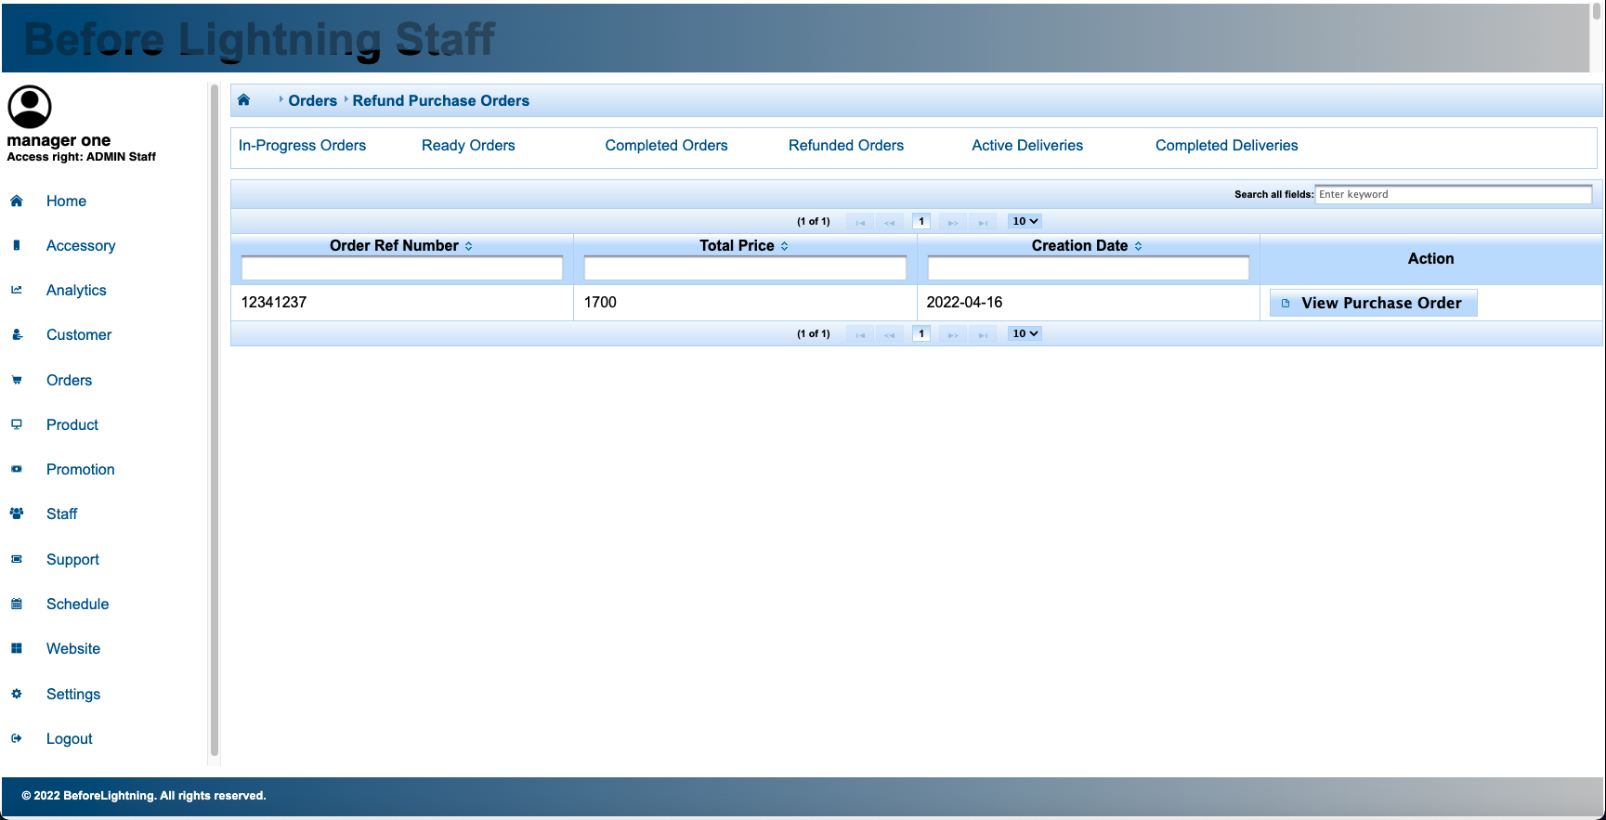

Fig. 1.5.7

In the refund order tab, staff can view the purchase order details of refunded orders.

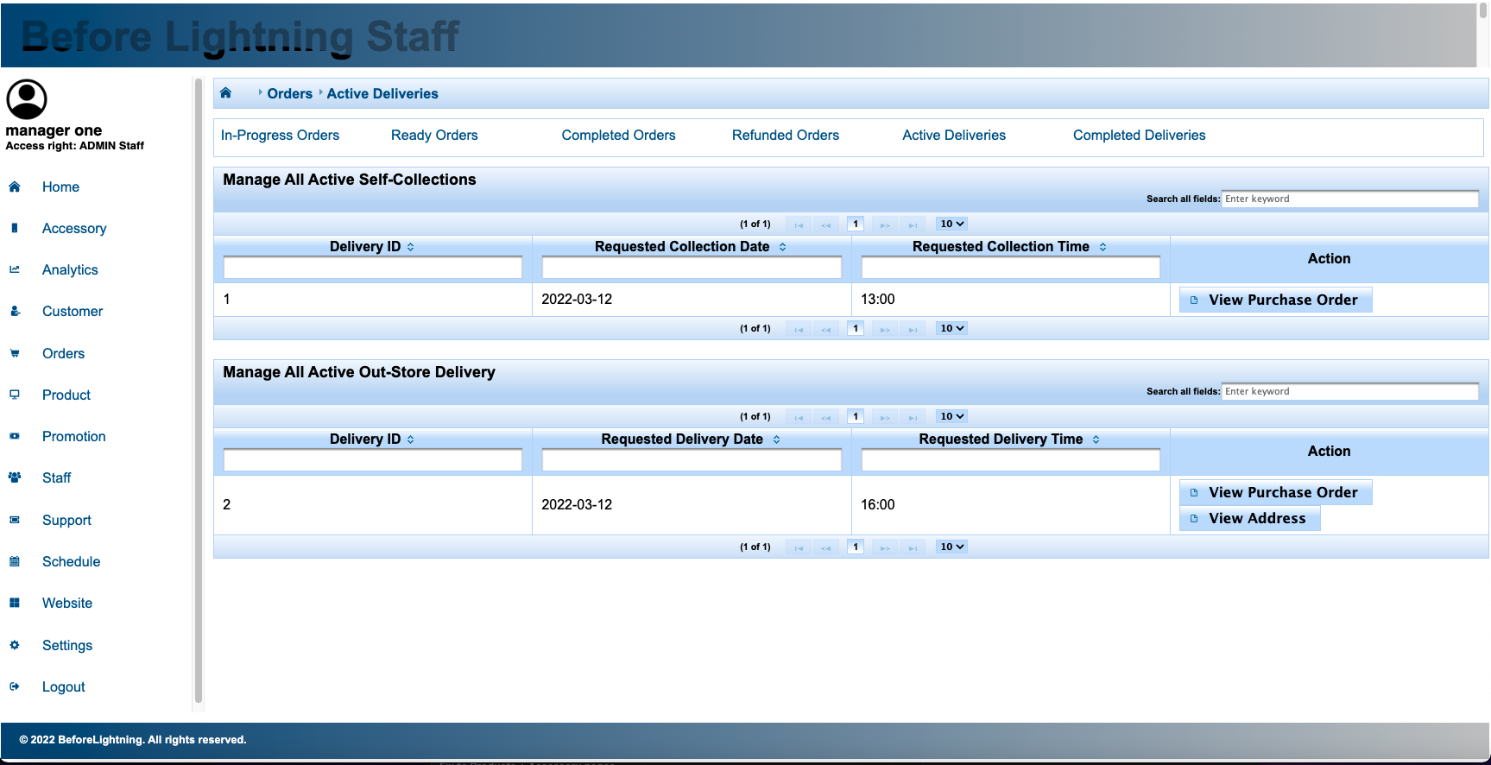

Fig. 1.5.8

Under the active delivery tab, you can manage all the active self-collections and out-store deliveries. Under the self-collection table, you can view the purchase order, while under the out-store delivery table you can view the purchase order, and also view the address the order is supposed to be delivered to.

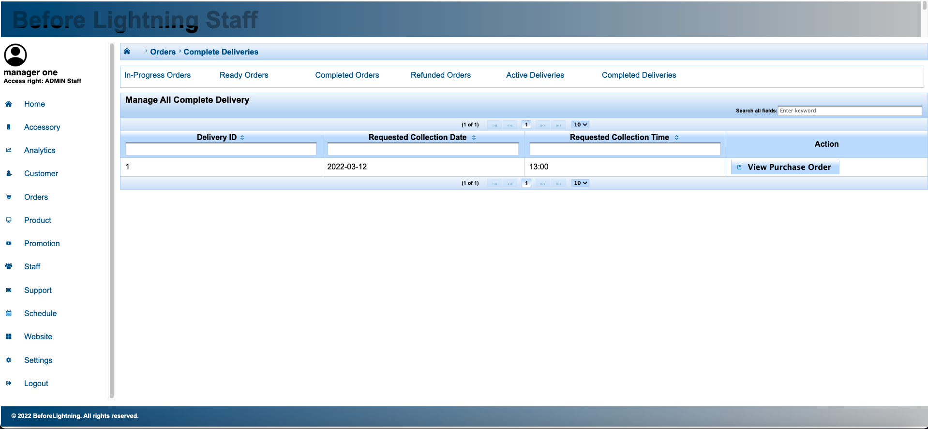

Fig. 1.5.9

Under the completed deliveries tab, you can view the purchase orders for completed deliveries.

1. Product
   1. View Live Products

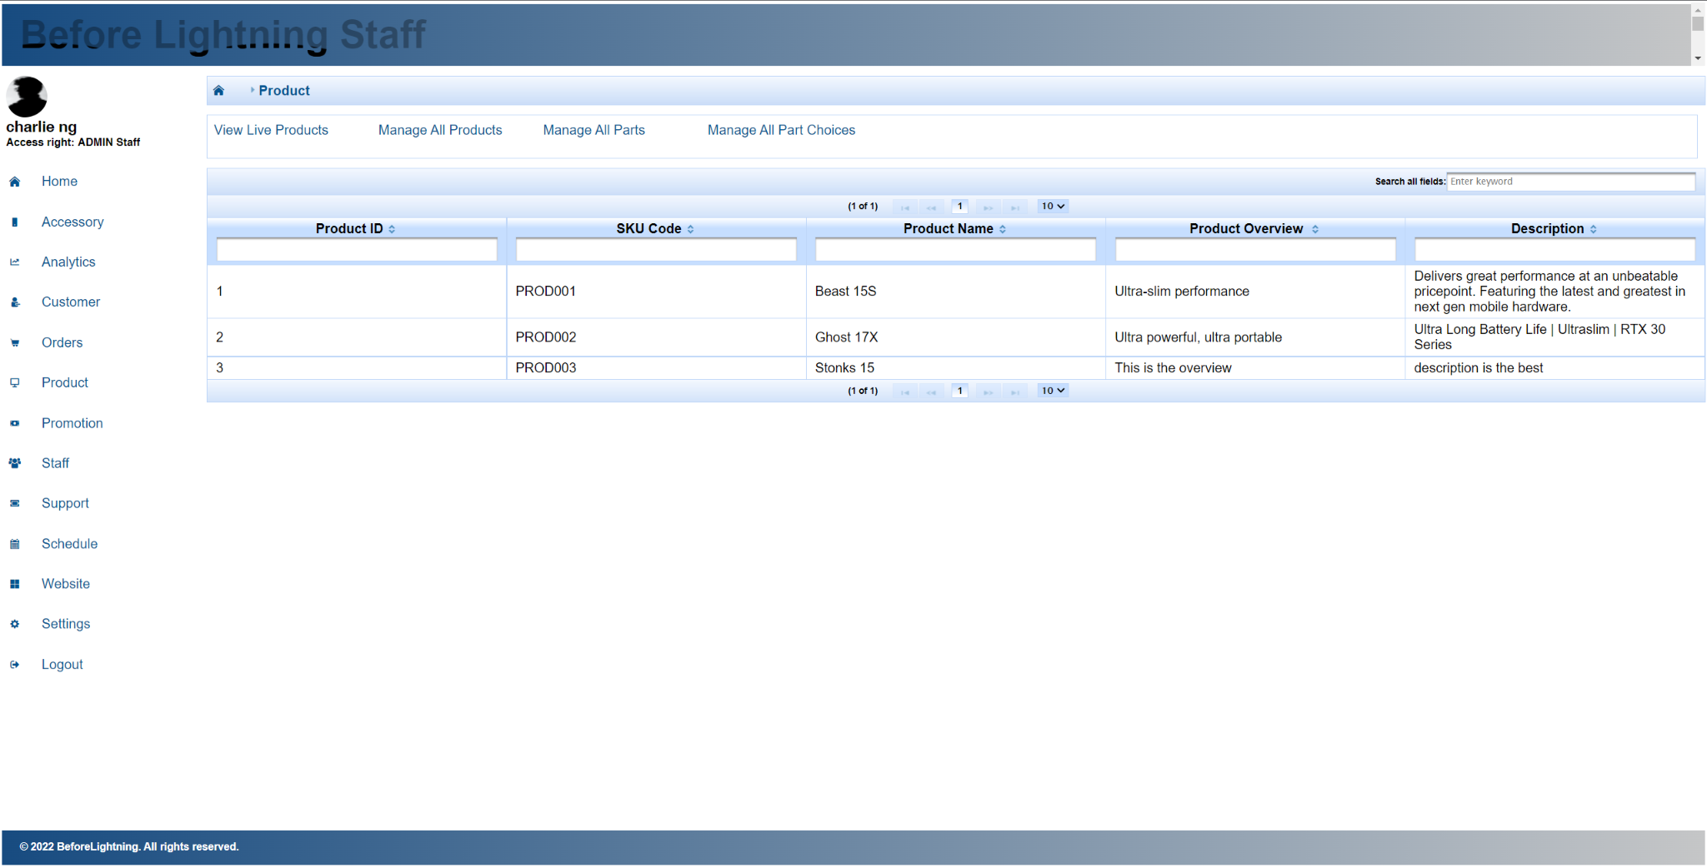

Fig. 1.6.1

The “View Live Products” page shows the list of all the products that exist in the inventory, and are currently sellable to customers in the Customer Portal, as shown in figure 1.6.1. It serves to help the staff know what products in their inventory are currently what the customers can see and purchase.

* 1. Manage All Products

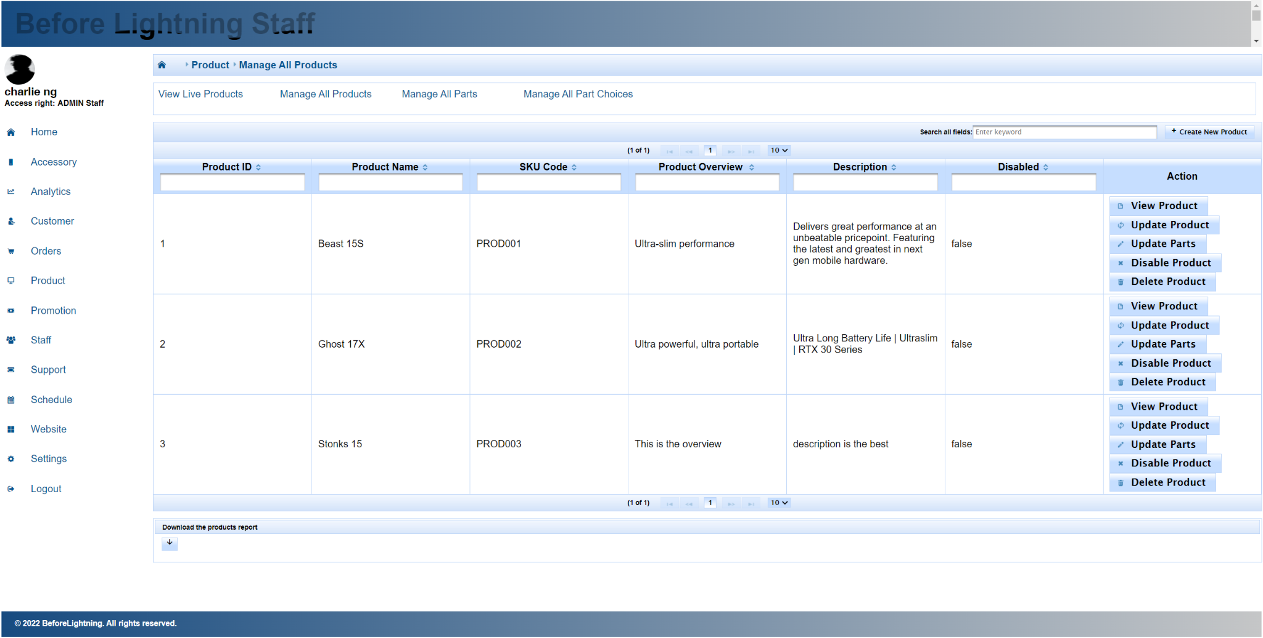

Fig. 1.6.2

The “Manage All Products'' page shows the list of all products, regardless if they are live or not, as shown in figure 1.6.2. The “View Product” button opens a dialog and displays the details of the product. The “Update Product” button opens a dialog and allows the staff to update the details about the product. The “Delete Product” button will allow the staff to delete the product, only if the product has no parts except for Chassis part linked to it. The “Disable Product” button will disable the product. Once disabled, the product will not show in the list of live products. Once disabled, the staff can enable the product once more to undo the disable. The “Create New Product” button opens a dialog that allows the staff to create a product, which will not have a Chassis part linked to it by default. A Chassis Part Choice is also created at the same time and linked to the Chassis part. The Chassis Part Choice will be used for compatibility checks of the part choices for the build. A product report can be downloaded from the button at the bottom to view the details of the products.

* 1. Manage All Parts

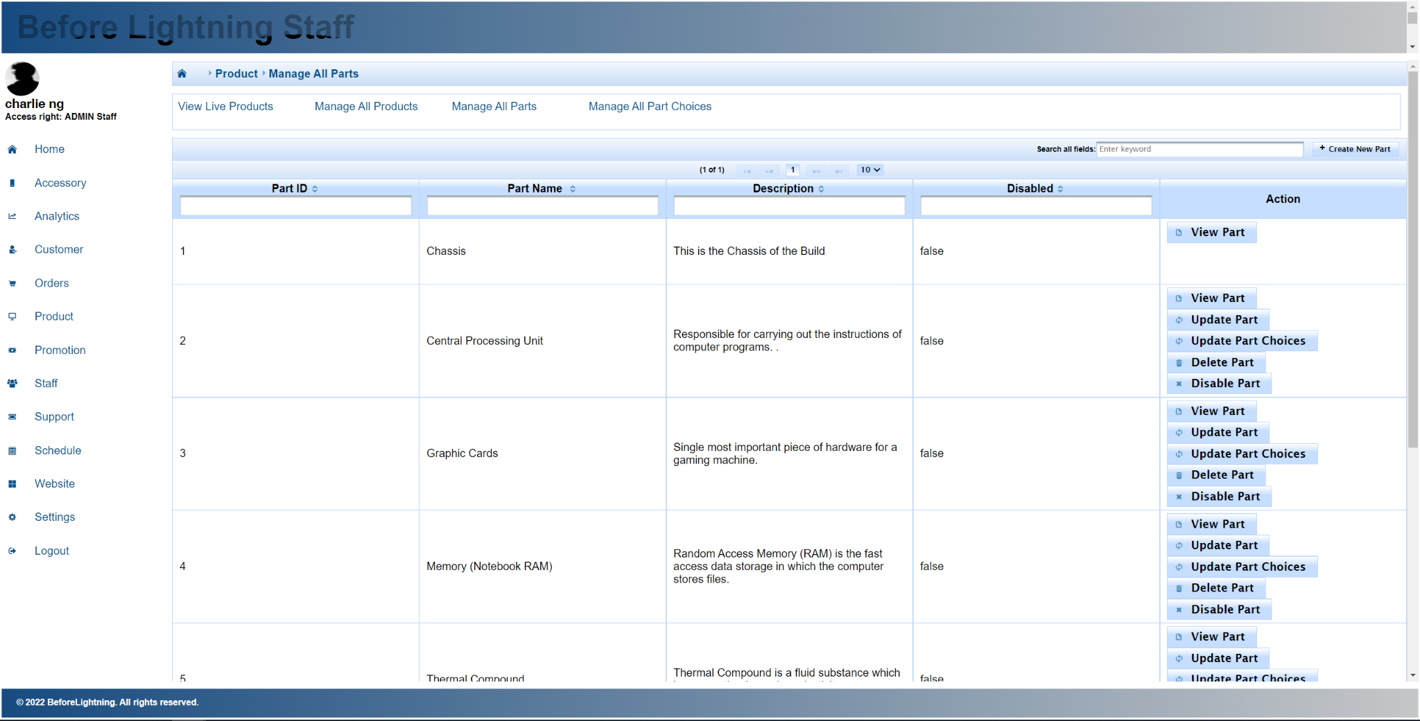

Fig. 1.6.3

The “Manage All Parts” page shows the list of all parts, regardless if they are live or not, as shown in figure 1.6.3. The “View Part” button opens a dialog and displays the details of the part. The “Update Part” button opens a dialog and allows the staff to update the details about the part. The “Update Part Choices'' button allows the staff to choose which part choices should link to the part. The “Delete Part” button will allow the staff to delete the part, only if the part is not linked to any products or part choices. The “Disable Part” button will disable the part. Once disabled, any product linked to this part will not show in the list of live products. Once disabled, the staff can enable the part once more to undo the disable. The “Create New Part” button opens a dialog that allows the staff to create a part, which will initially be linked to no Product or Part Choice. The Chassis Part is a default part and can only be viewed. A Parts report can be downloaded from the button at the bottom to view the details of the parts.

* 1. Manage All Part Choices

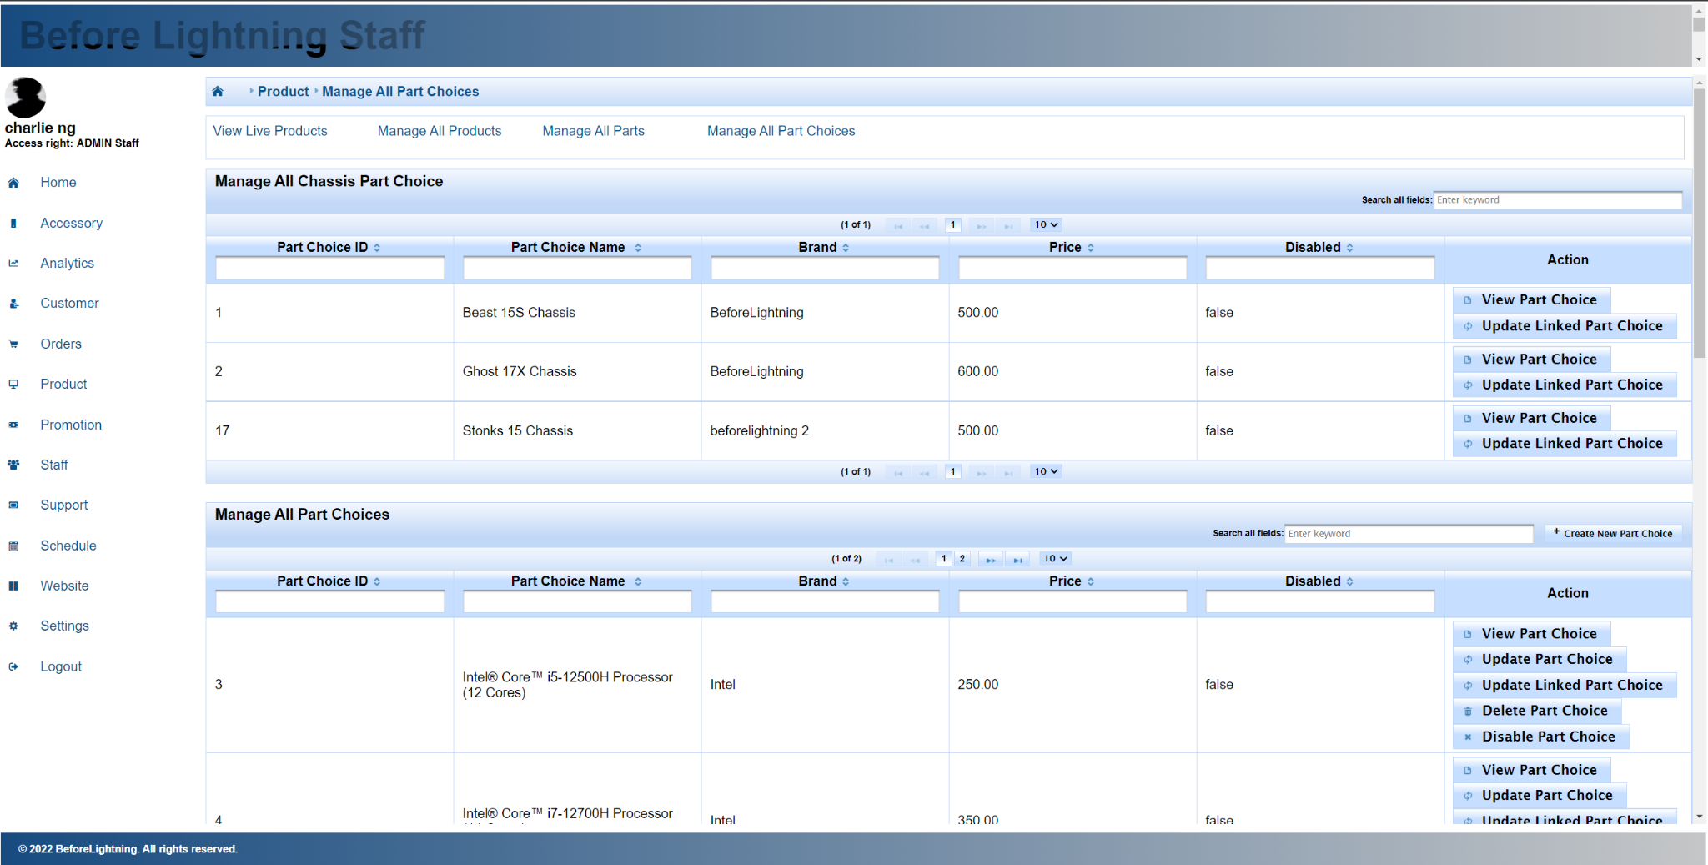

Fig. 1.6.4

The “Manage All Part Choices'' page shows the list of all part choices, regardless if they are live or not, as shown in figure 1.6.4. The table on top shows the Chassis Part Choices, and the staff can view the details of the part choices, and perform linking to Part Choices through the “Update Linked Part Choice”, which sets the part choices that will be compatible with the chassis part choice.

In the table below, the staff can view and update the part choice. The “Update Linked Part Choices'' button allows the staff to choose which chassis part choices should be compatible with the part choice. The “Disable Part Choice” button will disable the part choice. Once disabled, any product linked to this part will not show in the list of live products. Once disabled, the staff can enable the part choice once more to undo the disable. The “Create New Part Choice” button opens a dialog that allows the staff to create a part choice, and the staff will pick at least 1 Part and 1 Chassis Part Choice to link to. The Chassis Part Choice is a default part that is created when a Product is created. A part choice report can be downloaded from the button at the bottom to view the details of the part choices.

When all part choices under a part are disabled, the part is considered disabled, and any product with the part linked will no longer be live.

1. Promotion

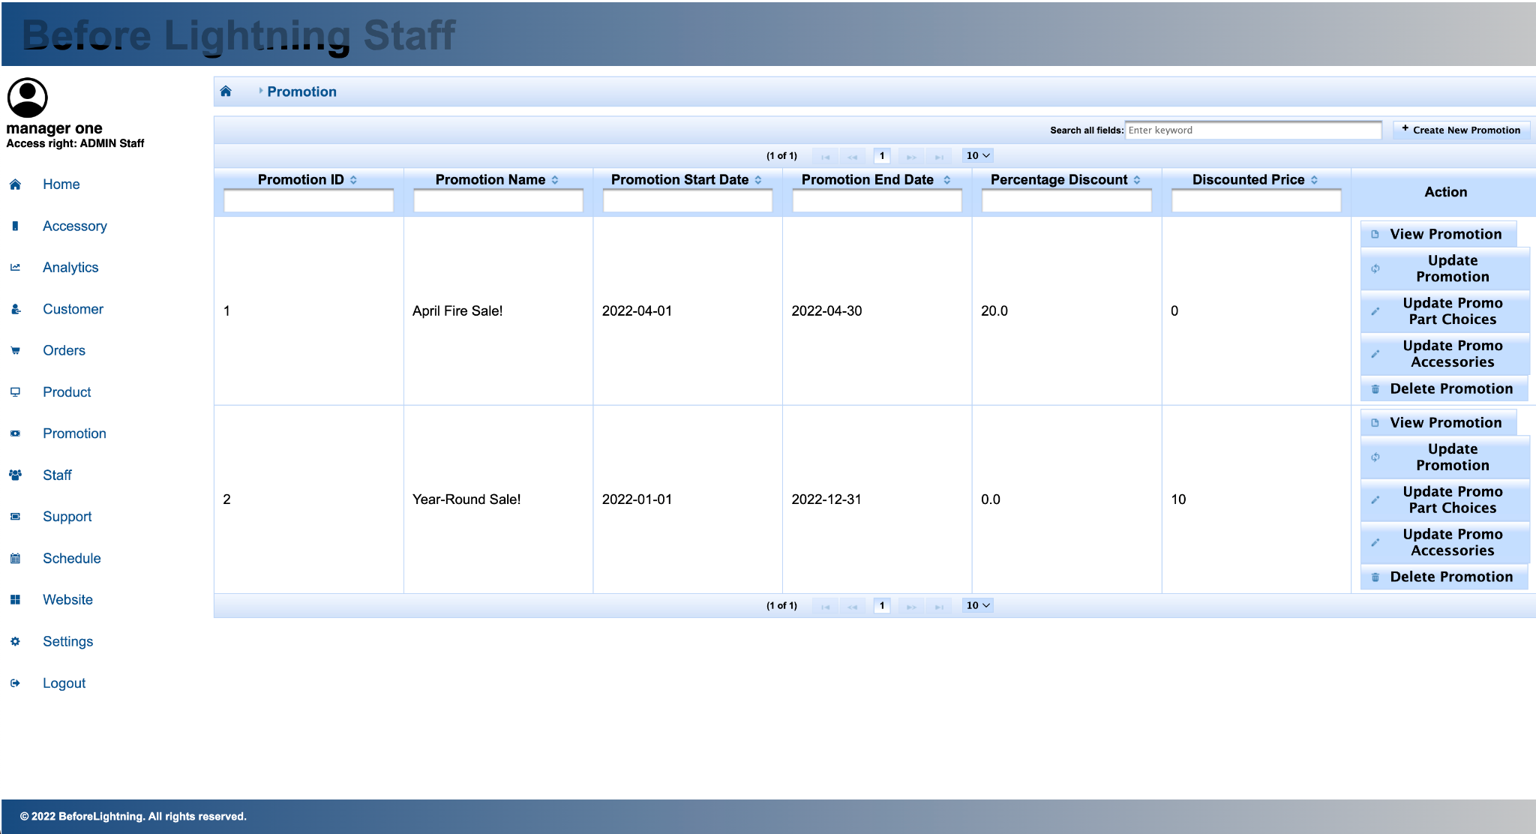

Fig. 1.7.1

Sales Staff will be able to create, view, update, and delete Promotions via the Promotion page. Details of the promotion such as promotion name, promotion starting date, promotion end date, discount percentage, and discounted price can be updated by clicking “Update Promotion”. To view promotional items and other details of the promotion, Sales Staff members can click on “View Promotion”. To update promotional accessories and part choices, Sales Staff can click on “Update Promo Accessories” and “Update Promo Part Choices” respectively.

1. Staff

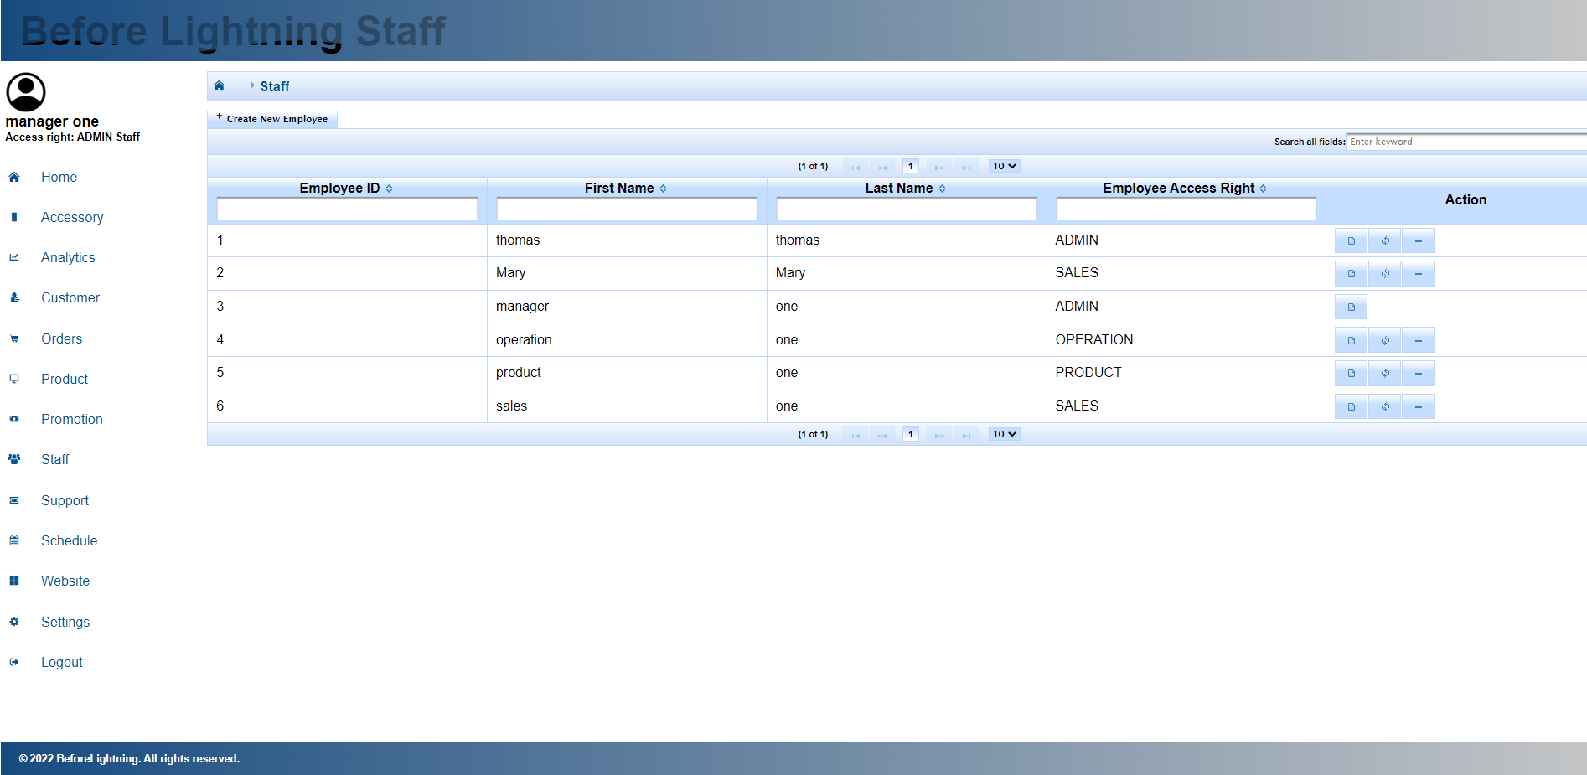

Fig. 1.8.1

Admin staff will be able to view a list of all staff registered inside the staff portal, as shown in figure 1.8.1. Information that can be obtained from this page is employee ID, first name, last name, and employee access rights.

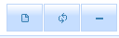

Fig 1.8.2

The button above inside the action column is view staff details, update staff details, and delete staff button respectively.

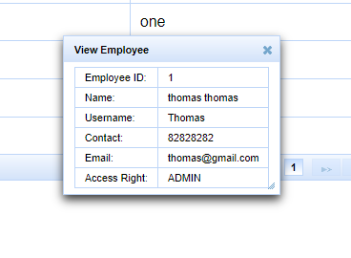

Fig. 1.8.3

Clicking the view staff button in the Action column will open up the dialogue box as shown in figure 1.8.3 above.

Additional information that can be obtained from this view employee details use case is the contact number and email of staff.

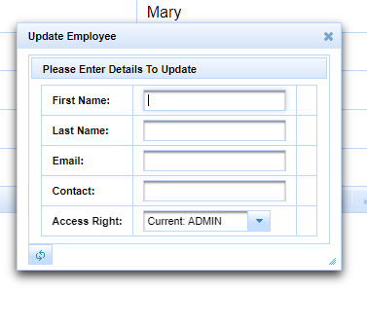

Fig. 1.8.4

Clicking the update employee button will lead the staff to this dialogue box as shown in figure 1.8.4. Staff would be able to update the employee details accordingly.

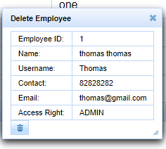

Fig. 1.8.5

Admin staff will also be able to delete the account of another staff within the system as shown in figure 1.8.5. He will then be directed to the dialogue box to confirm the deletion of the employee.

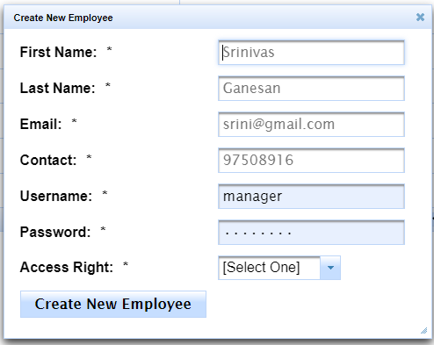

Fig. 1.8.6

The customer page also allows the staff to create a new employee account as shown in figure 1.8.6.

1. Support

The support page allows the operation staff to view a list of support tickets created by both registered and non-registered customers. Information obtainable from this page includes the email of the customer requesting support, the issue faced by them, as well as the status of each support ticket.

Clicking the view customer button will lead the staff into the dialogue box below if the customer is a registered member in the customer portal.

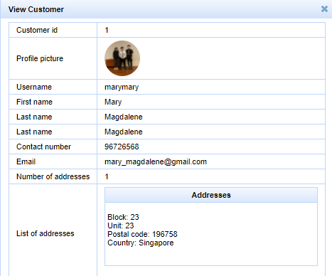

Fig. 1.9.1

Otherwise, it will show the dialogue box below.

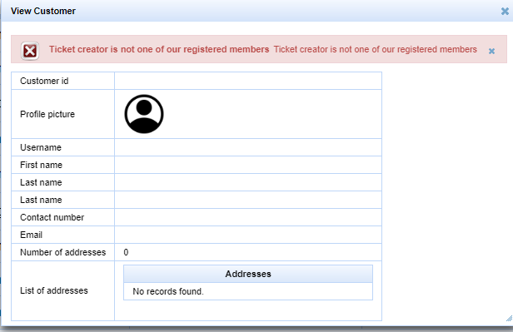

Fig. 1.9.2

Each support ticket will go through three statuses:

OPEN -> PROCESSING -> CLOSED

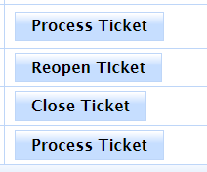

Fig. 1.9.3

The button inside the action column allows the staff to move the said support ticket to its next status. Even though a purchased ticket is closed, if needed, it can be reopened again. This support ticket status will be viewable by the customer who created them.

Fig. 1.9.4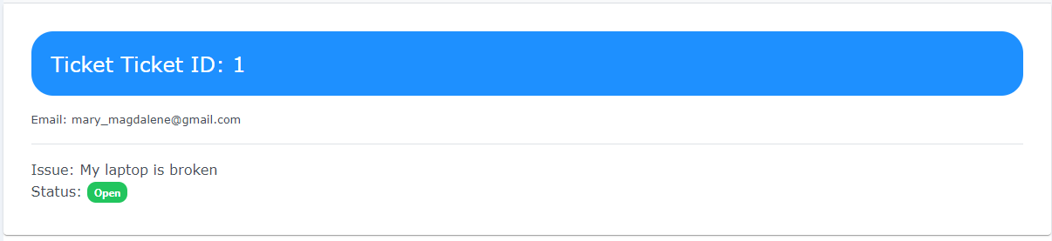

1. Schedule

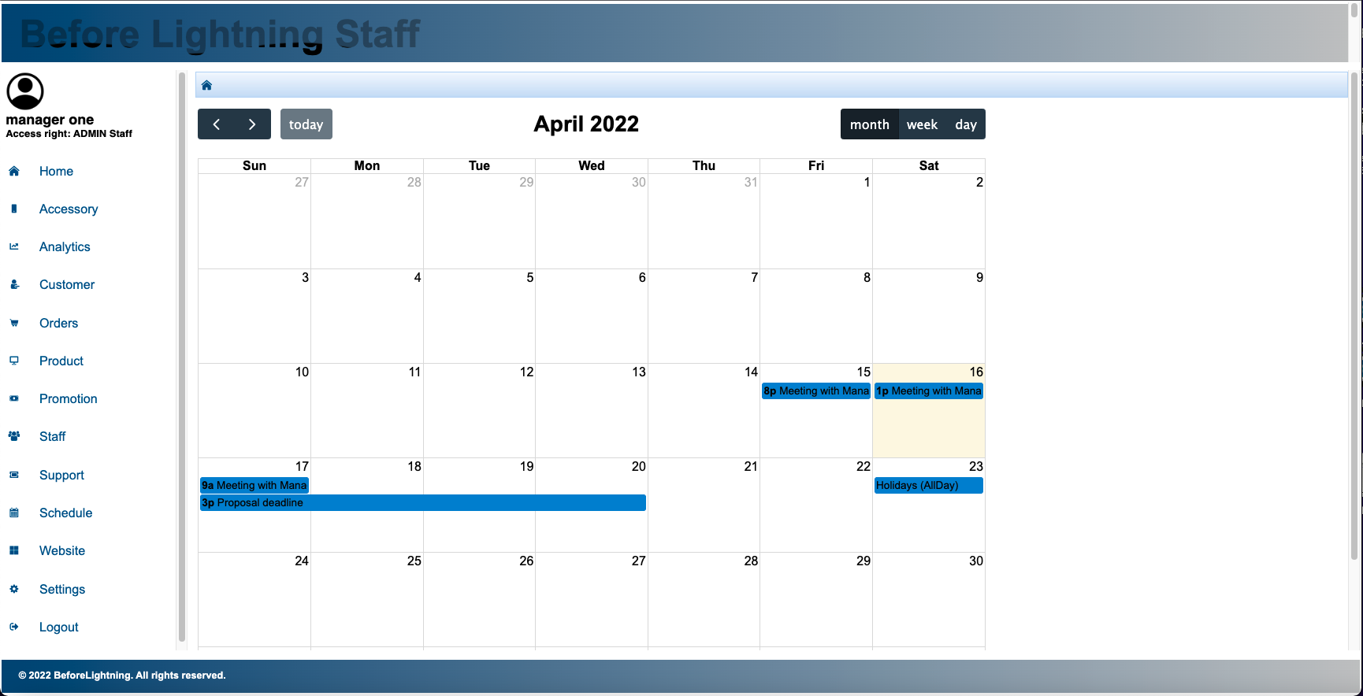

Fig. 1.10.1

Under the schedule tab, staff can plan their own schedule by editing the calendar and adding in an event, as shown in figure 1.10.1 They can input the name of the event, and the day and time which the event will begin and end. They also have the option to select if the event will be a full day event.

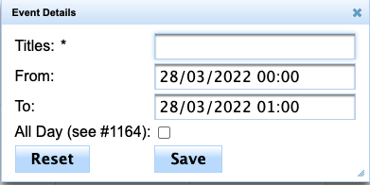

1. Website
   1. Forum

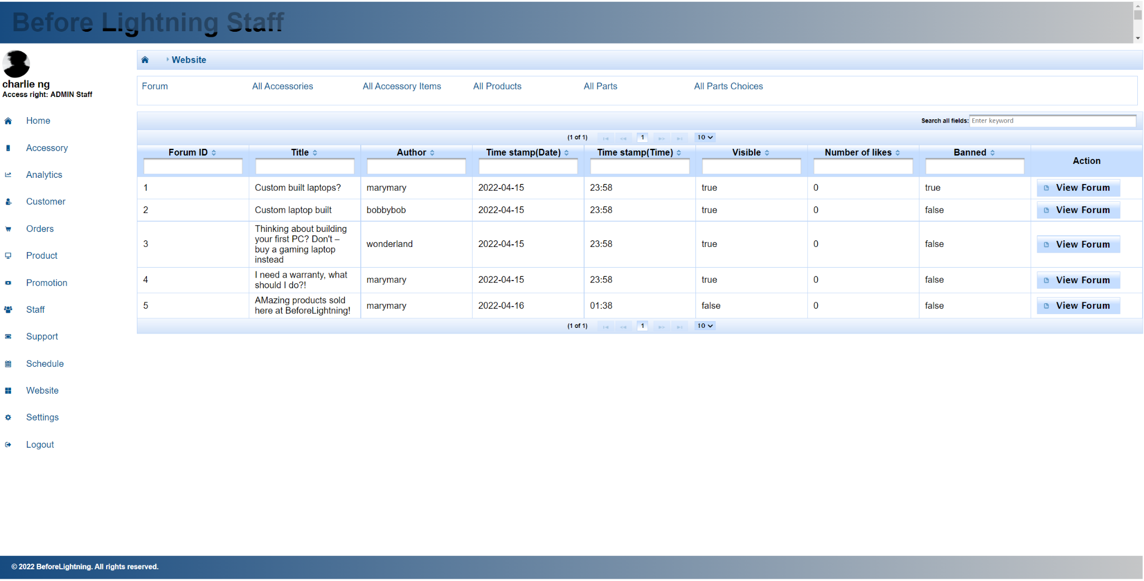

Fig. 1.11.1

The Forum page shows all the forum posts that customers create at the Customer portal. Staff can view a forum post to see details about the post, and they can ban the post, which will take it off the Customer Portal forum page. Staff can also unban the post.

* 1. All Accessories

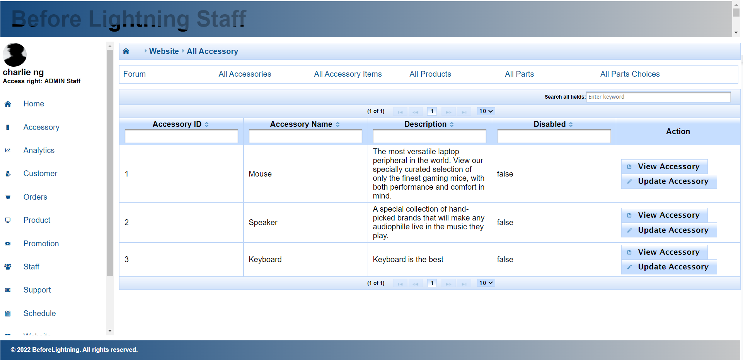

Fig. 1.11.2

The “All Accessories” page shows all the Accessories. A staff can view the details of the accessory and can update certain details of the accessory, such as description. The Website tab is used by the sales staff, who would have limited access to editing certain details such as the accessory name. Instead the sales staff would only be able to edit the description.

* 1. All Accessory Items

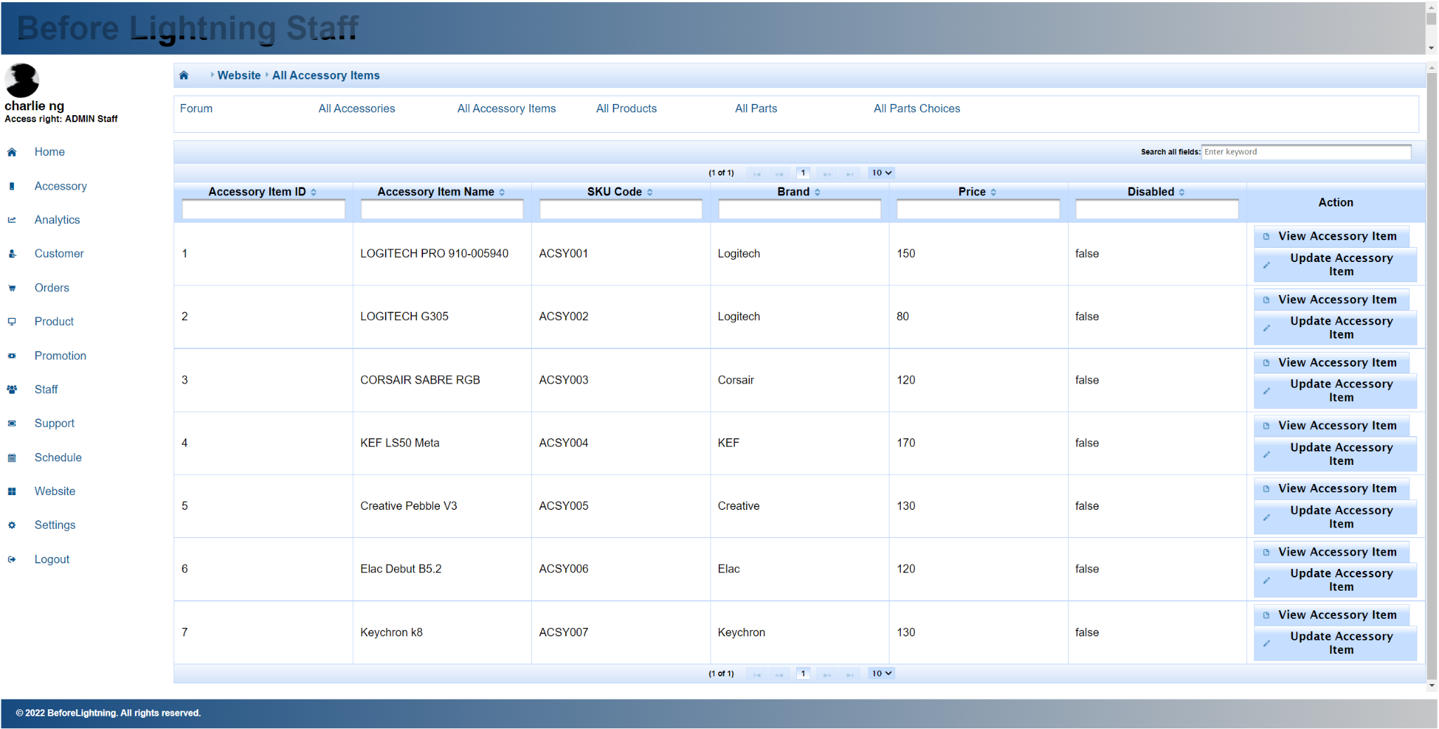

Fig. 1.11.3

The “All Accessory Items'' page shows all the accessory items. The staff can view the details of the accessory item and can update certain details of the accessory item, such as the image, brand and description. The Website tab is used by the sales staff, who would have limited access to editing certain details of the accessory item.

* 1. All Products

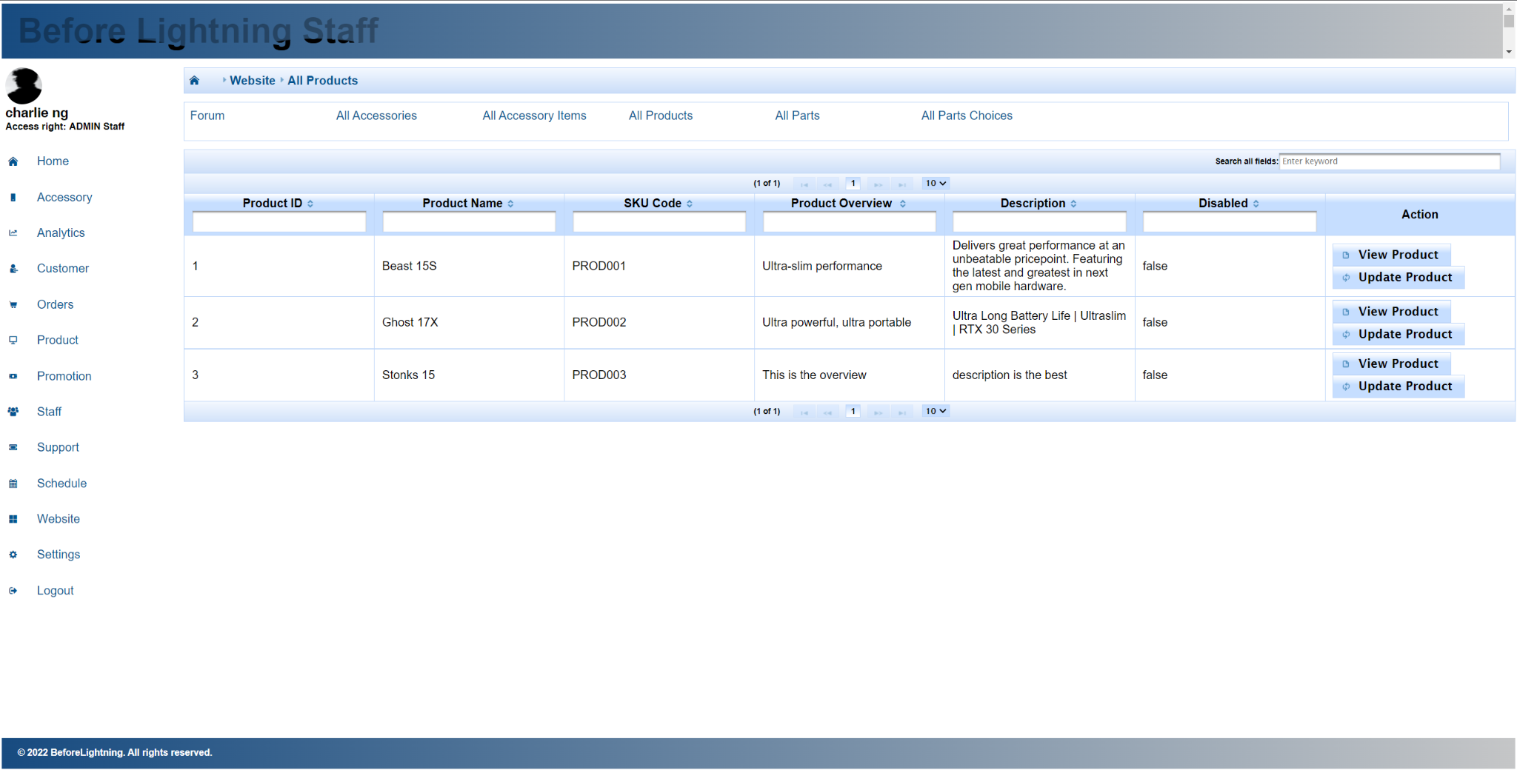

Fig. 1.11.4

The “All Products'' page shows all the products. The staff can view the details of the product and can update certain details of the product, such as the product overview, description, brand, and the image. The Website tab is used by the sales staff, who would have limited access to editing certain details of the product.

* 1. All Parts

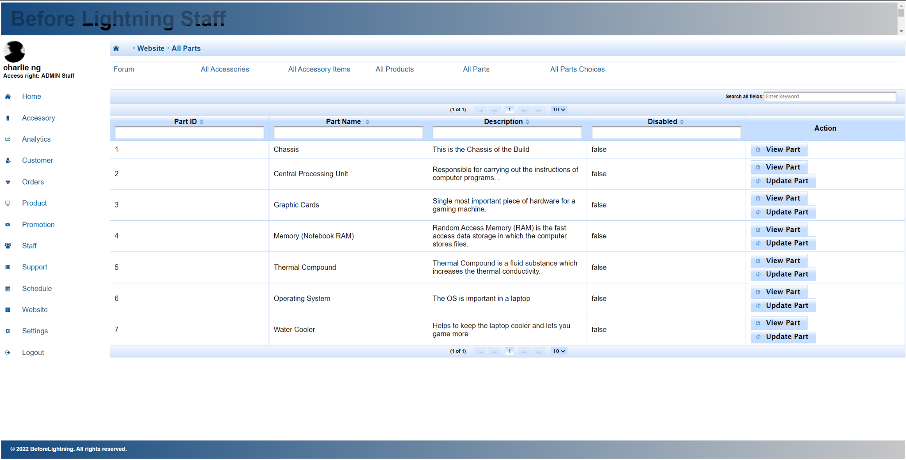

Fig. 1.11.5

The “All Parts” page shows all the parts. The staff can view the details of the part and can update certain details of the part, such as the description. The Website tab is used by the sales staff, who would have limited access to editing certain details of the part.

* 1. All Part Choices

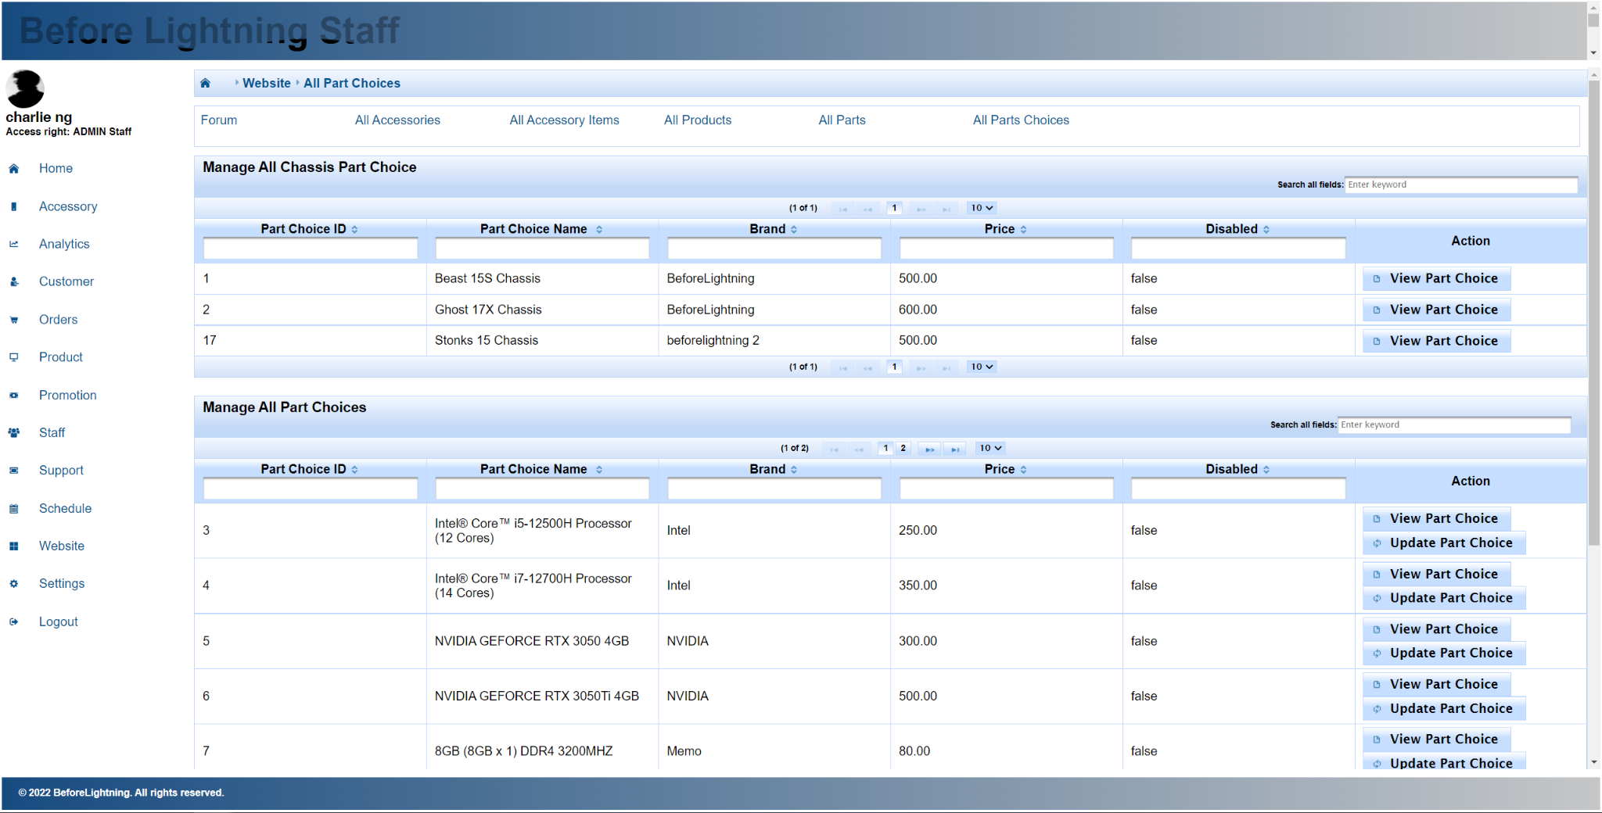

Fig. 1.11.6

The “All Part Choices” page shows all the part choices. The staff can view the details of the part choices and can update certain details of the part choice, such as the overview, description, brand and image. The Website tab is used by the sales staff, who would have limited access to editing certain details of the part choice.

1. Settings

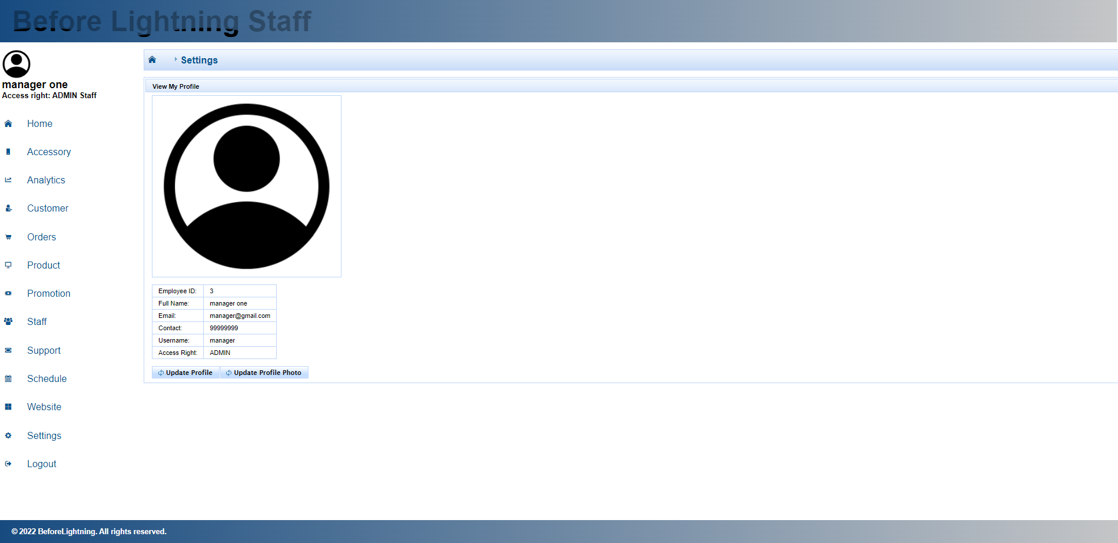

Fig. 1.12.1

The setting page will allow the staff to view his account details, such as employee ID, full name, email, contact, username, and access rights.

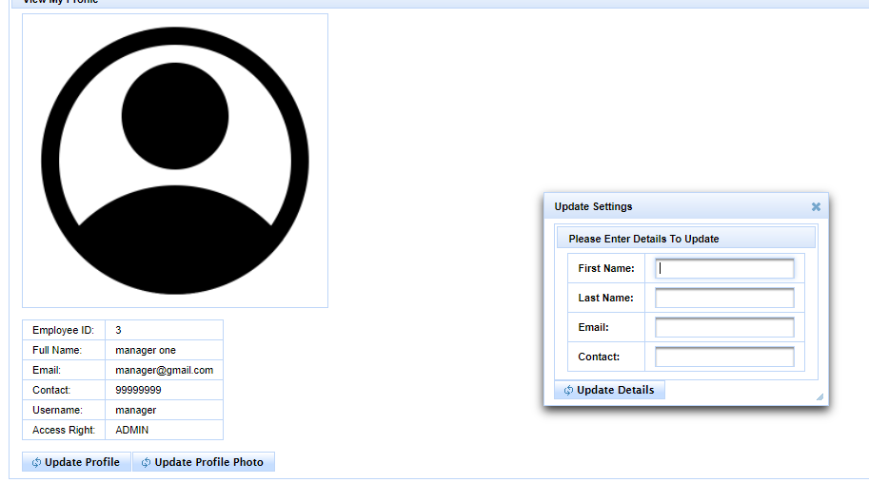

Fig. 1.12.2

Clicking the update profile button will lead the staff to the dialogue box, as shown in figure 1.12.2.

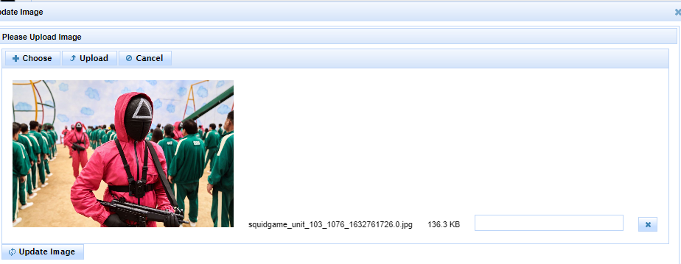

Fig. 1.12.3

Staff will then be able to update his account details accordingly, as shown in figure 1.12.3. Staff can also update his profile picture by clicking the ‘update profile photo’ button.

**Customer Portal**

1. Login/Logout

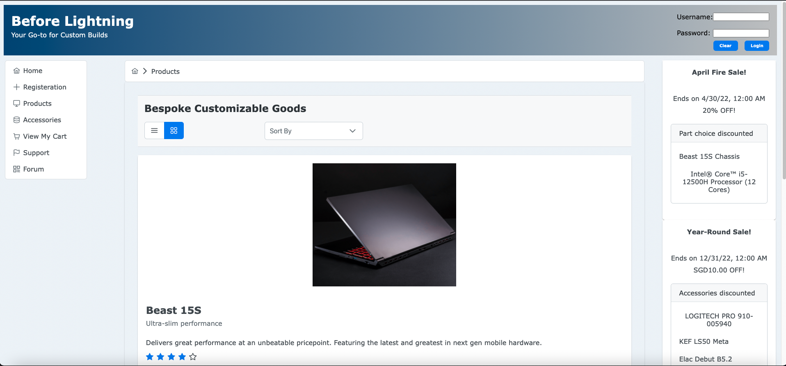

Fig. 2.1.1

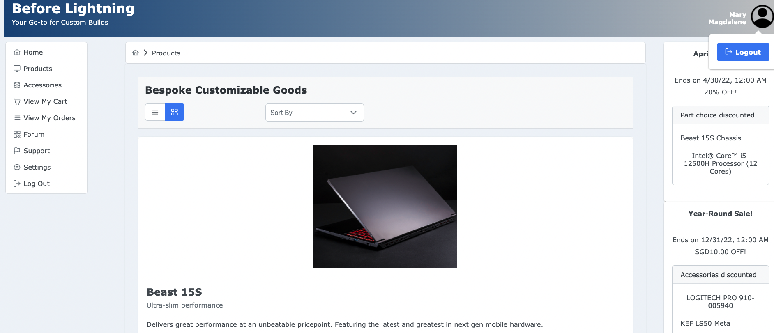

Fig. 2.1.2

Customers can log in to have access to more functions on the webpage and also have the ability to check out items. Logging out can be done in the main menu and through the logout button which will appear when the profile picture is clicked.

1. Registration

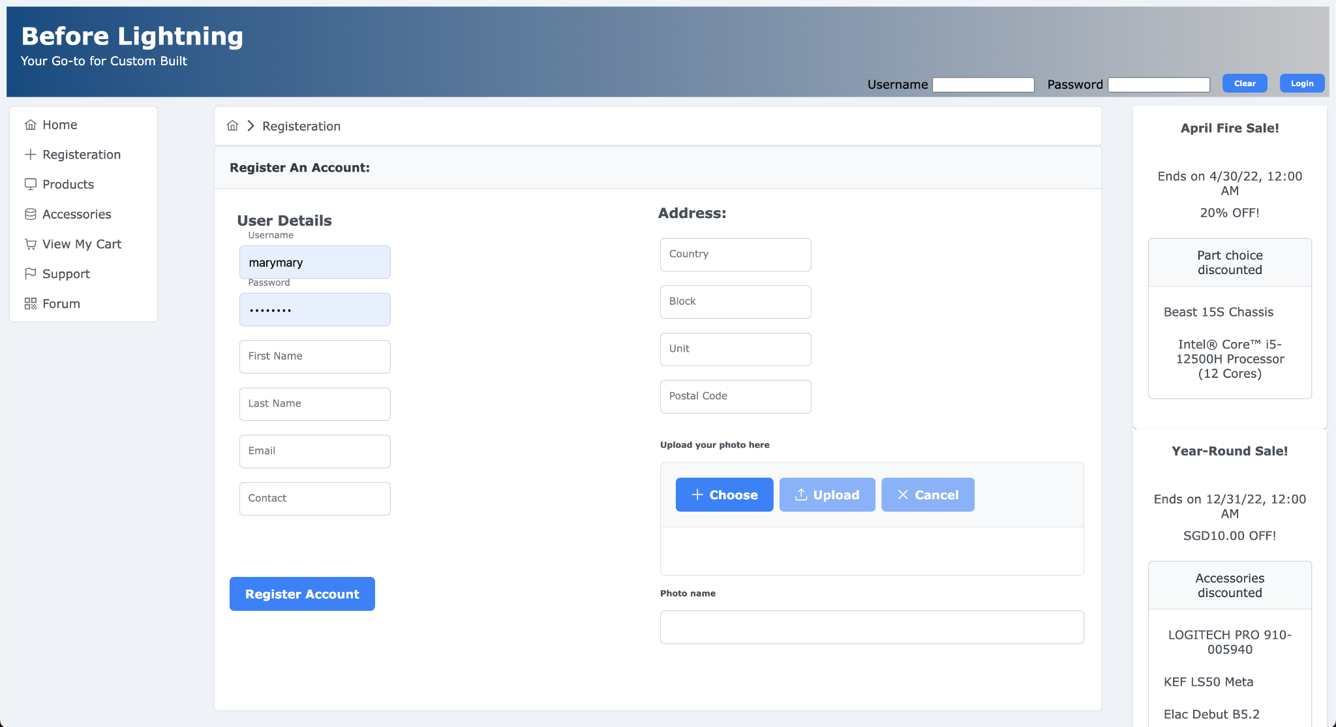

Fig. 2.2.1

Customers can register for an account by going to the Registration page. Registration page can only be accessible by users that are not logged in.

1. Products

The Customer will first be brought to the home page when they first enter the url. They will then select the “Products” tab at the side navigation to get to the “View All Products” page, as shown in figure 2.3.1 and 2.3.2.

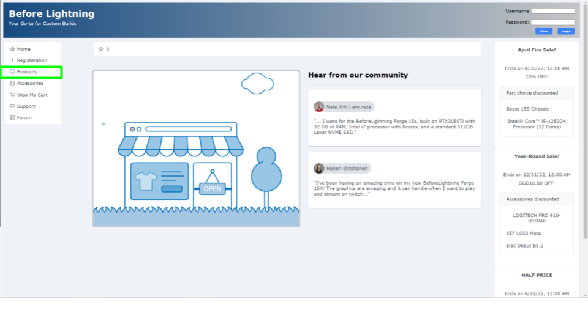

Fig. 2.3.1

Support page can be accessed by users that are not logged in. They can create a support ticket by clicking on “Create new Support Ticket” to submit their issue and email. However if they are not currently a member, they will not be able to view their submitted Support Ticket.

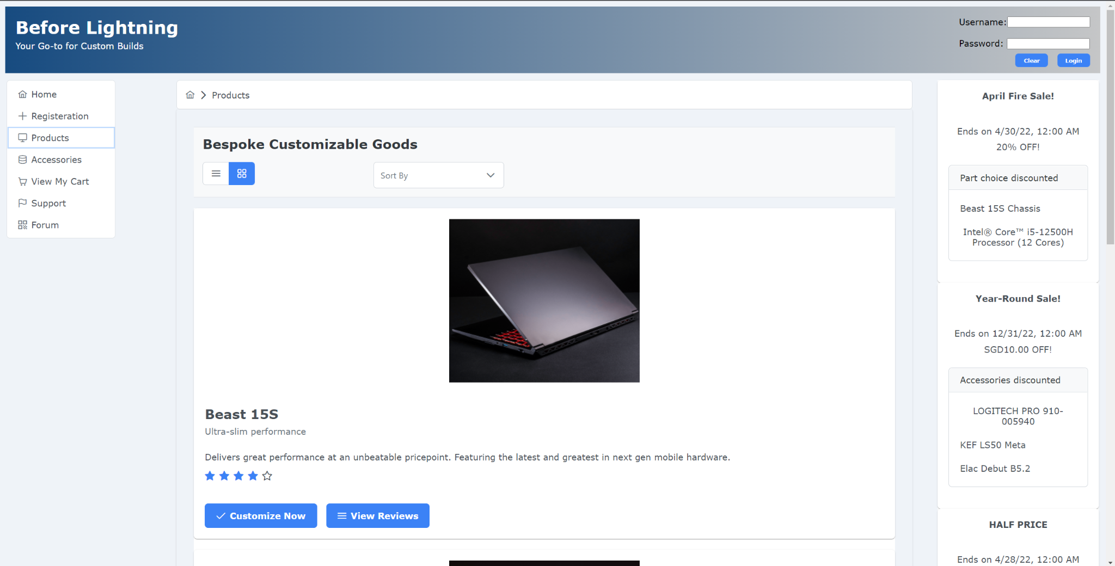

Fig. 2.3.2

Customers can select the Product that they would like by clicking on the “Customize Now” button for the Product they want as seen in figure 2.3.3. They will then select a Part Choice for every Part the laptop is required to have as shown in figure 2.3.4 onwards. All Part Choices shown here are compatible with the Chassis Part Choice of the Product.

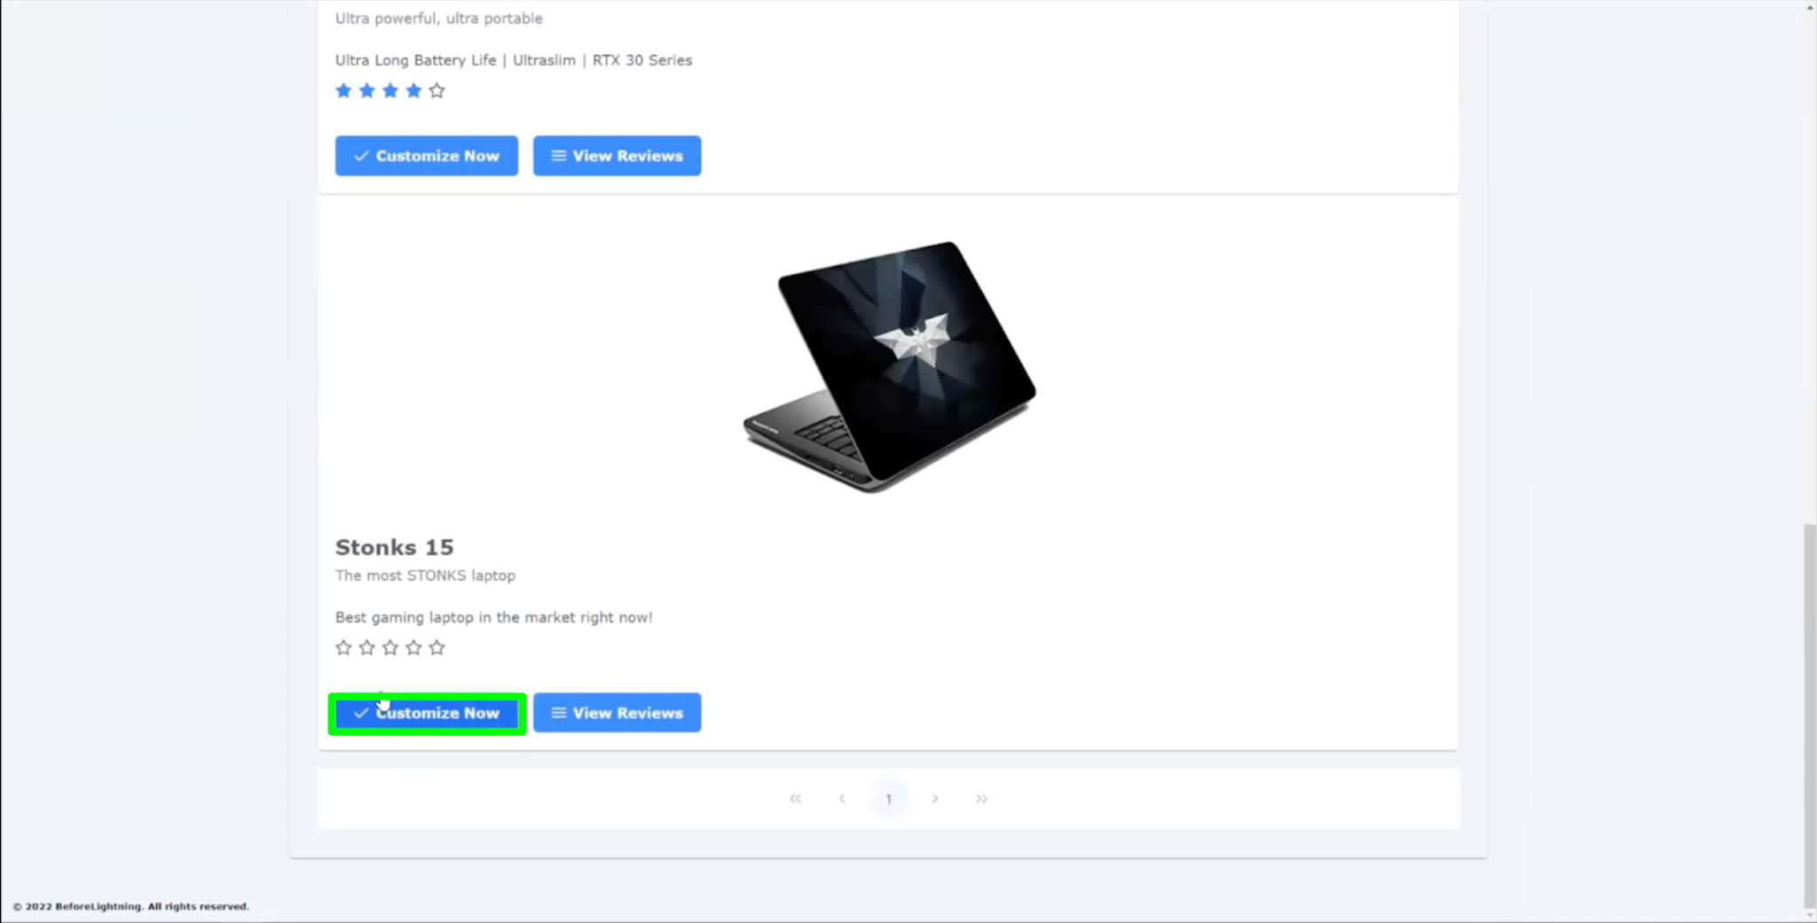

Fig. 2.3.3

Customers will select the only Chassis Part Choice from the dropdown list first. A notification message will be displayed to indicate successfully added Chassis to the build as shown in figure 2.3.4.

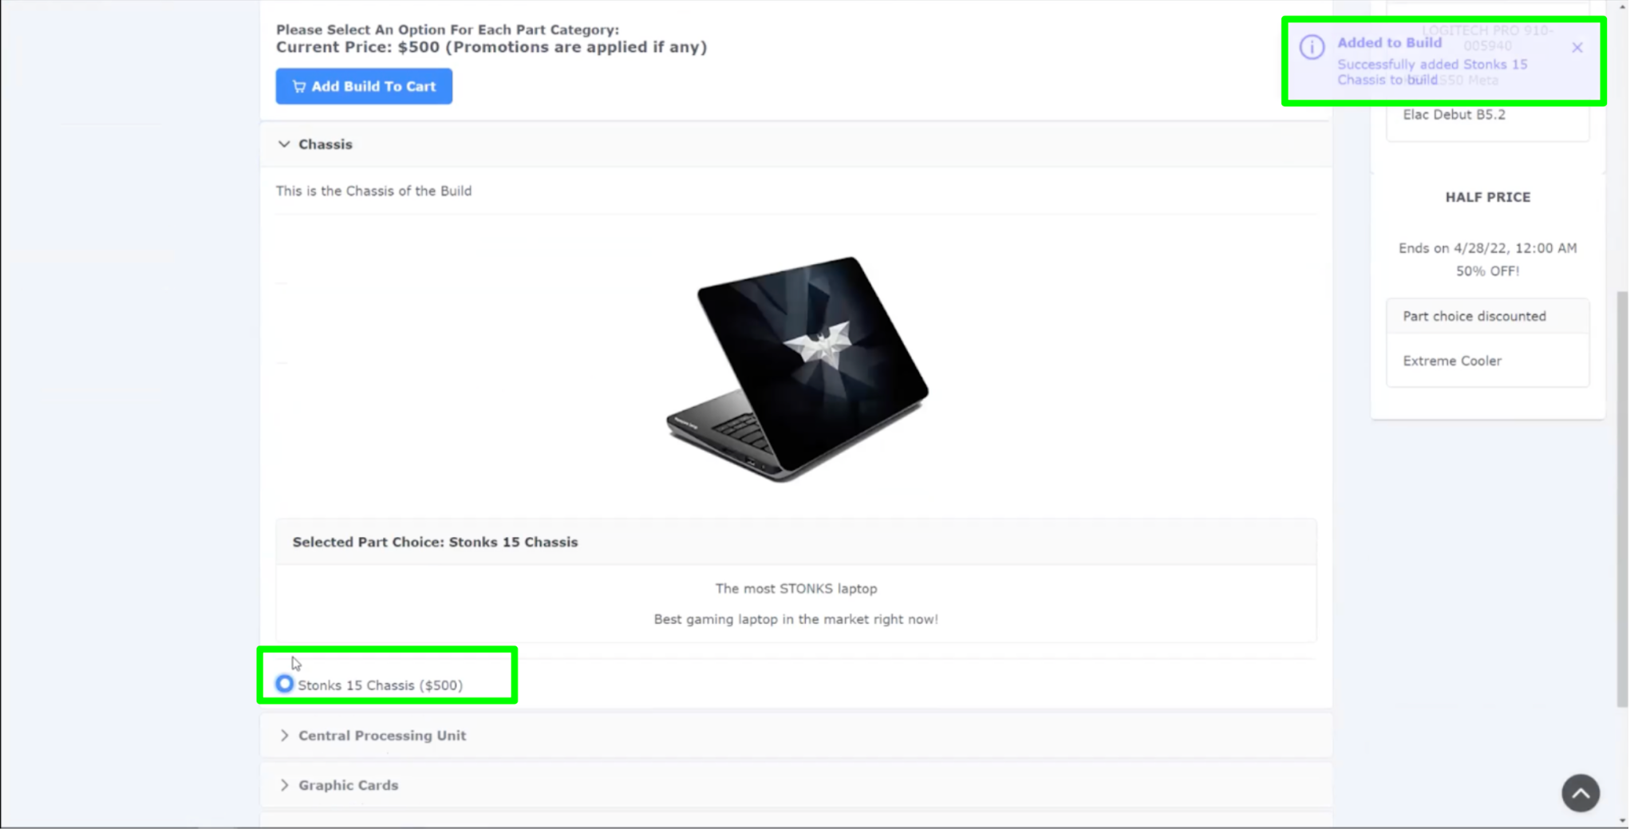

Fig. 2.3.4

From Here on, the customer will select a Part Choice for each Part that the Product is linked to. This can be seen from Figure 2.3.5, 2.3.6, 2.3.7, 2.3.8, 2.3.9, which show the selection of a Part Choice for each of the Part that was linked to the Product by the Staff in the Staff Portal.

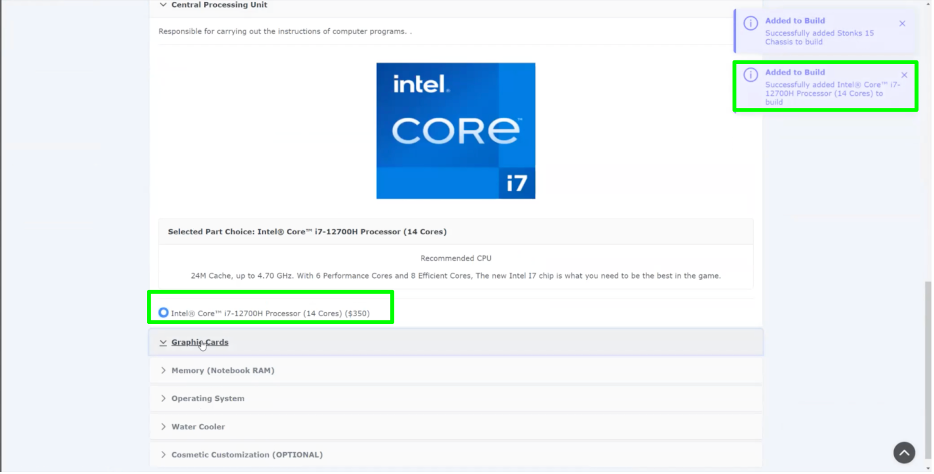

Fig. 2.3.5

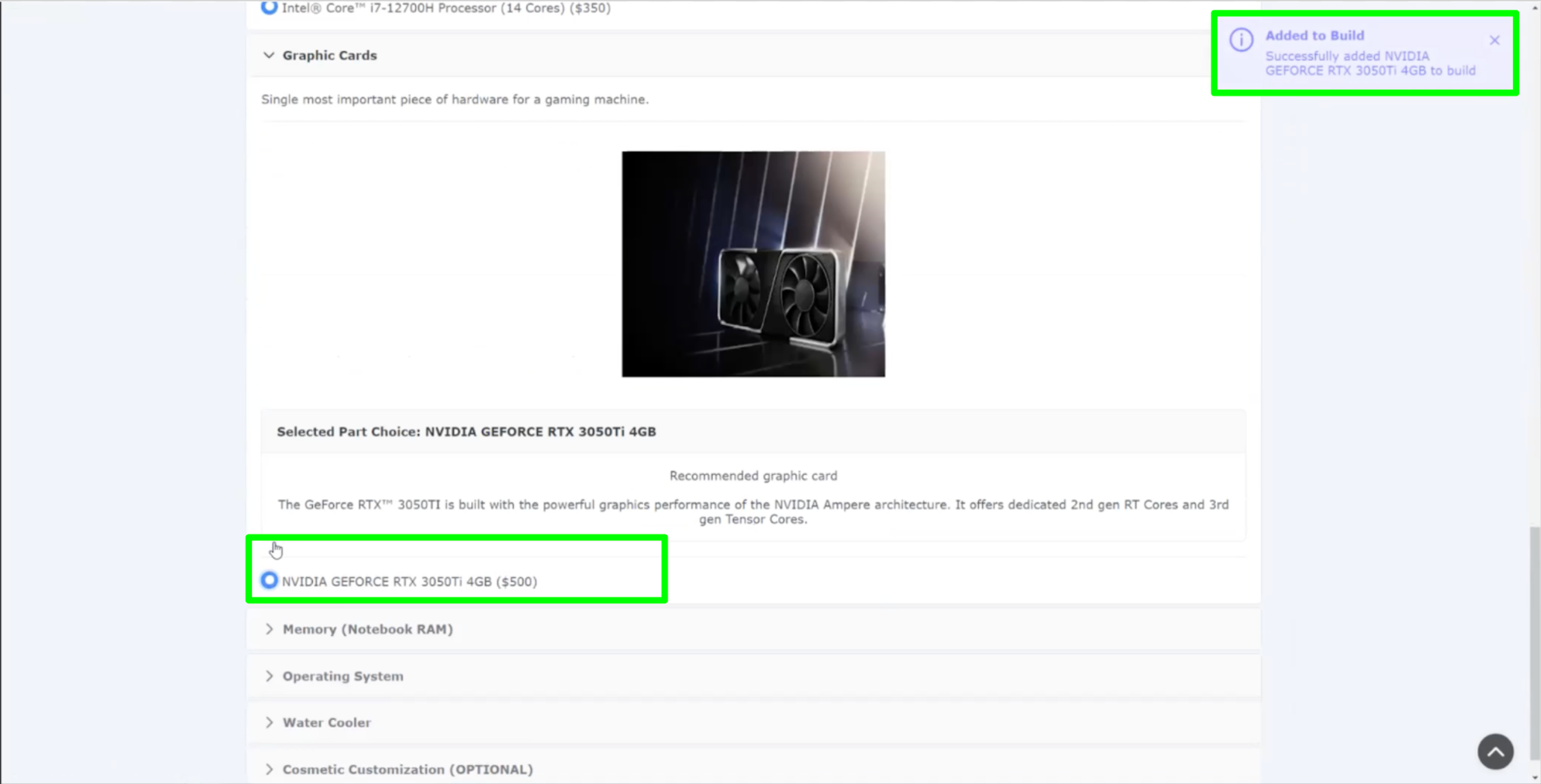

Fig. 2.3.6

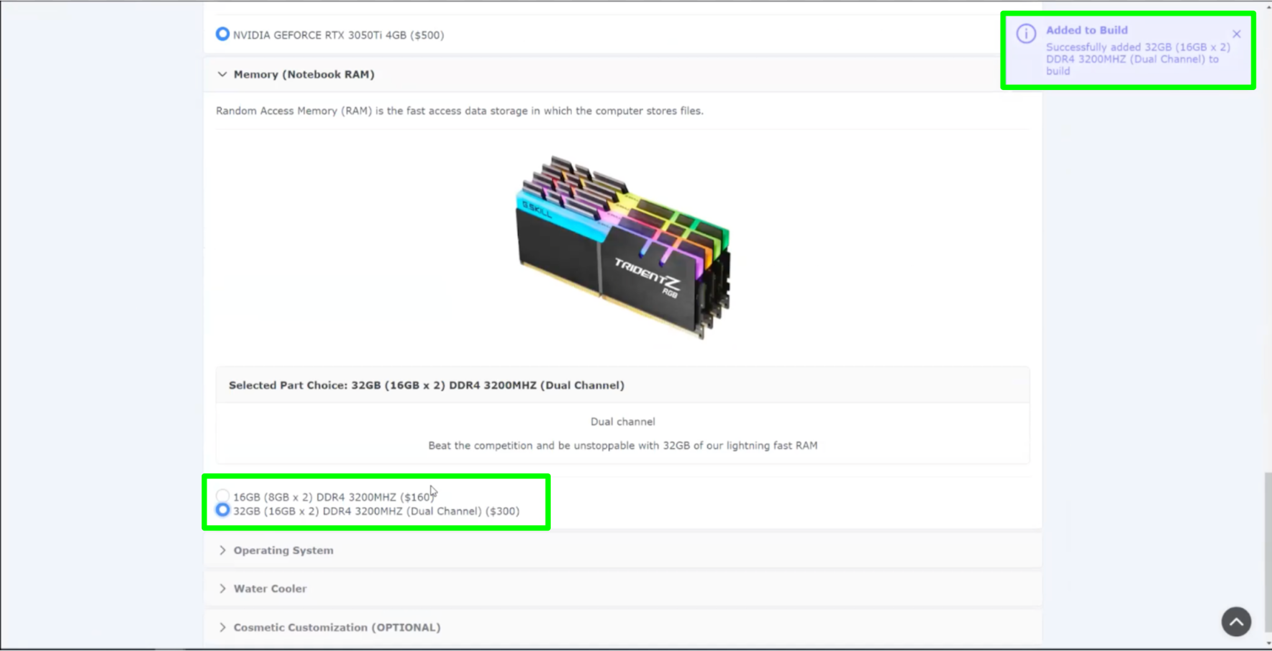

Fig. 2.3.7

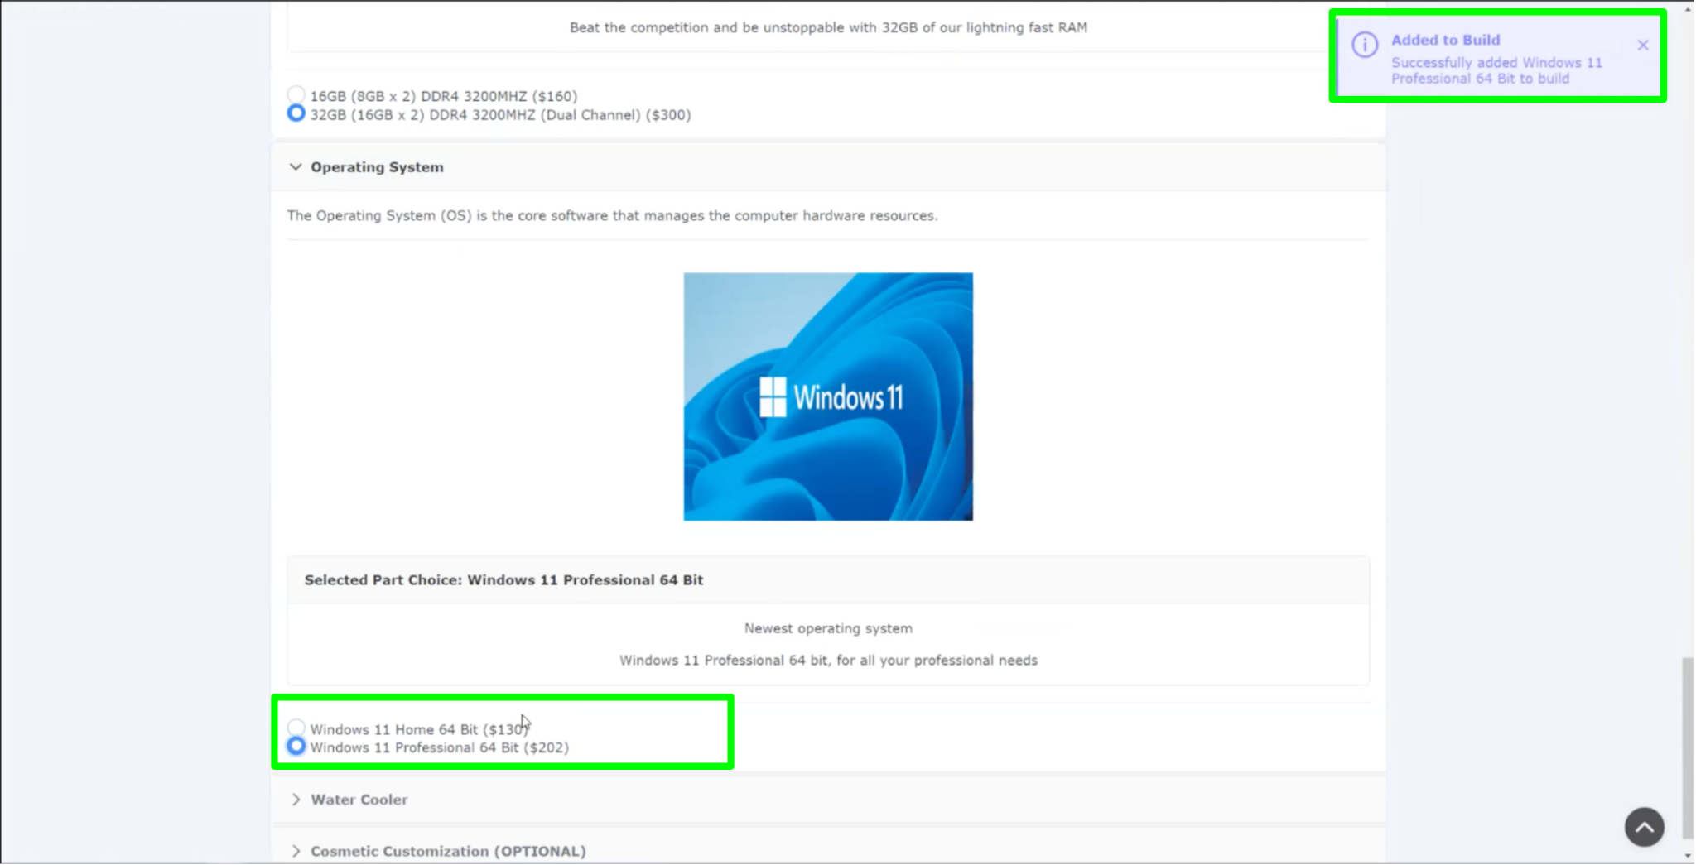

Fig. 2.3.8

If a selected Part Choice has a Promotion, then the promotion price will be applied to the Part Choice’s price when adding to the cart, and a message as shown in figure 2.3.9 will be shown to indicate that a promotion is present.

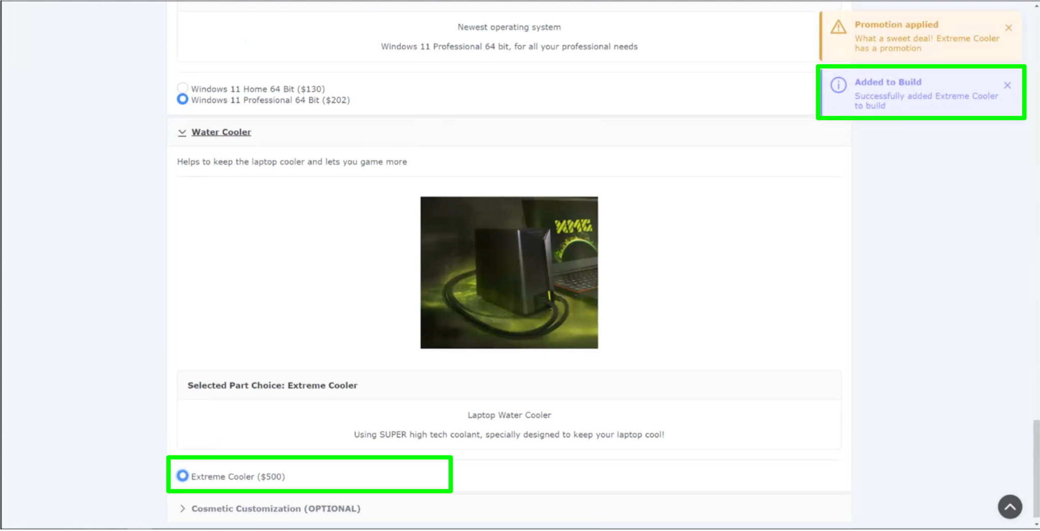

Fig. 2.3.9

The customer can optionally select Cosmetic Customizations by uploading an image of their choice to be printed on their laptop as shown in figure 2.3.10. This represents the Cosmetic Customization aspect of our application, where customers can future customize their builds through the build’s aesthetics.

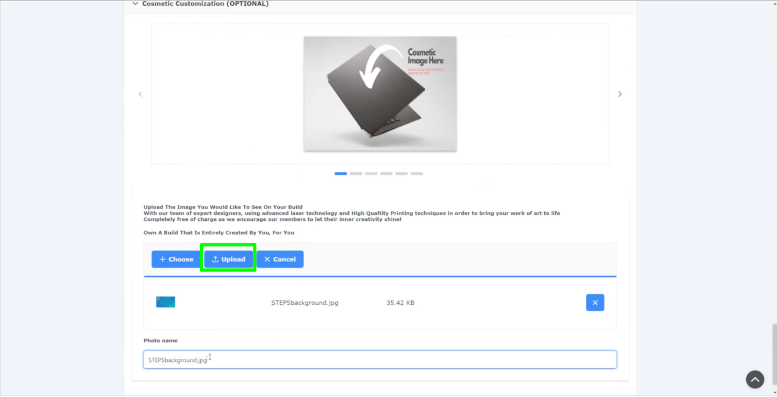

Fig. 2.3.10

Finally, customers can click on the “Add Build To Cart” button to add their completed customization build into their shopping cart as shown in figure 2.3.11.

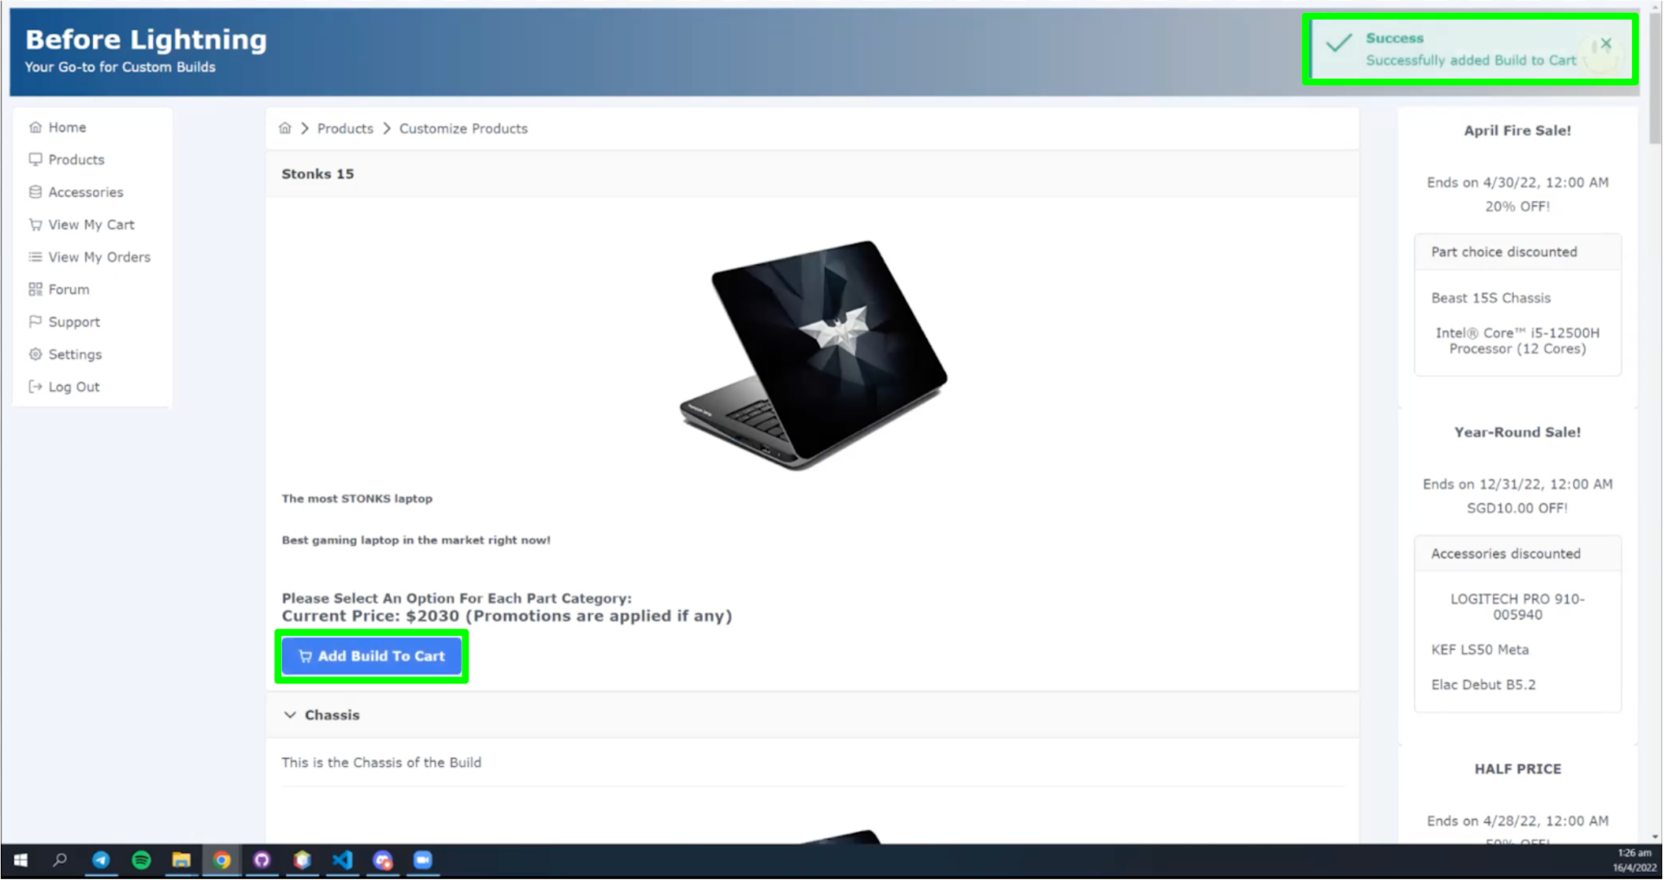

Fig. 2.3.11

1. Accessories

Customers can view all accessories at the Accessories page. To view all Mouse, they can click on the “View All” button in the “Mouse” section as shown in figure 2.4.1.

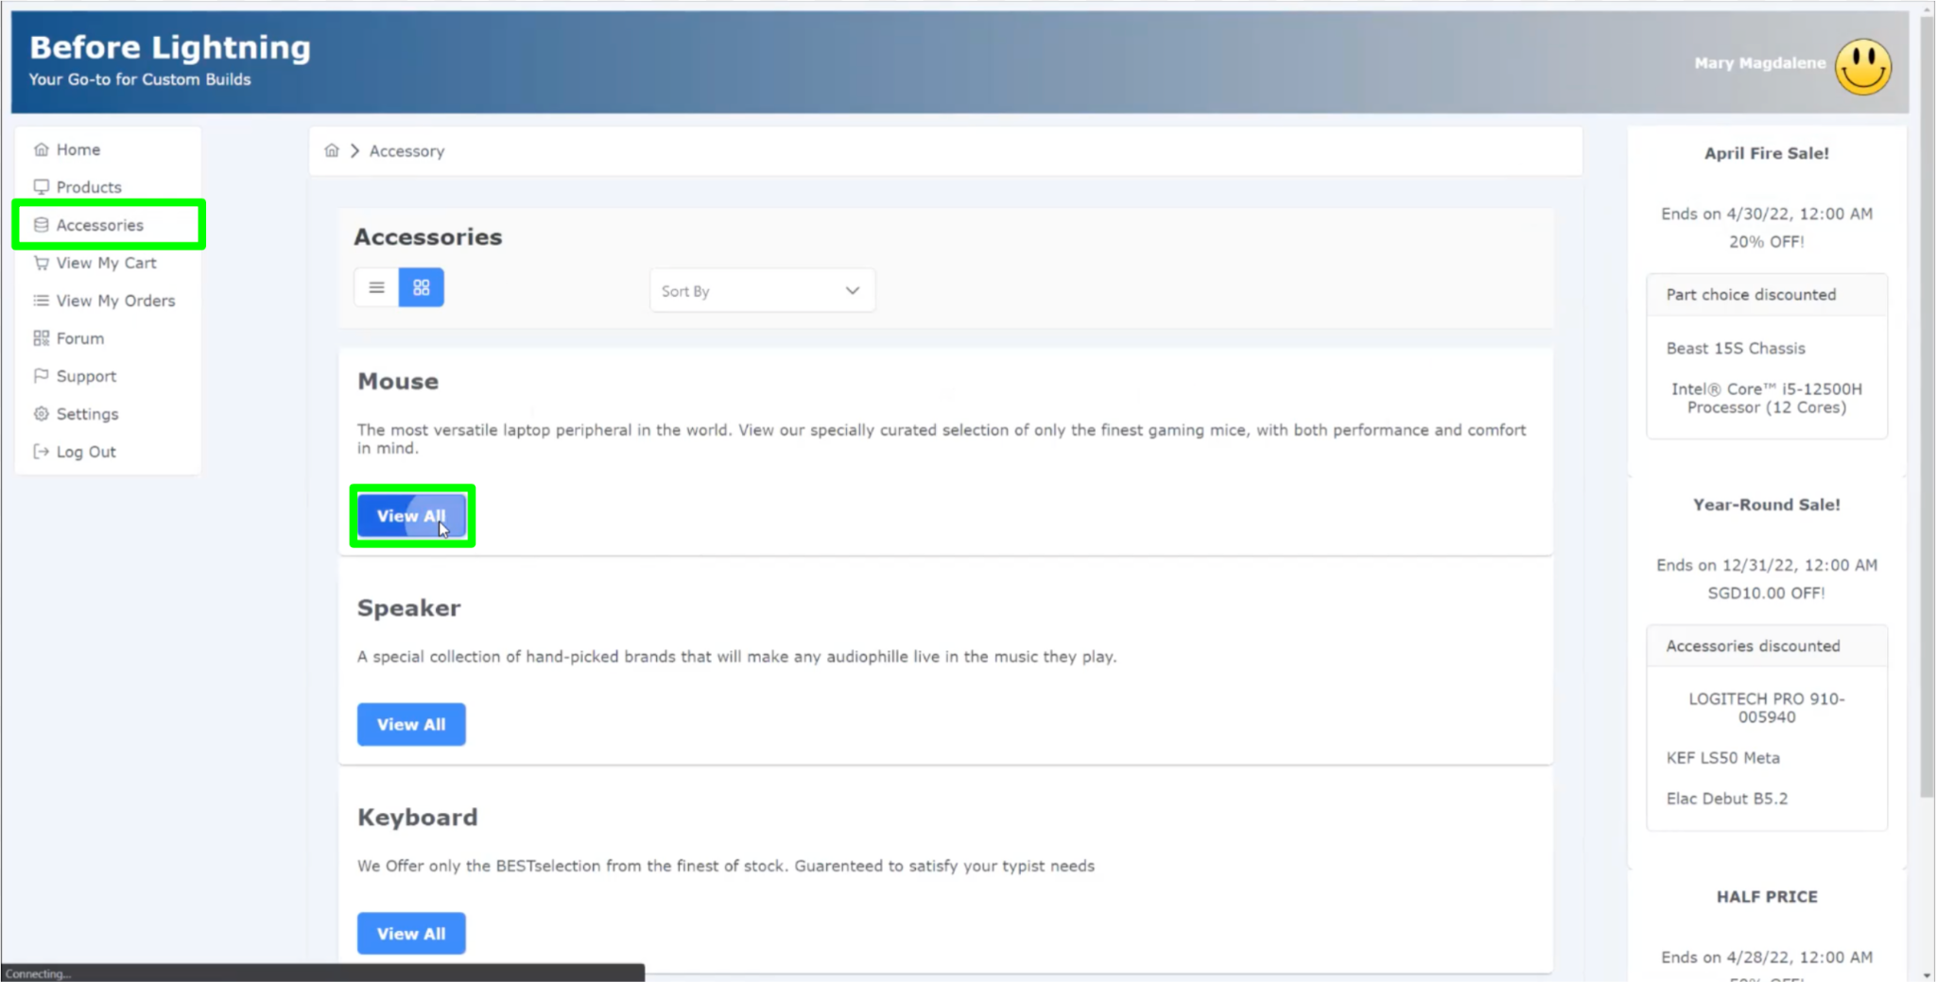

Fig. 2.4.1

Customers can add their desired mouse and quantity to their cart, and click “Confirm” to complete adding the selected accessory to cart as shown in figure 2.4.2.

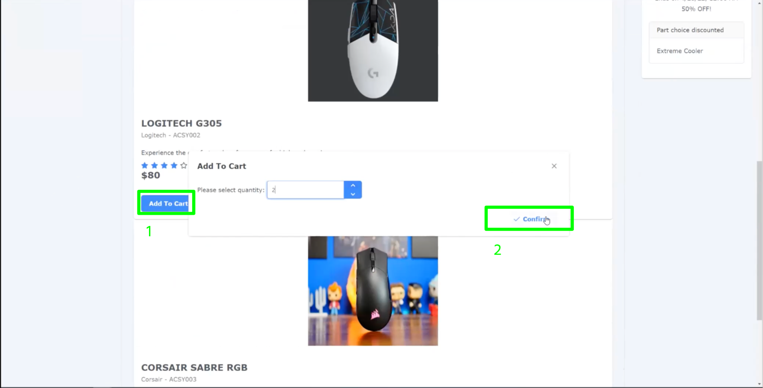

Fig. 2.4.2

A notification message is displayed to indicate the selected Accessory has been successfully added to Cart as shown in figure 2.4.3.

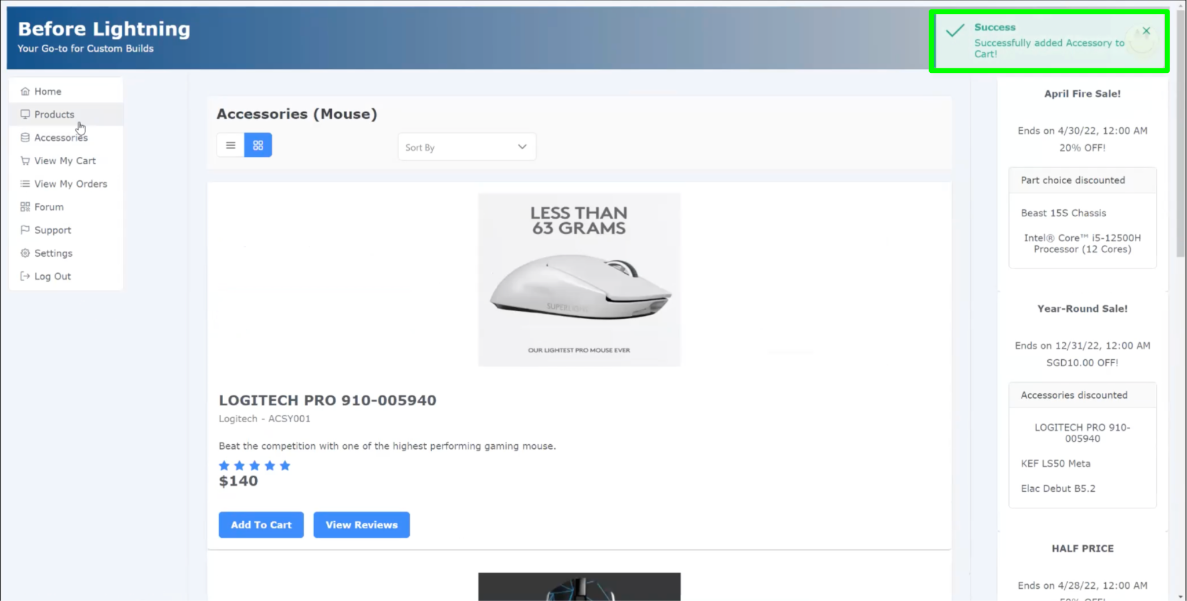

Fig. 2.4.3

Customers can view their cart by clicking on “View My Cart” at the menu bar. They can remove line items, or update the quantity for each of the line items in their cart. To check out, customers can click on the “Check Out” button as shown in figure 2.4.4. Customers can only checkout if they are logged in, and have a credit card added in their account.

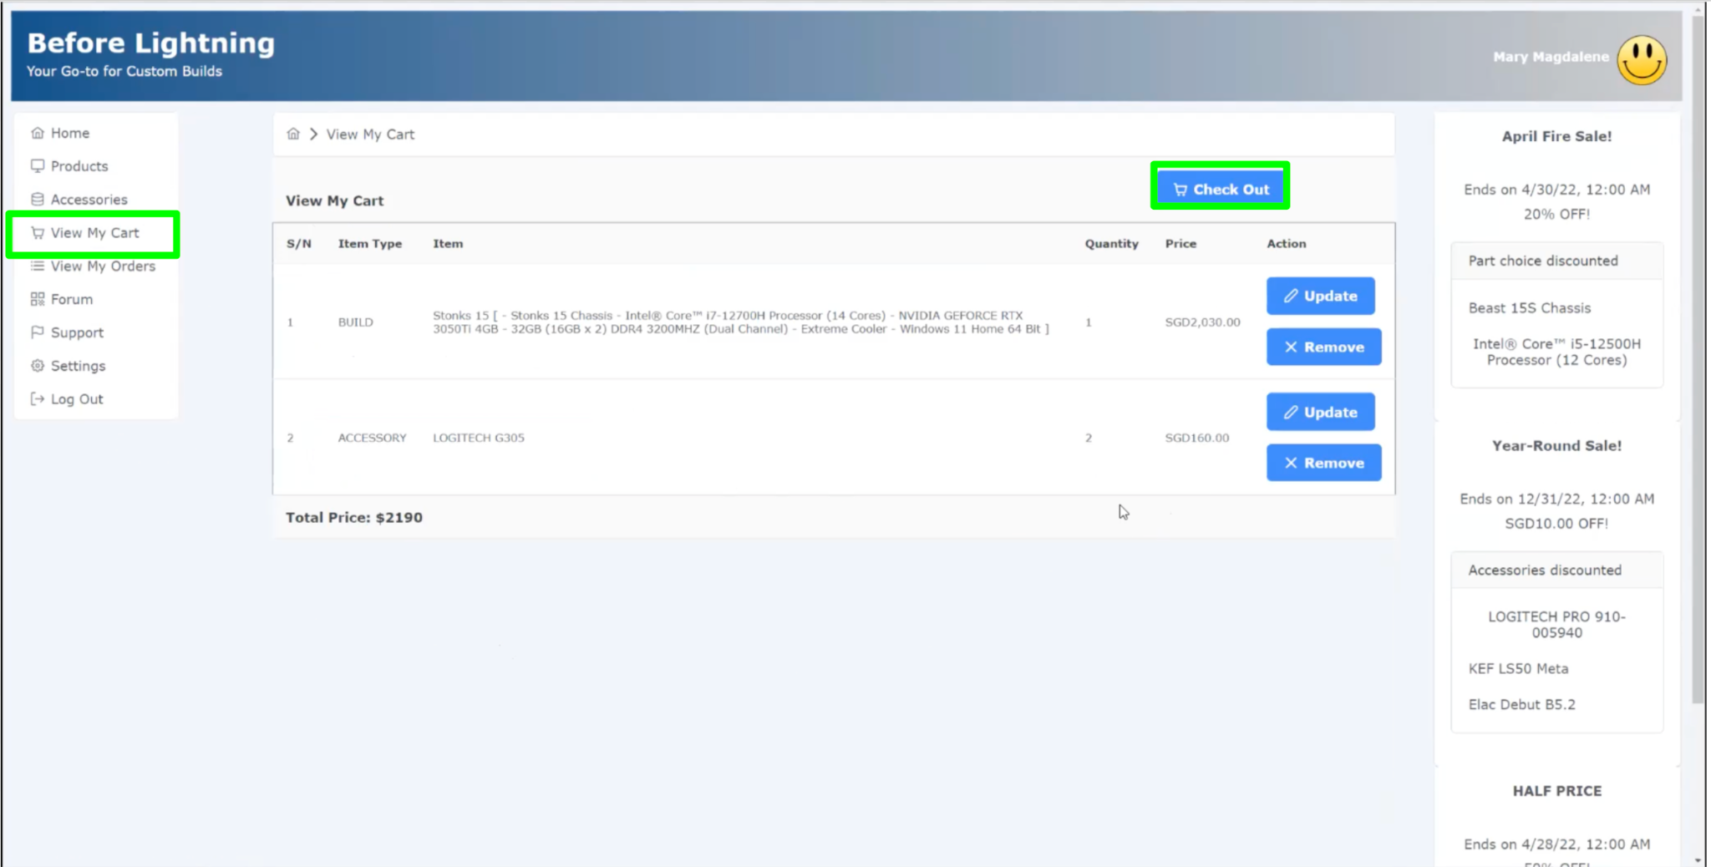

Fig. 2.4.4

1. View My Cart

Customers can choose between Self-Collection and Delivery. They will then be required to select their preferred time slot for collection/ delivery and enter their credit card details. To complete checking out, customers can click on the “Checkout Now” button as shown in figure 2.5.1.

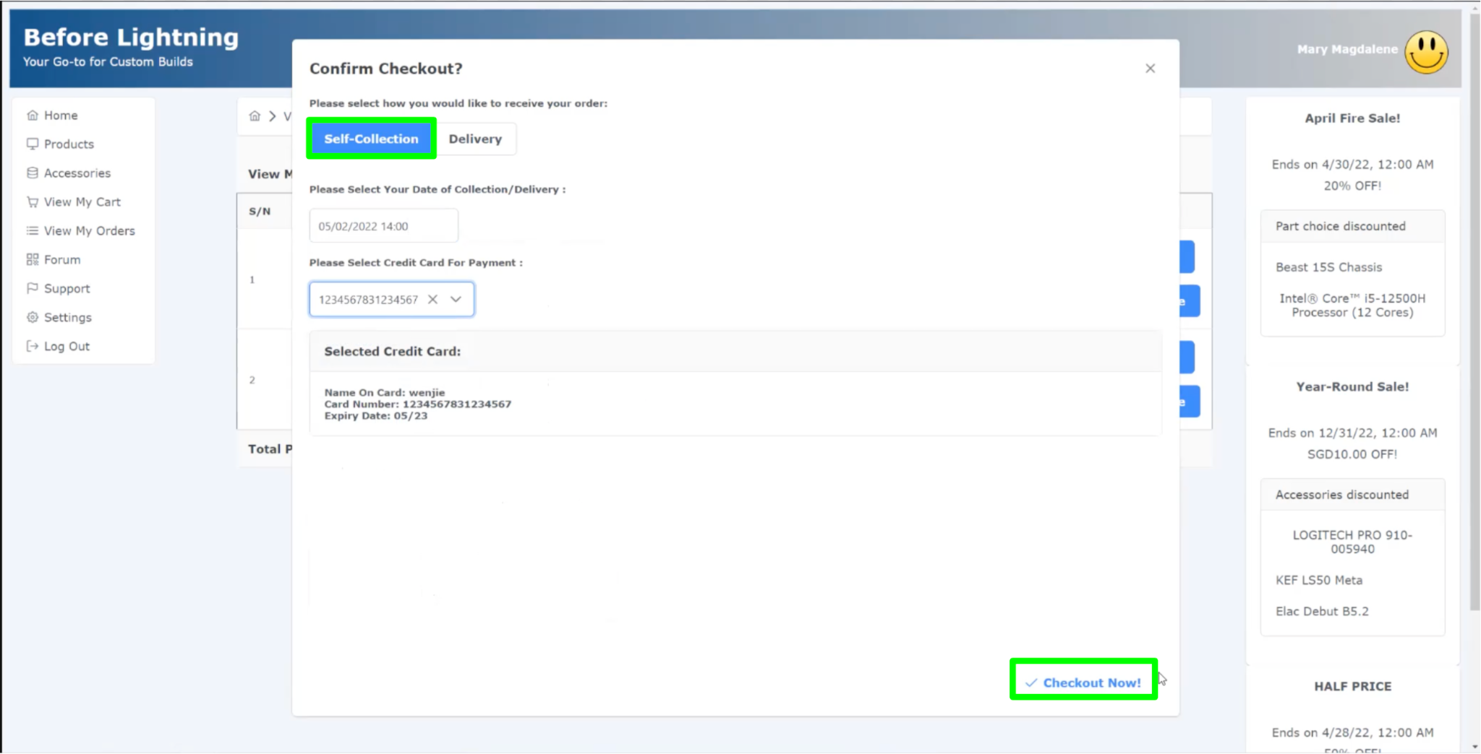

Fig. 2.5.1

A notification message is displayed to indicate they have successfully checked out their shopping cart as shown in figure 2.5.2.

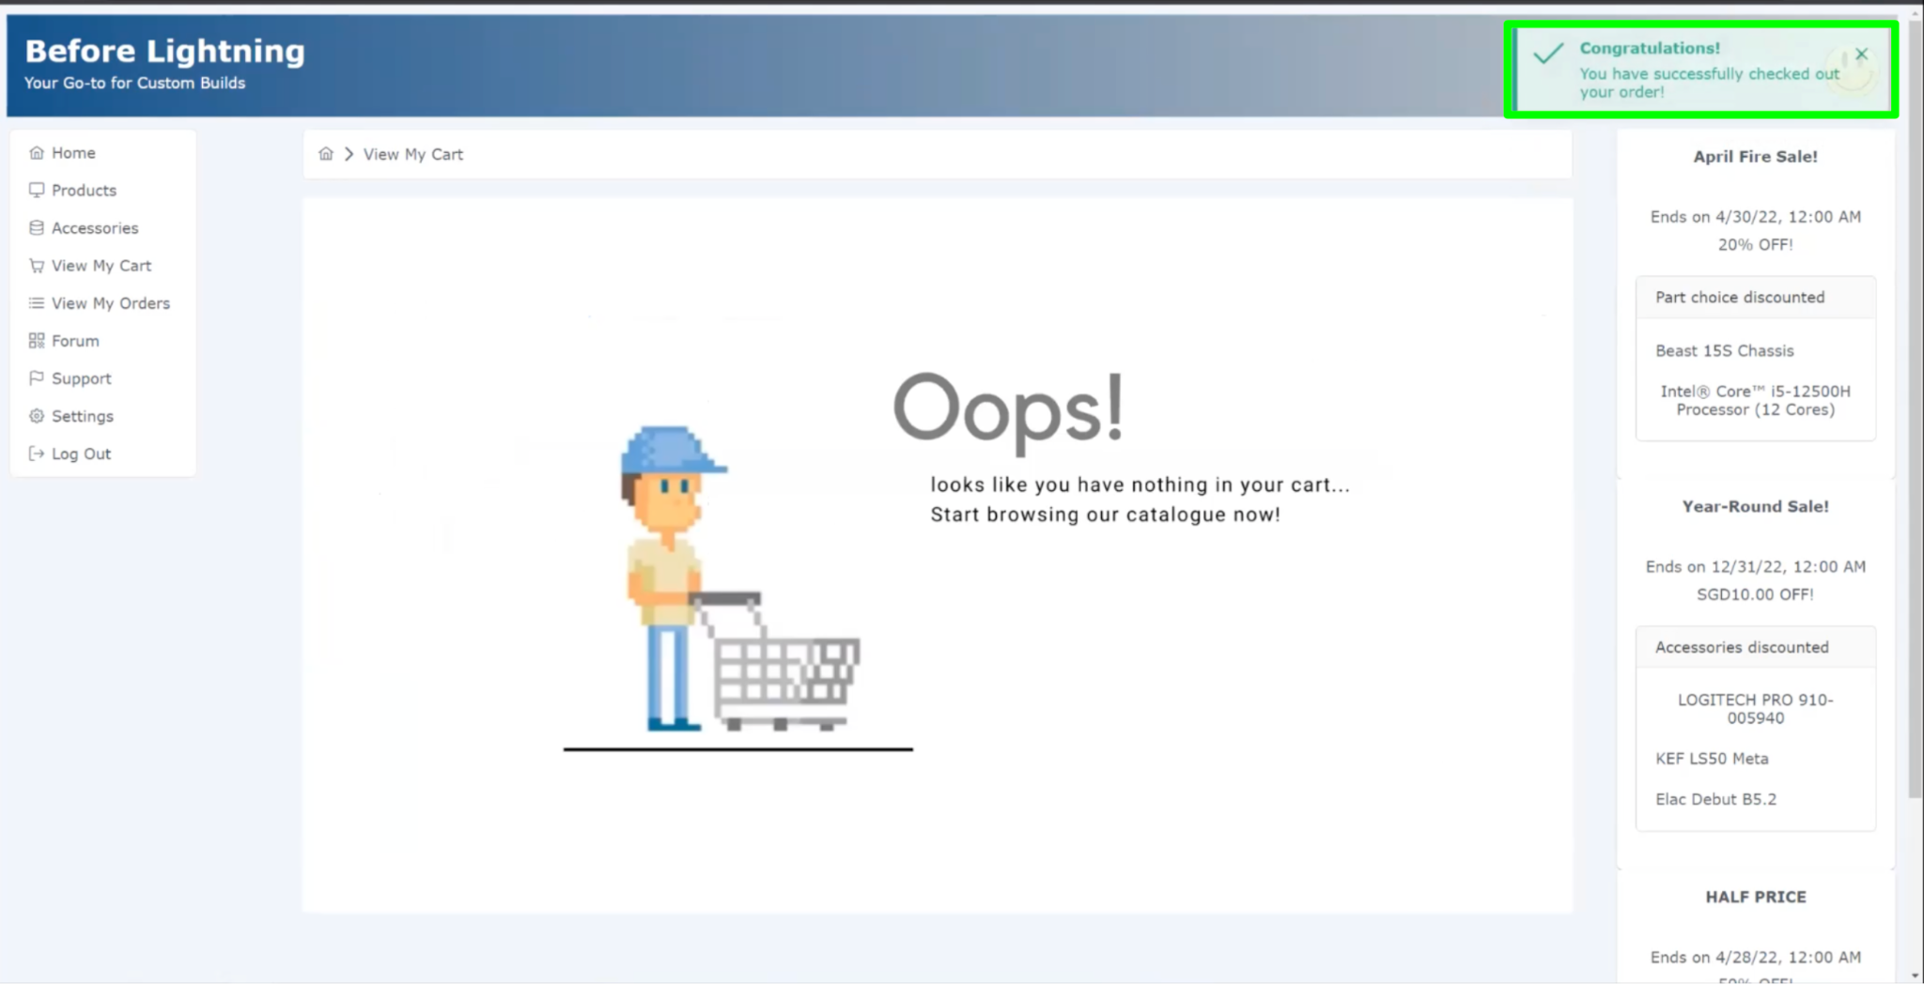

Fig. 2.5.2

1. View My Orders

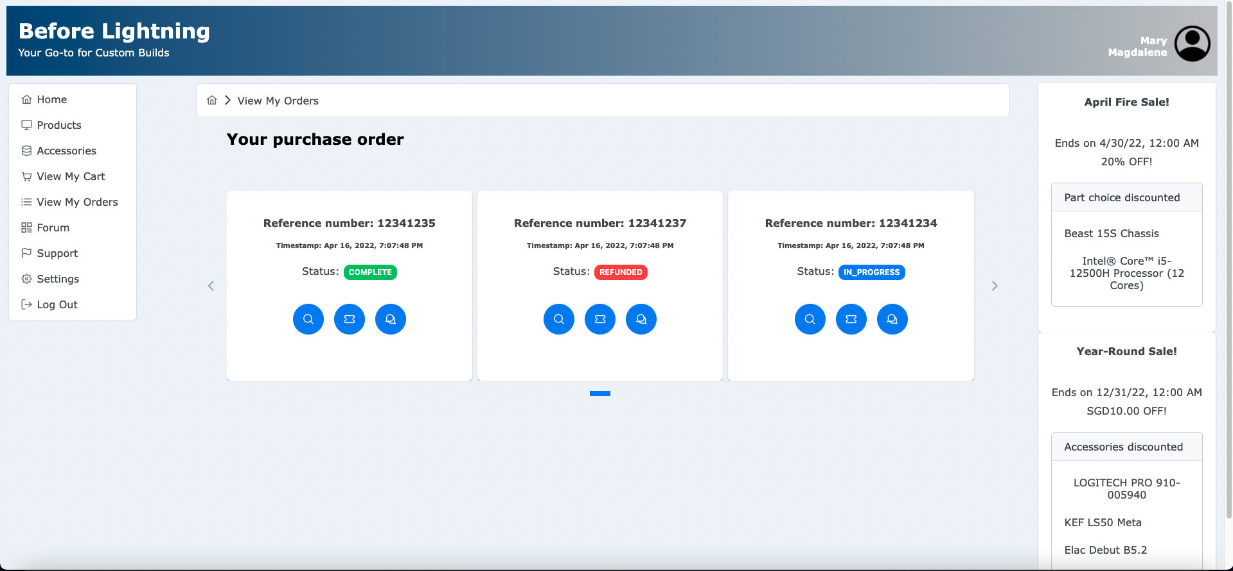

Fig. 2.6.1

Under the view my orders tab, customers can view all their orders, view the order details, and see the status of the orders. This status will be dynamically updated in accordance to status changes initiated on the backend.

To view their successful orders, customers can click on “View My Orders” on the menu bar. To view a particular order detail, they can click on the “Enlarge” icon as shown in figure 2.6.2.

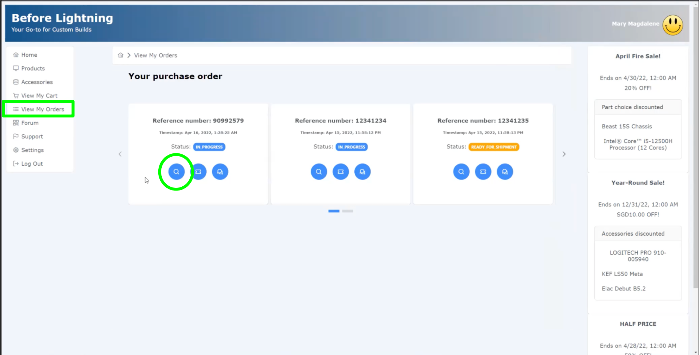

Fig. 2.6.2

A dialog will be displayed where customers can view the full details of their purchase order as shown in figure 2.6.3.

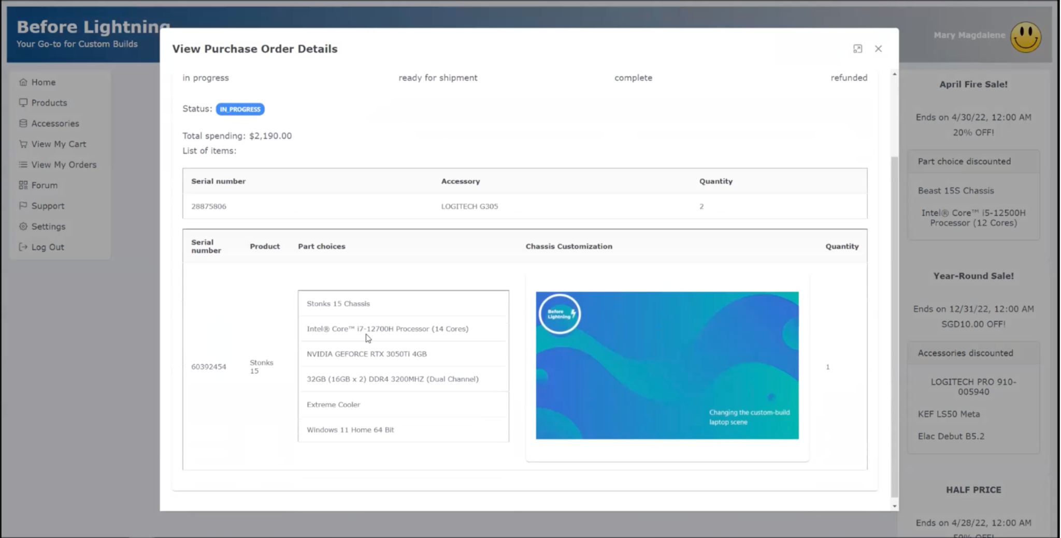

Fig. 2.6.3

The ticket icon redirects the user to the support page. The chat icon opens a dialog which allows users who have gotten their orders to leave a review, or to select a button that redirects them to the forum page.

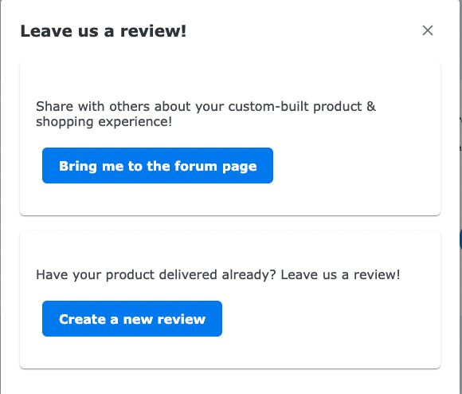

Fig. 2.6.4

1. Support

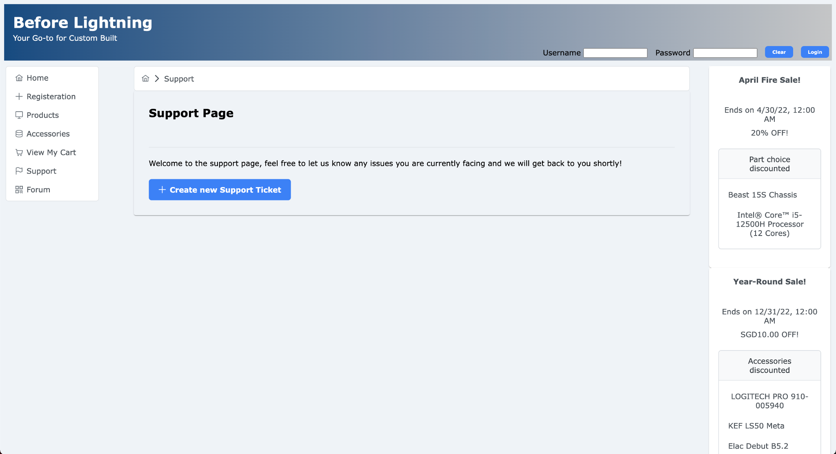

Fig. 2.7.1

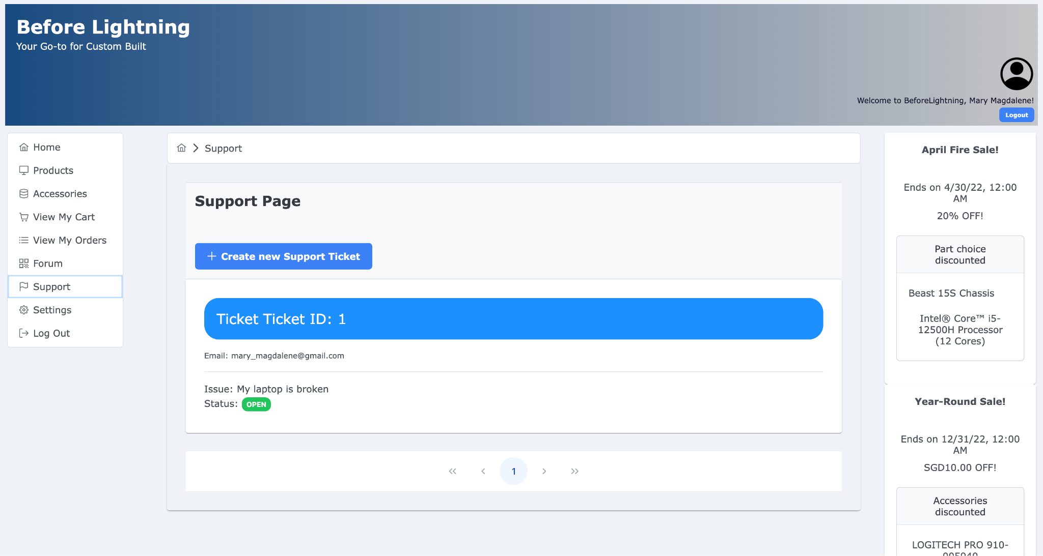

Fig. 2.7.2

Support page can also be accessed by users that are logged in. Members can view all their submitted Support Tickets as well as the status of their support ticket. They can create a support ticket by clicking on “Create new Support Ticket” to submit their issue.

1. Forum

The forum page has two tabs - all posts and my posts. 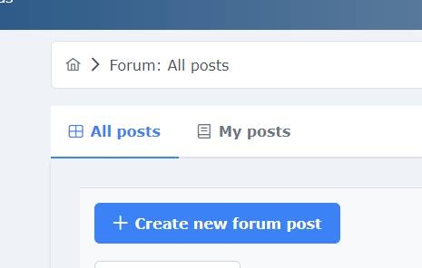

Fig. 2.8.1

The default tab is the all posts tab, in which both guests and the registered customers will have access to view the list of all visible and unbanned forum posts.

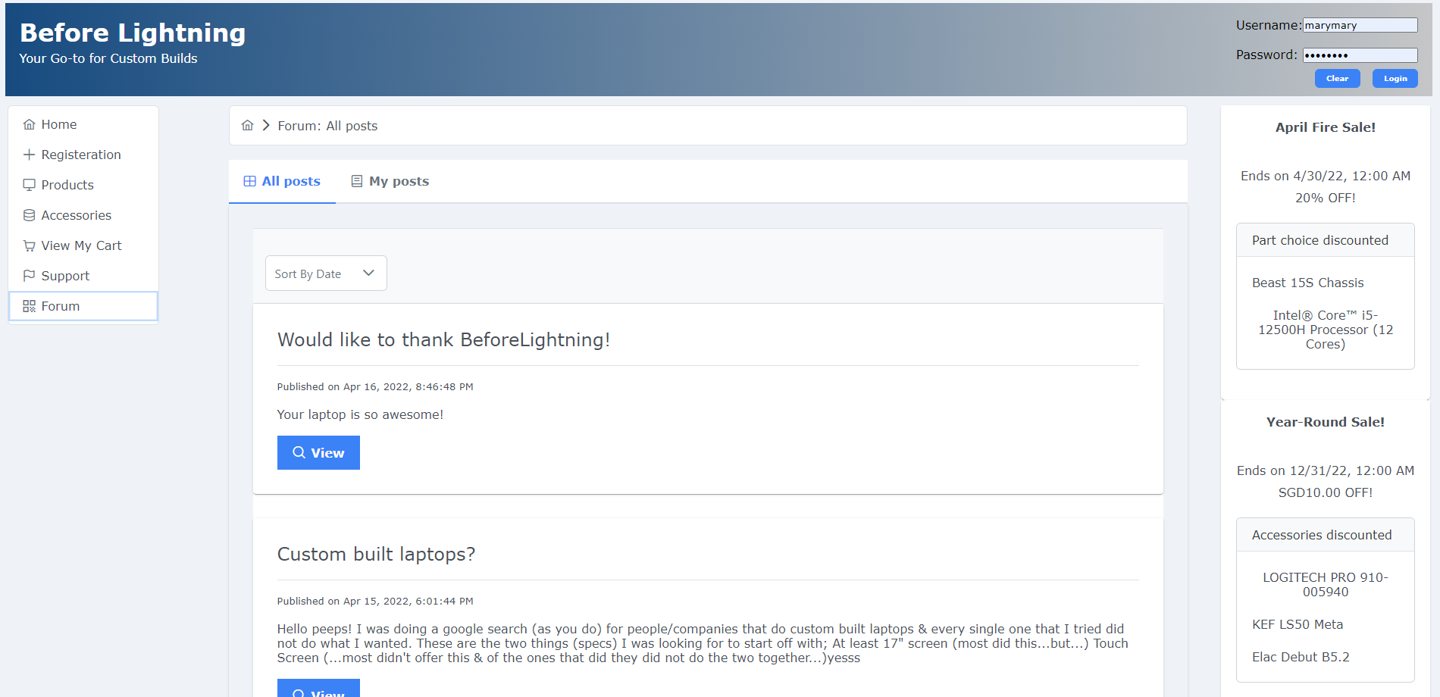

Fig. 2.8.2

The figure above is visible to a guest who has not logged in to our customer portal. For each forum post, there is only one action they could do - that is to view the forum post details.

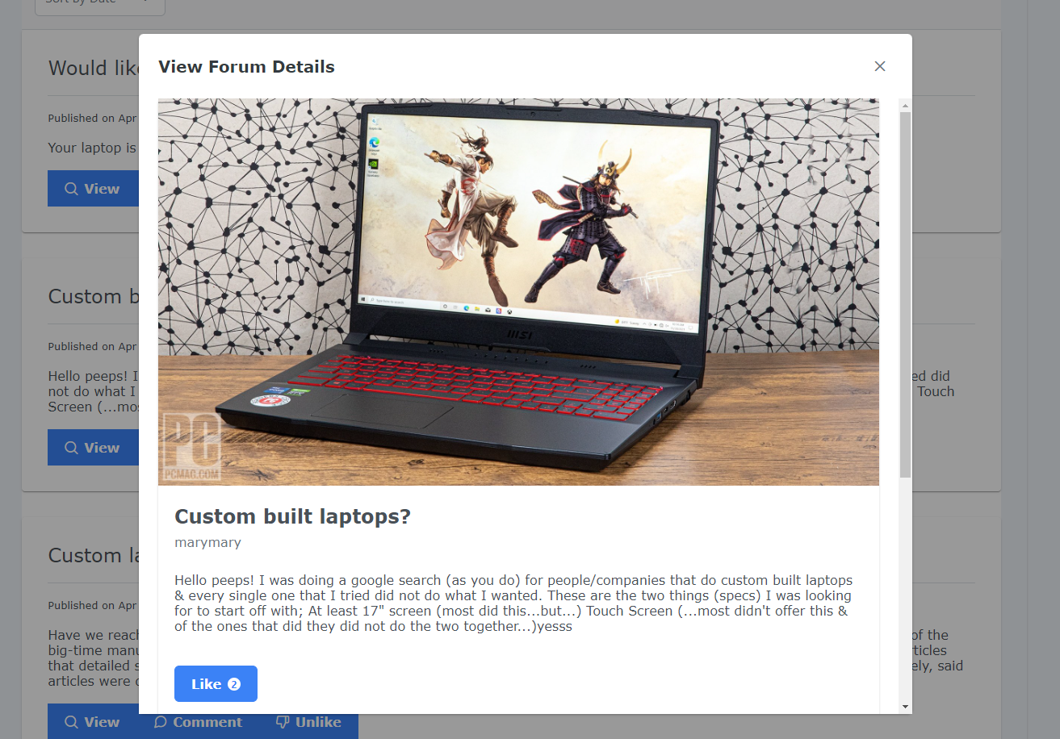

Fig. 2.8.3

Clicking the view forum post details will lead the guest to this dialogue box where he can see full details of the forum post - including any image uploaded for the specific forum post. On top of that, he will also be able to see the number of likes the forum post has. Clicking the like button will lead the guest to another pop-up window.

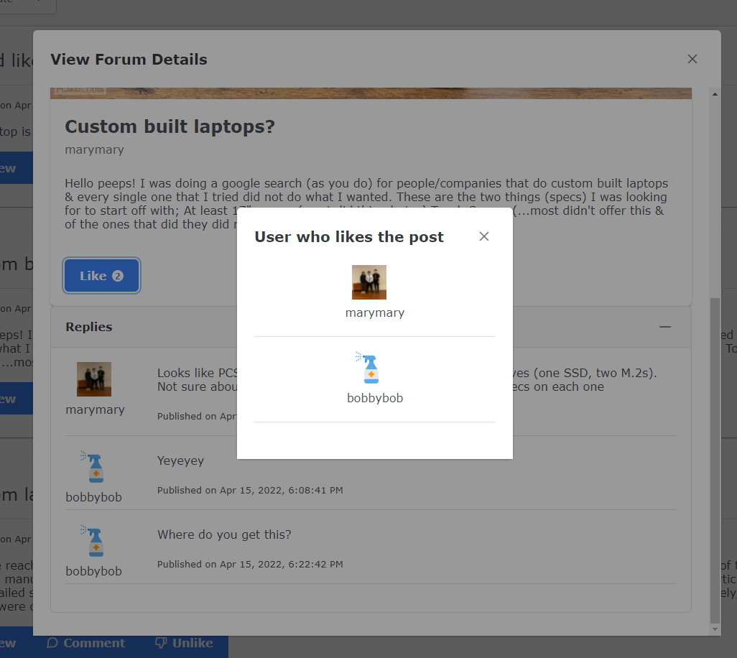

Fig. 2.8.4

The pop-up window will show the list of usernames of registered guests who like the forum post. 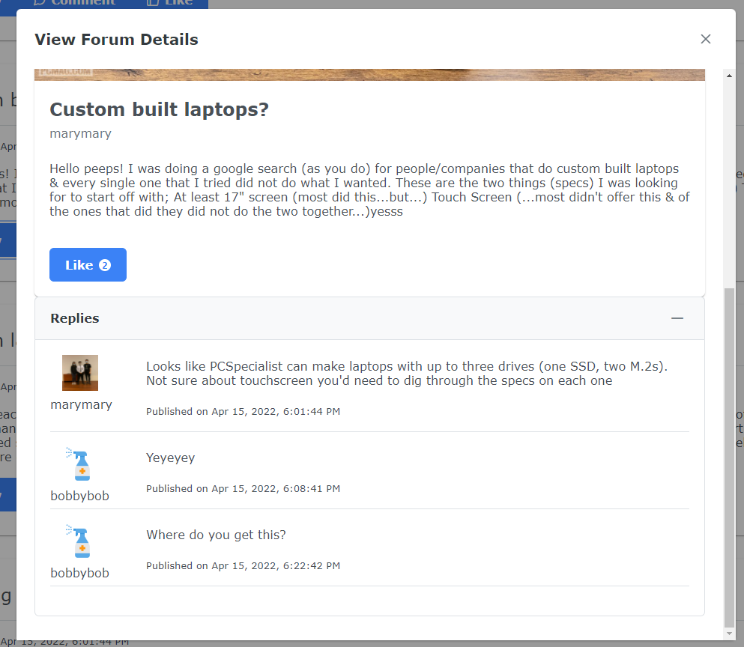

Fig. 2.8.5

The list of replies for a certain post will also be available for an unregistered customer to see.

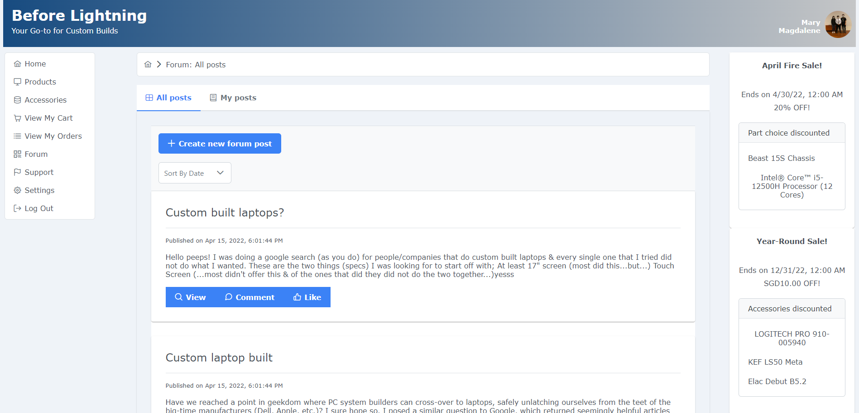

When logged in, a customer can see multiple options on the forum page. He will be able to create a new forum post.

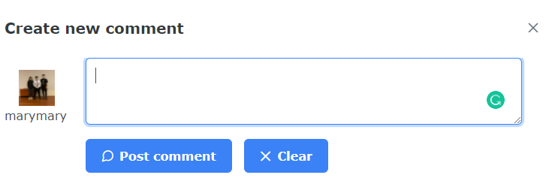

Fig. 2.8.6

Logged in users can also create a new comment!

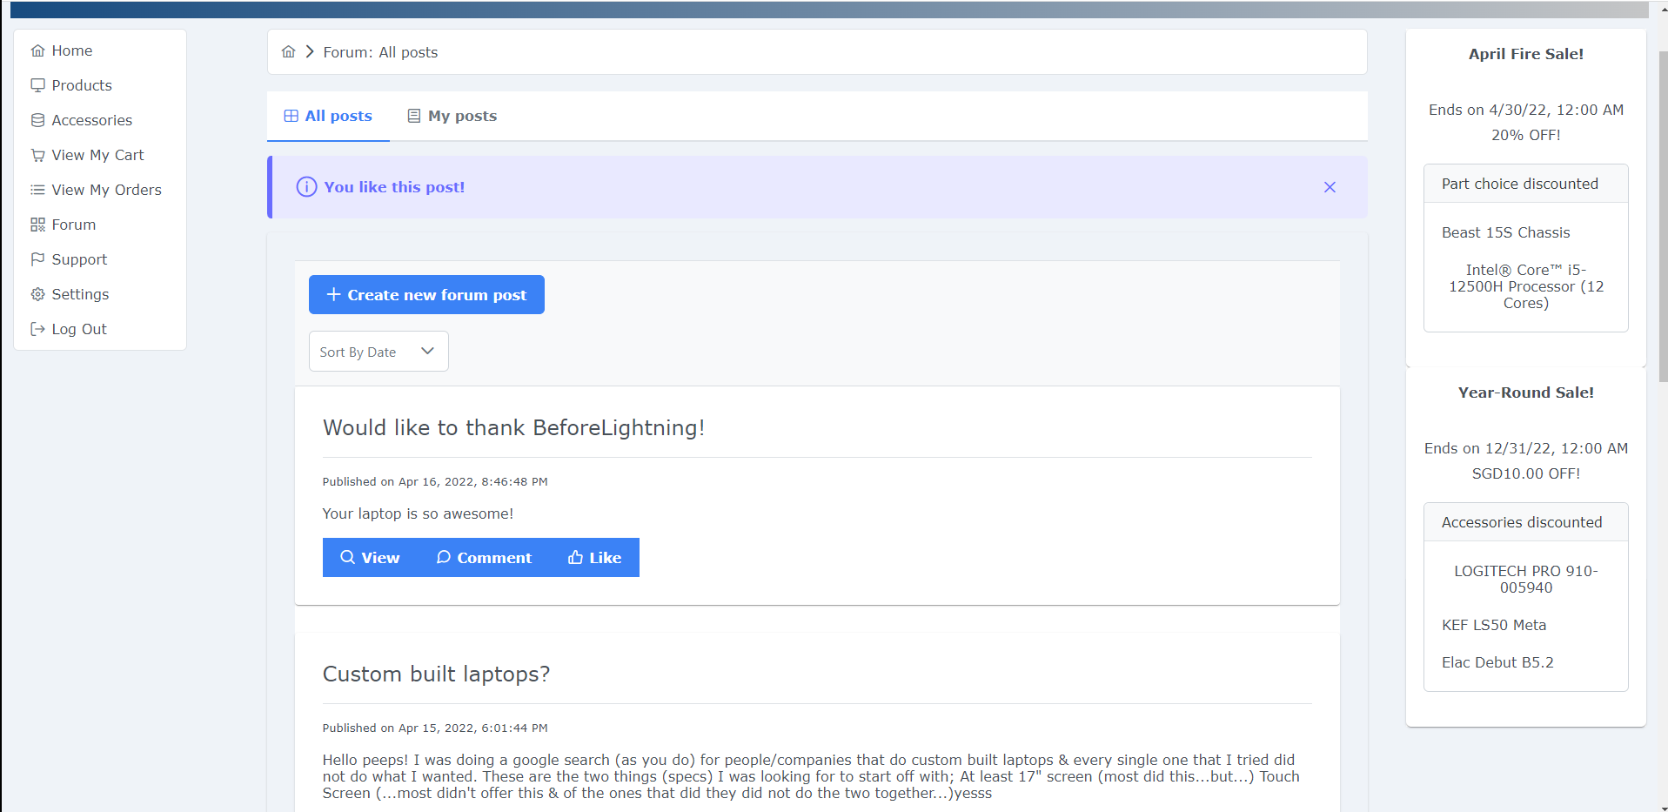

Fig. 2.8.7

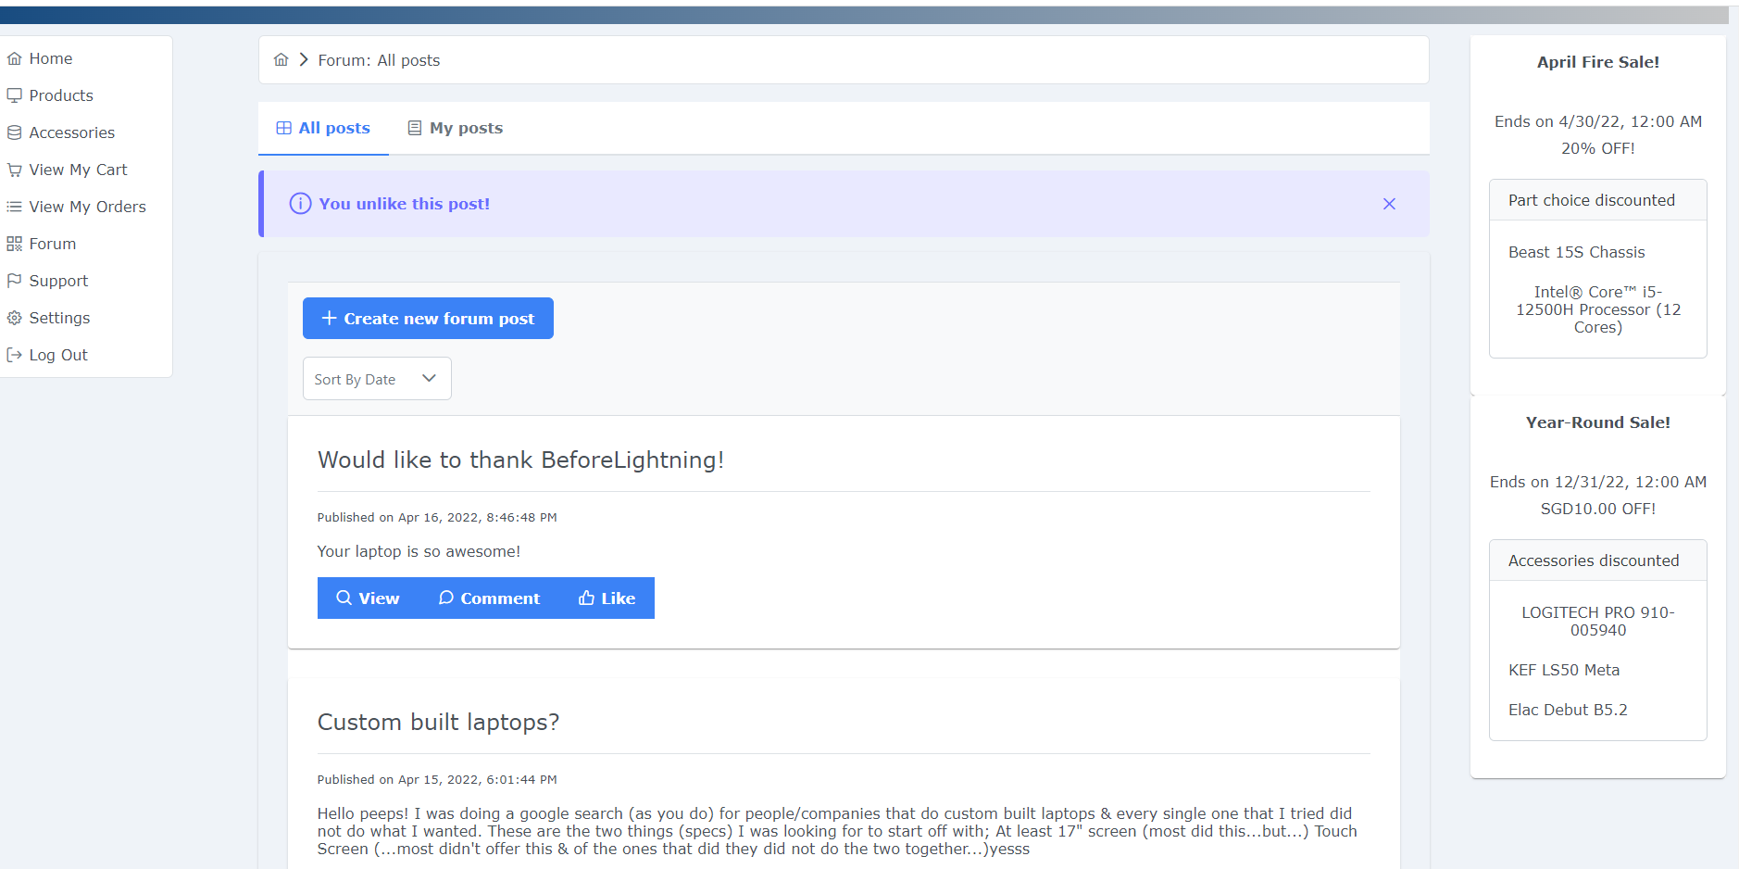

Fig. 2.8.8

Logged in user will be able to like any forum posts that he likes. He can also unlike the same post by clicking the same button!

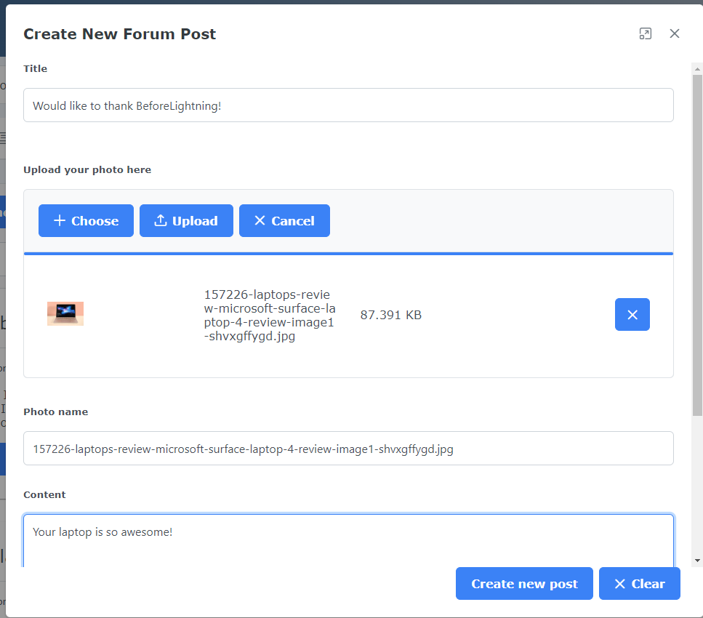

Fig. 2.8.9

In creating a forum post use case, there is an option for the customer to upload an image for the forum post.

Logged in customers will also be able to interact with other people’s forum posts.

The second tab, view my posts, will display a list of both visible and non-visible forum posts created by the account holder.

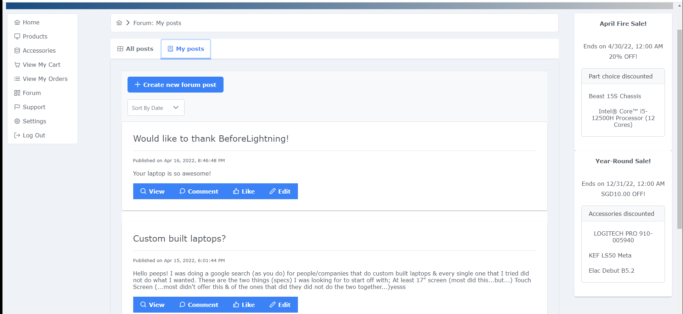

Fig. 2.8.10

The additional feature the my posts tab has as compared to that of the all posts tab is that the creator of the forum post can edit the forum post details.

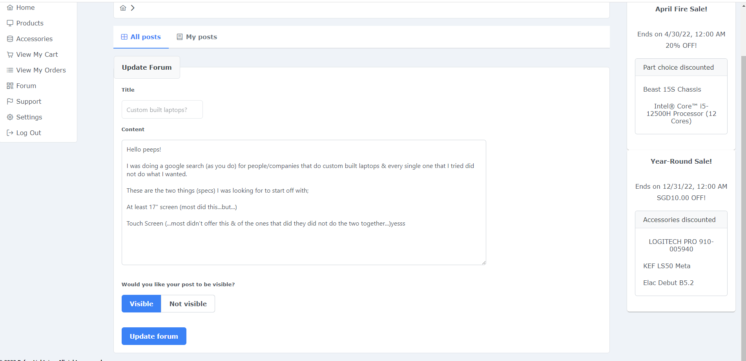

Fig. 2.8.11

Other than the content of the forum post itself, the creator of the forum post can also set the forum post as visible / non-visible!

1. Settings

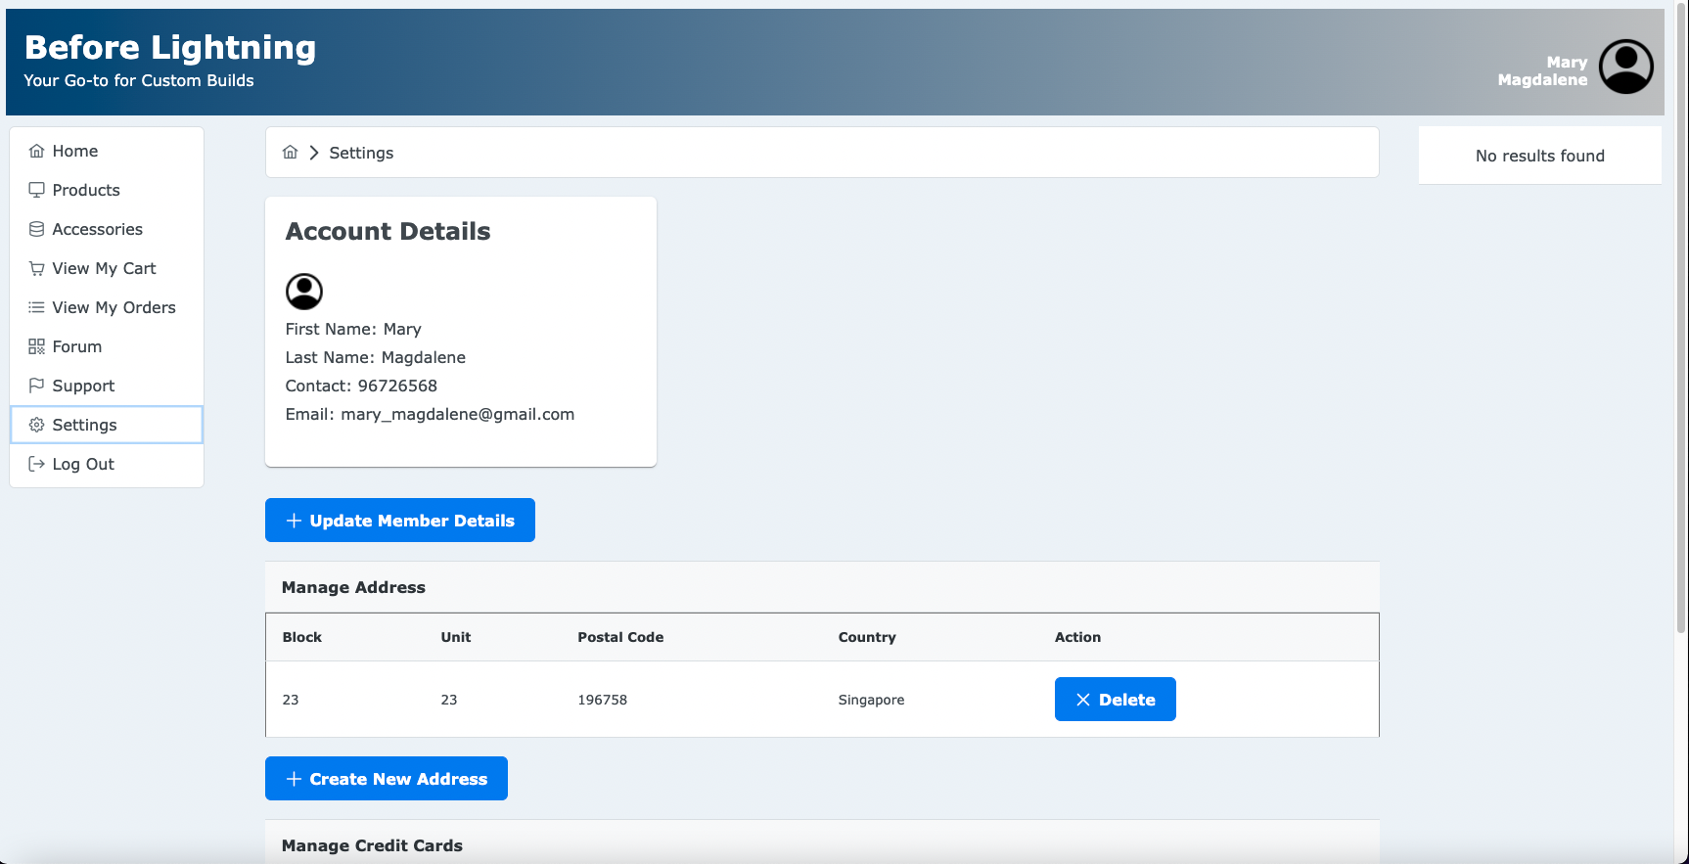

Fig. 2.9.1

## 

Fig. 2.9.2

In the settings page, users can manage their account details.

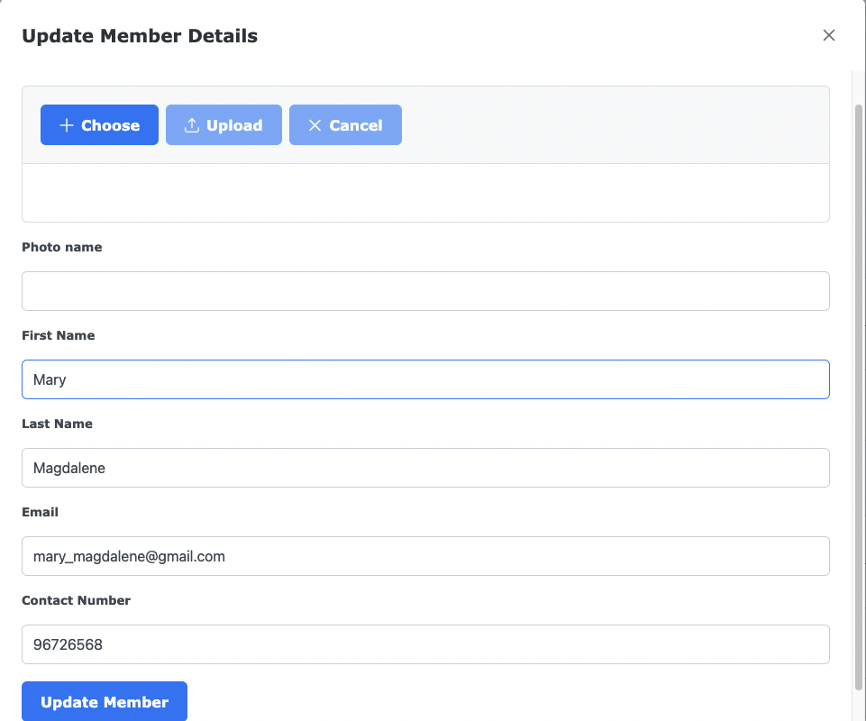

Fig. 2.9.3

They can manage their name, contact number, email and profile picture via the update member detail button.

## 

Fig. 2.9.4

The create new address takes in the block number, unit number, postal code and country to create a new address, which the customer has the option to delete.

## 

Fig. 2.9.5

The create new credit card button takes in the credit card number, name on card, expiration date and cvv to create a new credit card entry. The customer also has the ability to delete the credit card.

## **References**

Aftershock Website

<https://www.aftershockpc.com/>

Lenovo Website

<https://www.lenovo.com/>

HP Website

<https://www.hp.com/us-en/shop/vwa/custom-laptops/ordr=Customizable>

XoticPC Website

<https://xoticpc.com/>

Googoo Website

<http://www.googoo.com.sg/contactus.asp>